Environmental Impact Assessment of a
Collective Solar Water Heater System in West Bank
Aysar Yasin
An-Najah National University - Energy Engineering and Environmental Engineering
Nablus, Palestine - Aysar.yasin@najah.edu

Abstract—
West Bank and Gaza strip suffer from huge shortage of conventional energy sources and at the same time own high potential of solar energy radiations. The solar radiation can mainly be utilized for electricity generation using PV technology and for water heating using solar water heaters technology. Solar water heaters (SWH) are one of the most important applications utilized in West Bank and Gaza strip. This paper assesses the environmental impact of implementation of collective SWH systems in health sector through a case study of a hospital located in Nablus/West Bank. A collective SWH system supplemented with auxiliary heater for a hospital is designed in this study. The hospital demand for hot water is about 5500 liters /day. Indirect closed loop forced SWH with water storage tanks are used. Auxiliary water heating is to be provided via diesel fueled boiler.
RETScreen® software solar water heating project model is utilized in this paper to perform simulations. The total collectors’ area is 77.52 m² of evacuated type. The capacity of proposed system is about 47.6kW. The annual heating energy delivered by the SWH collector system is 62.2 MWh which corresponds to 61% solar fraction. The corresponding CO₂ saving is about 72.5 tons on the basis that coal is the base case electricity system fuel type. The CO₂ saving is about 27.9 tons if a diesel boiler provides the system with the required energy. The simple payback period of the project is 2.8 years and the equity payback is 2.2 years.
Keywords- solar water heating system; evacuated tubes collectors; RETScreen; solar fraction; Palestinian territories, GHG emission, financial indices.

Introduction
The excessive usage of energy depending on conventional energy sources increases the concentration of carbon dioxide in our atmosphere and other hazardous emissions likes NOxs and SOxs. The expected depletion of fossil fuels is another catastrophic problem. The systematic exploitation of renewable energy sources is one of the solutions adopted by energy decision makers all over the world.

West Bank and Gaza suffer from shortage and high prices of energy sources because of the political situation and specifically the occupation. The Palestinian authority purchases all its needs of petroleum products from Israeli market and about 92% of electrical energy from the Israeli Electric Corporation (IEC) which is considered one of the main problems to Palestinian economy.

Solar energy radiations are abundant in West Bank and Gaza (5.46 kWh/ m².day) which makes the exploitation of solar energy feasible.

Solar energy technologies use the sun's energy and light to provide heat, light, hot water, electricity, cooling for all sectors. Among those technologies is the SWH technology which is defined as technology used to transform sunlight energy into heat energy used to heat water by means of solar thermal collector.

SWH are extensively used in the residential sector in West Bank and Gaza, in which 68.2% of households use solar family systems, whereas, it is limited in the service and industry sectors [1]. The existing installed capacity in all sectors is totaled to 1,533,000 m² of which 7100 m² in the service sector, this can produce 650 GWh annually with corresponding CO₂ savings of 395,000 tons per year [1, 2].

The energy consumption in service and building sectors in West Bank and Gaza and in all other developing countries represents a major part of energy bill, approximately equal to 75% [3]. The electric water heating consumes the most electric power and emits the most pollutants during its life cycle [4].

This paper investigates the environmental benefits of a collective SWH based on evacuated tube collectors for hospital in West Bank. The technical and financial analyses are investigated as well. RETScreen® software SWH project model [5] is used to assess the energy based on solar radiation on horizontal and tilted surface, energy delivered from SWH system, GHG emissions, and energy saving. The financial indices are estimated in this study to evaluate the economic benefits like payback period, equity payback period and pre-tax IRR.

Geographical Context and Metrological Data
West Bank & Gaza Strip as shown in Figure 1 lies on the western edge of the Asian continent and the eastern extremity of the Mediterranean Sea, between 34º20’– 35º30’ E and 31º10’– 32º30 N.
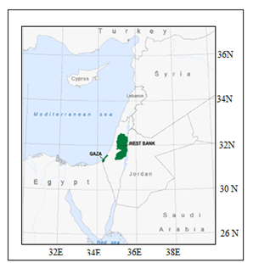
Figure 1: Location the Palestinian Territories in the region, [7]

It includes of two land areas; the West Bank 5800 km2, and the Gaza Strip 365 km². The metrological data used in this study are mainly based on the Atlas of solar resources of Palestinian territories [6], the local metrological stations followed to An Najah Energy Research Center, and the database recorded by National Aeronautics and Space Administration NASA.

The monthly variations of daily solar radiation on horizontal surface of the selected sites are presented in Figure 2. The data are imported from Atlas of solar resources of Palestinian territories [6].

Figure 2 indicates that differences between sites are small as the variability in yearly averages of global horizontal irradiation (GHI) is only 1.5% while monthly averages have differences ranging from 1.1% in May to 5.2% in February [6].

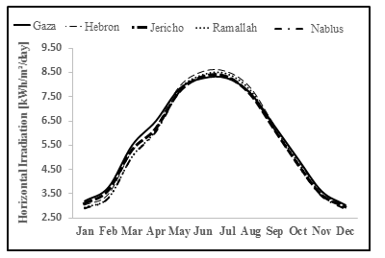
Figure 2. Monthly variation of daily solar radiation on horizontal surface
The hospital taken as a case study is located in Nablus city/west bank. The authentic climatic data like latitude, longitude, location elevation, heating and cooling design temperature are imported from its database recorded by National Aeronautics and Space Administration (NASA) [7]. A detailed values of air temperature and daily solar radiations on monthly and annual basis are shown in Table 1.

Table 1: climate data of location with latitude 31.9º and longitude 35.2º [7]
 | Air temperature | Daily solar radiation - horizontal
Month | °C | kWh/m²/d
January | 7.7 | 3.37
February | 8.2 | 4.20
March | 10.4 | 5.30
April | 15.1 | 6.81
May | 19.1 | 7.83
June | 21.4 | 8.57
July | 23.1 | 8.40
August | 23.1 | 7.85
September | 21.8 | 6.73
October | 19.1 | 5.28
November | 14.1 | 3.74
December | 9.7 | 3.05
 | 16.1 | 5.94

TECHNICAL ANALYSIS
The proposed collective SWH system provides the domestic hot water for the hospital is shown in Figure 3. The main components used to build the collective solar water heater system are illustrated in Table 2.

Table 2: collective SWH components

item | Component
1 | Evacuated panel 2 m² , 18 pipes
2 | Flat plate stainless steel hot water heat exchanger 40 kW
3 | Pumps
4 | Hot Water Storage Tank ( 2000 liter)
5 | Cold water makeup plastic tank 1000 liter
6 | Expansion Tank (200 Liter)
7 | Piping system and its accessories for closed loop SWH and piping system between storage tanks
8 | Control system with differential thermostat
9 | Valves, safety valves, Thermometers , Pressure indicators, impulse hot water, pipes, etc (on the roof, not to apartments)
10 | Fixtures
11 | Auxiliary Heating System (diesel fueled Boiler)

The system is designed with the aid of RETScreenTM software [8]. The system is classified as a forced-indirect closed solar water heater system with supplementary heater. The daily hot water consumption is about 5500 Litres. The load is calculated based on the number of beds in the hospital which is 60 beds and the occupancy rate which is about 45%. The required water temperature of the water is 60 ˚C and the Operating days per week is seven.

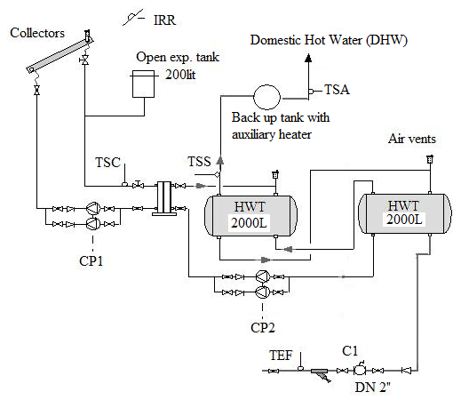
Figure 3: Collective SWH system layout with the required measuring sensors (forced – indirect closed system)

The solar tracking mode of the system is fixed in which the collective SWH system is south-facing 45˚ azimuth angle and inclination angle of the collectors is 42 ˚. The total collectors’ area is 77.52 m² of evacuated type and the cross sectional area of each collector is 2.28 m². The capacity of proposed system is 46.7kW taking into account of 5% miscellaneous losses. The annual heating energy delivered by the SWH collector system is 62.2 MWh which corresponds to 60% solar fraction.

The storages capacity of the system is 4000 Litres and two well-insulated storage tanks are used. An external flat plate heat exchanger is used with 85% efficiency. The system includes at least two pumps each of 1kW capacity. The annual energy consumed by the pumps us 2 MWh.

A diesel fuelled boiler is used to compensate the low radiation in winter or in case of a reduction in water temperature. The proposed boiler capacity is 40kW with seasonal efficiency 85%. The existing diesel fuelled boiler is used in the study. The proposed system is to be installed in the centre of the load as the building is horizontally extended. 10% of miscellaneous losses were proposed in order to compensate the transmission losses.

Environmental Asseessment
The utilization of solar energy has positive environmental impacts besides the savings in money. This study evaluates the environmental impacts from the operation of collective SWH system in one of the Palestinian hospitals (Etihad hospital/Nablus) without considering the manufacturing impacts. This study evaluates the gas emissions produced in case the utilized solar energy is delivered from electric and diesel boilers.
To investigate the environmental benefits of utilizing solar energy instead of conventional sources of energy, air pollution saved derived from the reduction in consumption of electricity and/or diesel, conventionally used for water heating in Palestine, are to be evaluated. It is easy to translate the amounts of energy saved into the corresponding amounts of air pollution saved by using special equations designed to each specific type of pollutants.
Table 3 illustrates the annual energy utilized from solar water heater and the corresponding energy required from die sel/electric boiler.
Table 3: Annual energy utilized from SWH
Energy utilized / needed | MWh/year
Energy utilized From SWH | 62.2
Energy needed from Diesel boiler with 80% efficiency | 77.75
Energy needed from electric boiler with 90% efficiency | 69.12
This amount of energy in case it is taken from diesel or electric boiler could save significant quantities of gas emissions mainly carbon dioxide (CO₂) which is considered the main player of greenhouse gases. The CO₂ saved emissions by utilizing collective SWH is shown in Figure 4.
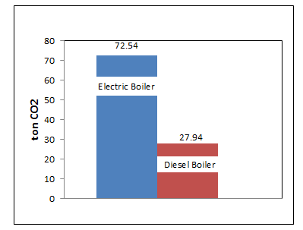
Figure 4: CO₂ saved emissions by utilizing collective SWH
Figure 5 shows the amounts of saved emissions of other pollutants types.
Collective SWH systems have a good potential to reduce gas emissions which are considered an important factor to evaluate the performance of any energy system. The results show that by using solar energy, considerable amounts of greenhouse polluting gasses are saved. The investigated system gives positive and very promising performance and financial characteristics. Therefore, utilizing the collective solar heating is efficient, cost effective and friendlier to the environment. The reduction of greenhouse gasses pollution is the main advantage of utilizing solar energy. Therefore, solar energy systems should be employed whenever possible in order to achieve a sustainable future.
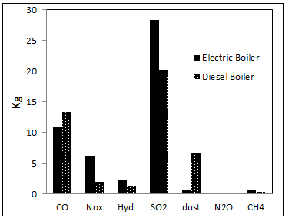
Figure 5: Different saved gas emissions by utilizing collective SWH

Financial analysis
The inflation rate is projected to be 15% over the 20-year life of the project. The current electricity tariff is 0.17$/kWh. The cost of the SWH system can be depreciated in the first year in accordance with the tax laws favouring the use of renewable energy equipment. The financial viability of the proposed project is illustrated Table 4.
Table 4: Financial viability of the proposed collective SWH system
Pre-tax IRR - assets | % | 56.6%
Simple payback | yr | 2.8
Equity payback | yr | 2.2

The pre-tax IRR is less than the inflation rate which is an indication of the feasibility of this project. The simple payback period is about three years which is considered another indication of the project’s feasibility. After 2.2 years the project starts to recover the costs. Figure 6 shows the cumulative cash flows of the proposed project.

Conclusion
Utilizing SWH technology in Palestine for water heating is feasible, efficient, and cost effective.
The utilized annual heat energy from the proposed collective SWH system of the hospital is 62.2 MWh and the corresponding CO₂ saving is about 72.5 tons on the basis that coal is the base case electricity system fuel type while The CO₂ saving is about 27.9 tons if a diesel boiler provides the system with the required energy.
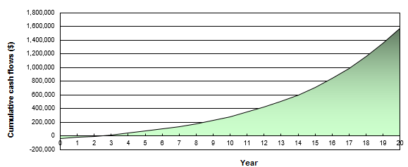
Figure 6: Cumulative cash flow
The proposed collective SWH contributes about 61% from the total thermal energy demand of the hospital. This fraction can be increased if further solar collectors are installed.
Collective SWH systems have a good potential to reduce gas emissions which are considered an important factor to evaluate the performance of any energy system. The results show that by using solar energy, considerable amounts of greenhouse polluting gasses are saved.

The investigated system gives positive and very promising performance and financial characteristics. Therefore, utilizing the collective solar heating are efficient, cost effective and friendlier to the environment.

Collective SWH systems technology usage is very limited in service sector in Palestinian due to the lack of awareness within consumers about the significant profit that could be gained in energy saving and gas emissions reduction.

References
- PCBS, Palestinian Central Bureau of Statistics, 2010.
- PEC, Palestinian Energy Center,2007. SOLATERM project, Palestine country report.
- PEA, Palestinian Energy Authority (2010), Energy sector strategy 2011 -2013.
- Taborianski V.M. and Prado R.T.A., (2004), Comparative evaluation of the contribution of residential water heating systems to the variation of greenhouse gases stock in the atmosphere, Building and Environment 39 (6) (2004), pp. 645–652.
- RETScreen® software online manual (2005), solar water heating project model. RETScreen International Clean Energy Decision Support Centre; www.retscreen.net
- Atlas of solar resources of the Palestinian territories (2014), Report No. 126-01/2014 Palestinian Energy Authority.
- A NASA satellite-derived global meteorology and surface solar energy climatology website for RETScreen parameter inputs. https://eosweb.larc.nasa.gov/sse/RETScreen/
- RETScreen® international software Product Database. RETScreen International Clean Energy Decision Support Centre; 2015. www.retscreen.net.

