**Effect of snowfall on steel structures in the west bank Risk Assessment study**

N. N. Samaro1, A. R. Hasan2,[1]*, M. B. Dwaikat3,I. Al Qasem2, R. Nassar2

*1Faculty of Graduate Studies, An-Najah National University, P. O. Box 7, Nablus, Palestine*

*2Department of Civil Engineering, An-Najah National University, P. O. Box 7, Nablus, Palestine*

*3Department of Building Engineering, An-Najah National University, P. O. Box 7, Nablus, Palestine*

Abstract**:**

In the last decade, several steel structures in Palestine were damaged partially or completely due to snowfall and its accumulation. Losses were mainly in the assets and domestic animals. Such damages to existing structures are expected to increase in the future, if not properly addressed, due to climate change effects in the region that represented for snow by the increase of: (i) frequency of snowfall; (ii) spatial coverage for severe events; (iii) depths averages; and (iv) melting period. These events are alarming to decision makers, engineering practitioners, contractors and assets owners involved in licensing, designing constructing, and operating steel structures. Several cases of damaged structures were analyzed by SAP2000 to account for causes of damages. Damages of structures were mainly attributed to poor design and construction practices, with absence of regular check-ups and maintenance. Climate change urges a modification in the adopted design codes in Palestine for the design snow loads.

**Keywords:** Climate change; Palestine; Snowfall; Steel structures.

# Introduction

In the last two decades, hundreds of steel structures were constructed in Palestine. Steel structures are preferred over reinforced concrete structures in industrial and commercial facilities, since they have longer spans that suits the need for show rooms, storage, and housing of large number of machines and workers, also due to its lighter weight, faster and easier to fabricate, install and modify, and considered as sustainable construction material that can be reused and recycled. However, steel structures require more protection and maintenance to maintain structures’ life cycle.

Beyond the said benefits of steel structures, several damages were occurred in recent years in Palestine due to snowfall and its accumulation on the top of structures, and caused mainly losses in assets and some domestic animals.

Snow disaster is one of the most serious and influenced hazards, which not only threatens human life and property, but also brings great damages to economy, society, resources, and environment (Gao, 2016). Increasing of snowfall measures (such as: depths, frequency, spatial coverage, and melting period) in Palestine and the region, are attributed to climate change.

Extreme weather events, as extreme snowfalls, can cause loss of life and significant damage to property and people (NAE, 2016). Moreover, it could act as a “threat multiplier” by increasing conflict and variation in several regions, so it should be identified and studied carefully in order to give a roadmap for future researches to better understand its instability and vulnerability (Brauch et al., 2011).

This paper generally shed light on climate change in the region, concentrated on snowfall events as a consequence of climate change, and elaborated on their effects on steel structures as vulnerable parts of structure. The research utilized SAP2000 for analysis of selected case studies that experienced failure due to snow accumulation in the past 5 years. Conclusions and recommendations were drafted based on the studied cases.

# Climate change – general review

Climate change could affect the whole earth and cause urgent problems such as in the environmental, social and economic. It may have negative consequences if the correct action is not taken directly (Grigoroudis et al., 2016). Climate change shifts the distributions of a set of climatic variables, including temperature, precipitation, humidity, wind speed, sunshine duration, and evaporation (Zhang et al., 2017). It also affects all regions around the world: ice shields are melting and the sea level is rising; in some regions, extreme precipitation events are becoming more common; other area are experiencing an increase in extreme heat waves and droughts (Seif-Ennasr et al., 2016). Also, may influence various components like air, water, plants, animals and human beings, which, if not respond for, may lead to catastrophes. (VijayaVenkataRaman et al., 2011). And so, climate change calls for innovative adaptive responses in order to minimize the negative impacts that may result. Different organizations have major roles in implementing mitigation and adaptation options to avoid negative effects of climate change that could affect structures and human health (Glaas et al., 2017).

Palestine, as part of the Middle East, have been and will be subjected to many serious climate changes that include increases in temperature and sea level rise, reduction in the annual rainfall also hydro-meteorological dangers such as heat waves, droughts, floods, storms. These physical impacts may cause failures in many societal and economical aspects (Pe’er and Safriel, 2000; Salem, 2011; Hawajri, 2016). According to UNEP (2003), Middle East is a meeting of many escalating environmental threats that include climate change, and so, there is a need for disaster risk reduction and management fields in Palestine. Several actions should be formulated and developed in order to minimize the hazard effects such as: legislation toward disaster preparedness and prevention, linking policies and operations, coordination of central and local governments, awareness and training, and developing a risk management database (Al Dabbeek, 2010).

Intergovernmental panel on climate change (IPCC) and based on their fourth assessment report predicted that, for the southern and eastern Mediterranean, where Palestine is part of, warming over the 21st century will be larger to be between 2.2 and 5.1oC. Annual precipitation is very likely to decrease in the area up to 10% by 2020 and 20% by 2050 with an increased risk of summer droughts (IPCC, 2007; Lelieveld et al., 2012).

No predictions were found in literature for expected variation in snowfall levels in Palestine or the nearby region.

# Snowfall events in Palestine

The Palestinian Meteorological Department (PMD) has started to record snowfall events since 1997. No earlier record was found for West Bank, except for Jerusalem through the Israeli Metrological Services (IMS). Based on records of the PMD (2016), snowfall events occur frequently in Palestine over areas of 500+ masl[2] (Fig.1). For areas of 500-800 masl, snow has fallen with an average of 3 times per decade, and over areas of 800+ masl with an average of 4.5 times per decade, both of the 20th century. During the 20th century, most of the snowfalls occurred as once throughout the certain year that had snowfall. Multiple events as 2-3 times in a year were started in the 21st century, and specifically since 2008. The largest depth recorded was as 90 cm in Jerusalem in 1950.

To predict future snowfall events; obtained data of the IMS (2016) were analyzed. Recorded depths in cm were averaged for decades of the 20th century (Fig. 2). An increasing, and so alarming, trend is noticed. It’s too early to account for data of the 21st century, but it worth mentioning that snow had fallen 6 times in Jerusalem during the 1st decade of the 21st century with an average depth of 19 cm, and for the 2nd decade up to 2017, snow has fallen 3 times in Jerusalem and other areas of Palestine that has elevations of 500+ masl, being the extremist event of snowfall was recorded in 2013 as 65 cm depth in Ramallah and Jerusalem, and 50 cm depth in Hebron, with frequent falls of snow as 3 times for the same year.

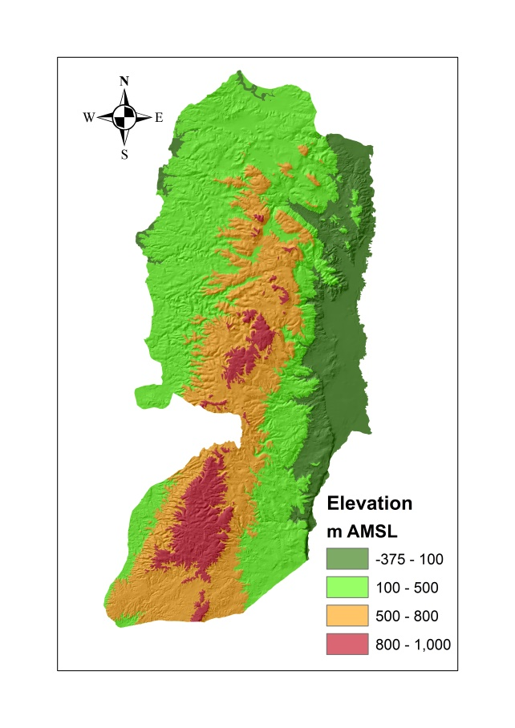

**\*Figure 1.** Elevations as meter above sea level (masl) for West Bank, Palestine



**Figure 2.** Average snowfall depths in Jerusalem during the decades of the 20th century.

# Damages of steel structures due to snowfall in Palestine

Damages of steel structure facilities due to snowfall in Palestine were gathered from different media sources. Owners of these facilities were contacted and interviewed. Design documents for damaged facilities were collected when possible. Most of the damaged structures were an arbitrarily built storage structures and animal house-farms in rural areas. Table 1 lists the major damaged structures for industrial facilities and commercial facilities that all occurred in 2013.

**Table 1.** Damaged steel structures in Palestine due to snowfall in 2013.

|  |  |  |  |  |
| --- | --- | --- | --- | --- |
| **Company** | **Location** | **Elevation (masl)** | **Lossesa (JD)** | **Description of losses** |
| Al Mahaba company for transportation | Hebron | 930 | 400,000 | Severe damages to structures, 8 trucks, and private car |
| Jamaeen stonecutting factory | Jamaeen, Nablus | 530 | 10,000 | Partial damages in assets |
| Geneva company | Ramallah | 880 | Not known | Partial damages to structure and other asserts |
| Italian company | Ramallah | 880 | 200,000 | Severe damages to property, materials and in the structure, stop the work temporarily |
| Royal company | Hebron | 930 | 0.5 Million | Damages in the company truss, trucks, and materials |
| Shahatet company | Hebron | 930 | 15,500 | Affected the company truss, trucks and losses in properties |
| a Losses were estimated in Jordanian Dinar based in currency prices of 2016, and rounded by thousands. | | | | |

In addition to damages in Table 1, a major previous damage occurred at Birzeit University, Ramallah, where a collapse of the physical education building occurred in February 2003 due to snow accumulation. Losses were only of property due to the fact that the collapse was in the evening. Snow accumulation ranged between 20-30 cm, failure was sudden and swift bringing most of the steel structure down in seconds (Barakat, 2013).

# Review of the Jordanian national building code (2006)

In Palestine, the Jordanian national building code (JNBC, 2006) is usually used for design of concrete and steel structures. The approach adopted in the JNBC (2006) for computing snow load is reviewed hereunder.

According to the JNBC (2006), the snow load on the roof can be estimated using the following equation:

Sd = So * μi  …………. (1)

Where:

Sd = Snow load on roof which represents the snow load density on the building roof (kN/m2).

So = Site snow load which represents the accumulated snow load density above building site (kN/m2).

μi = Snow load shape coefficient which represents the ratio between the snow load on the roof of the building caused by wind and the accumulated snow at the building site.

For snow load on roof estimation (Sd) and based on equation (1), site snow load (So) at different heights (masl), or simply (h in meters) can be obtainedfromTable (2) which illustrates snow loads for different heights:

**Table (2)**. Snow loads due to building heights (JNBC, 2006)

|  |  |
| --- | --- |
| Snow load (So) kN/m2 | Height of structure from the sea (h) in meters |
| 0 | 250 > h |
| (h-250)/800 | 500 > h > 250 |
| (h-400)/320 | 1500 > h > 500 |

Snow load shape coefficient (μi),is usually estimated for inclined (tilted) roofs for both regular (Fig. 3) and non-regular snow loads (Fig. 4), and based on the tilt angle (α) of the building roof to its horizon

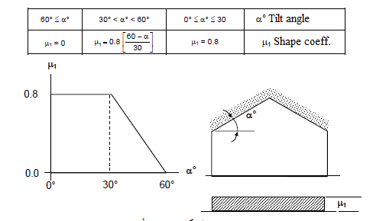

Figure 3. Shape coefficients for a regular snow loads on tilted roofs (JNBC, 2006).

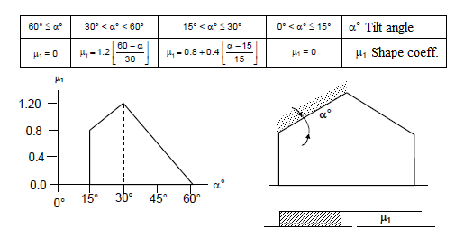

Figure 4. Shape coefficients for non-regular snow loads on tilted roofs (JNBC, 2006).

Load and resistance factor design method (LRFD) was used. In the current research it was focused on the two main factors that may affect the structure which are the snow and dead loads and it was assumed the same load combinations in accordance with the Jordanian design code which include 1.4*D* and1.2*D* + 1.6*S (*Where: **D** is Dead load, and **S**is Snow load)

# Damages’ causes of steel structures in Palestine

In order to determine whether damages occurred in several steel structures (Table 1) were occurred due to errors in the design code, design procedure, or during the construction of structures, two case studies from Table (1) were analyzed for their trusses structure; Jamaeen stonecutting factory and the Italian company.

*Case 1:*

Jamaeen town is located 16 km southwest of Nablus city with h= 530 m. The damaged structure had an area of 375 m2. The structure was modeled, checked and analyzed by using SAP2000 software.

Based on equation (1) and Table (2), Site snow load (S0) = (h-400)/320 = 0.4

From Figure (3), snow load shape coefficient ( μi )= 0.8

Thus: snow load on roof (Sd) =So * μi = 0.4 *0.8= 0.32 kN/m2

Loading:

The structural elements are subjected to the following loads:

* Dead load: calculated from self-weight by the software.
* Dead load from purlins and ceiling cover = 0.6 kN/ m
* Snow load = Sd * Tributary Area = 0.32 *5 = 1.6 kN/m

Materials and steel sections:

The used materials and steel sections are:

* Steel type A36
* Frame sections were illustrated in the below Tables (3, 4 and 5).

**Table 3.** Pipe frame sections

|  |  |  |
| --- | --- | --- |
| Wall thickness (mm) | Outside diameter (m) | Material |
| **5** | 0.1 | **Pipe section 1** |
| **5** | 0.25 | **Pipe section 2** |
| **5** | 0.15 | **Pipe section 3** |

**Table 4** Tube frame section

|  |  |  |  |  |
| --- | --- | --- | --- | --- |
| Web thickness (mm) | Flange thickness (mm) | Outside width (m) | Outside depth (m) | Material |
| **3** | 3 | 0.1 | 0.15 | **Tube section** |

**Table 5.** IPE (I section) frame section

|  |  |  |  |  |
| --- | --- | --- | --- | --- |
| Web thickness (mm) | Top flange thickness (mm) | Top flange width (m) | Outside height (m) | Material |
| 6.2 | 9.8 | 0.12 | 0.24 | IPE 240 |

Area section that was used in the structure is shown in Table (6).

**Table 6.** Ceiling cover area section

|  |  |  |  |
| --- | --- | --- | --- |
| Type | Bending (mm) | Membrane (mm) | Material type |
| **Shell thin** | 5 | 5 | Steel A 36 |

Evaluation of steel truss:

The 3D view for the structure is represented in Figure (5) below as built design in reality, it can be noticed that the ceiling cover is colored by the green color. The white lines is for pipe section 2, the blue lines is for pipe section 1, the cyan color is for pipe section 3, and the dark pink color represents the tube section. Finally the IPE 20 section is colored by the gold color. Support conditions are considered simple as shown in the figure below.

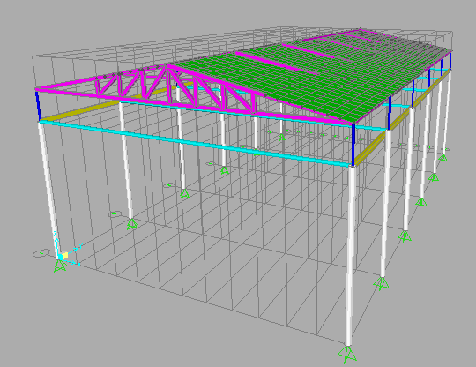

**Figure 5.** 3D view for the first case study truss in SAP software.

2D analysis was carried for the truss rather than the 3D analysis because of the instability of the truss and the truss was not designed with bracing. An interior truss was chosen to be designed as shown in Figure (6) below.

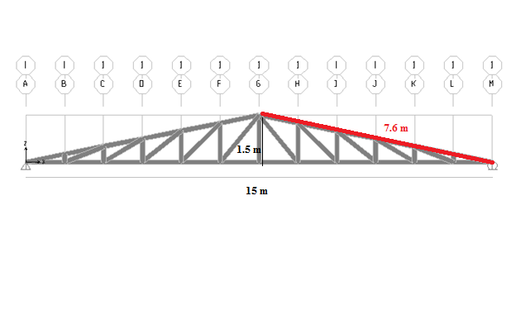

**Figure 6.** Aninterior truss from the first case study in SAP2000 software.

Model validation:

To validate SAP2000 model of the structure, two checks are performed, namely compatibility check and equilibrium check.

Compatibility check:

Figure (7) shows the whole structure deforms smoothly which implies that compatibility is satisfied.

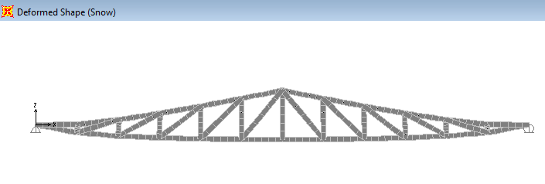

**Figure 7.** Compatibility check in the first case study truss.

Equilibrium check:

Equilibrium check is satisfied according to the results that shown in Table (7).

**Table 7.** Equilibrium check results for the first case study.

|  |  |  |  |
| --- | --- | --- | --- |
| Reaction results from Loads | Total SAP load (kN) | Total manual load (kN) | Error |
| **Dead load** | 15.44 | 15 | 0.029 |
| **Snow load** | 24.48 | 24 | 0.02 |

Calculations for the manual load are illustrated below:

Snow load:

Snow load = load * tributary area = 0.32*5= 1.6 kN/m

Total load (Snow) = 1.6*15= **24 kN**

Dead loads:

Dead load from purlins and ceiling cover = 0.6 kN/ m

Dead load from truss members = 6 kN

Dead load = 6 + (0.6 * 15) = **15 kN**

It should be noted that the dead load and snow load errors were < 0.05 which are acceptable according to codes of practice.

According to the previous, checks assured the validity of the model for the analysis of the case studies.

For the current steel design, (AISC360-05/IBC2006) design code was used in order to check the truss safety. Results are shown in Figure (8) below, colors in the figure represents the utilization ratio which is defined as the fraction of load by capacity, starting by the cyan (safe) color to the red (not safe) one, indeed figure manifest that the truss is safe under the loads according to the Jordanian loads code.

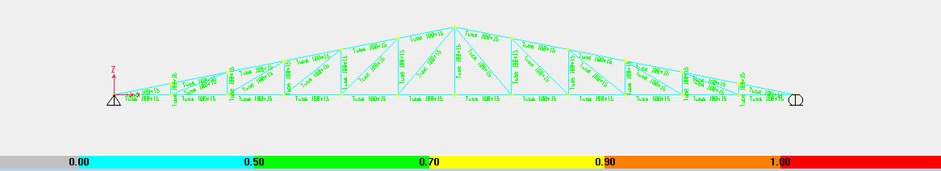

**Figure 8.** Design result for the first case study truss.

*Case 2*

The second case, the truss of the Italian company with an area of 1200 m2, and located at h= 860 m. Following similar steps of case 1, steps of analysis are summarized below.

Based on equation (1), and Table (2):

S0 = 1.44

μi =0.8

Then: Sd = 1.15 kN/m2

Loading:

The 2D structural elements are subjected to the following loads:

* Dead load: calculated from self-weight by the software.
* Dead load for purlins and ceiling cover = 0.6 kN/m
* Snow load = Sd * T.A =1.15*2m= 2.3 kN/m

Materials:

The materials are:

* Steel type A36
* Tube section frame 15*100 were used in the structure.

Design for steel truss:

The 2D view for the truss is shown in Figure (9).

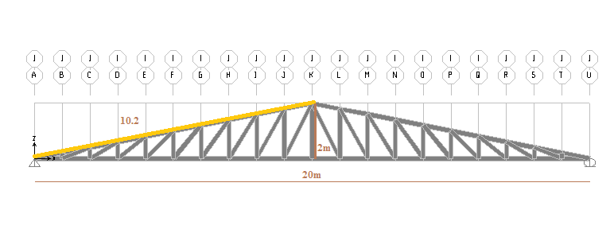

**Figure 9.** 2D view in SAP2000 for second case study.

Compatibility check and Equilibrium checks:

The structure deforms smoothly (Fig. 10) which implies that compatibility is satisfied, and equilibrium of structure was satisfied (Table 8).

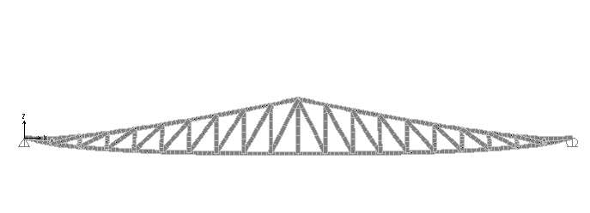

**Figure 10.** Equilibrium check is satisfied according to the results that shown in Table (7).

**Table 8.** Equilibrium check results for the second case study.

|  |  |  |  |
| --- | --- | --- | --- |
| Reaction results from Loads | Total SAP load (kN) | Total manual load (kN) | Error |
| **Dead load** | 22 | 21 | 0.047 < 0.05 OK |
| **Snow load** | 47 | 46 | 0.021 < 0.05 OK |

For Steel Design, Figure (11) below clarify that the structure is safe under the calculated loads which depends on the Jordanian code.

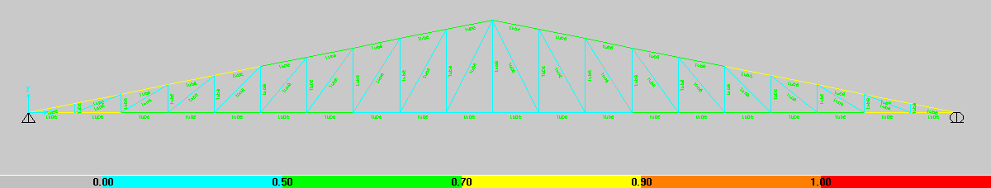

**Figure 11.** Safe design for the steel truss in the second case study.

After analyzing the two cases, it can be concluded that the used sections in the trusses were safe under the loads according to the JNBC (2016).

# Discussion of results of studied cases

Several steel structures were collapsed in the last few years, causes of such event may be related to the unexpected snow load, the instability of the structure, improper design of the structural members and connections, combined natural events (of wind and snow) or combined human and natural events.

Until recently, snow loads used for design practices in Palestine were determined based on the requirements of the Jordanian Code. Despite the fact that the snow load in the above studied cases as computed based on the Jordanian Code concluded as safe, these cases appeared to be unsafe under certain circumstances. A modification to the snow load in the Jordanian code may be needed due to the increasing trend showed in Fig (2). Damages of the structures in Table (1) are mainly attributed to poor construction practices and supervision, lack of periodic inspection and maintenance.

# Conclusions and recommendations

In recent years, steel structures in Palestine faced unexpected amount of snowfall which led to collapse in many applications. Many steel structures were not properly designed and constructed to current codes of practice. The climate change lead to variations and increase of snowfall in Palestine, and this urge modifications to the adopted design code of steel structures.

To mitigate hazards of snowfall and its accumulation on steel structures, control tools such as removal of snow and early maintenance of structures can help in avoiding or mitigating such hazards. Municipalities, engineering association, and local authorities are recommended to employ effective control tools reviewing designs of steel structures, monitoring construction projects, and organize periodic check-ups campaigns.

# References

Al Dabbeek, J. (2010). An Assessment on Disaster Risk Reduction in the Occupied Palestinian Territory. An - Najah Univ. J. Res., Vol. 24.

Barakat, M. (2013). Collapse of the physical education building at Birzeit University: a case study on forensic engineering. Proceeding of the 1st International Conference of Civil Engineering in Palestine, Al-Bireh.

Brauch, H., Spring, Ú., Mesjasz, C., Grin, J., Kameri-Mbote, P., chourou, B., Dunay, P. and Birkmann, J. (2011). *Coping with Global Environmental Change, Disasters and Security - Threats, Challenges, Vulnerabilities and Risks*. Hexagon Series on Human and Environmental Security and Peace. Springer, New York.

Gao, J (2016). Analysis and assessment of the risk of snow and freezing disaster in China. International Journal of Disaster Risk Reduction, 19, pp.334-340.

Glaas, E., Ballantyne, A., Neset, T. and Linnér, B. (2017). *Visualization for supporting individual climate change adaptation planning: Assessment of a web-based tool.* Landscape and Urban Planning, 158, pp.1-11.

Grigoroudis, E, Kanellos, F., Kouikoglou, V., and Phillis, Y.( 2016) Optimal abatement policies and related behavioral aspects of climate change. Environmental Development, Vol. 19, pp.10-22.

Hawajri, O. (2016). Natural disasters and complex humanitarian emergencies in the occupied Palestinian territories. Spain: Emergency and disaster reports journal.

IPCC (2007). Regional Climate Projections. In: Climate Change. The Physical Science Basis. Contribution of Working Group I to the Fourth Assessment Report of the Intergovernmental Panel on Climate Change.

IMS (2016). Israeli Metrological Services, accessed online: <http://www.ims.gov.il/IMSEng/TRAINING/Reports+and+Publications/Reports+and+Publications>.

JNBC (2006). Jordanian national building Code, *Loads and forces code.* Amman, Jordan.

Lelieveld, J., Hadjinicolaou, P., Kostopoulou, E., Chenoweth, J., El Maayar, M., Giannakopoulos, C., Hannides, C., Lange, M., Tanarhte, M., Tyrlis E. and Xoplaki, E. (2012). Climate change and impacts in the Eastern Mediterranean and the Middle East. Climatic Change, 114(3-4), pp.667-687.

NAE, 2016. *Attribution of Extreme Weather Events in the Context of Climate Change.* National Academies of Sciences, Engineering, and Medicine. Washington, DC

PMD (2016). Palestinian Meteorological Department. (Personal Contact).

Salem, H. (2012). Social, Environmental and Security Impacts of Climate Change on the Eastern Mediterranean, Coping with Global Environmental Change, Disasters and Security: Threats, Challenges, Vulnerabilities and Risks (H.G. Brauch, Ú. Oswald Spring, C. Mesjasz, J. Grin, P. Kameri-Mbote, B. Chourou, P. Dunay, J. Birkmann (Eds.)). Springer, Berlin Heidelberg, 2012, pp.421-445.

Seif-Ennasr, M., Zaaboul, R., Hirich, A., Carolett, G., Bouchaou, L., El Morjani, Z., Beraaouz, E., McDonnell, R. and Choukr-Allah, R. 2016). Climate change and adaptive water management measures in Chtouka Aït Baha region (Morocco). Science of The Total Environment, Vol. 573, pp.862-875.

UNEP (2003). Desk Study on the Environment in the Occupied Palestinian Territories report. 2003.

VijayaVenkataRaman, S., Iniyan, S., and Goic R. (2012). A review of climate change, mitigation and adaptation. Renewable and Sustainable Energy Reviews, Vol. 16(1), pp.878–897

Zhang, P., Zhang, J. and Chen, M. (2016). Economic impacts of climate change on agriculture: The importance of additional climatic variables other than temperature and precipitation. Journal of Environmental Economics and Management, Vol. 83, pp.8-31.

1. * Corresponding Author: Dr. A. Rasem Hasan, Civil Engineering Department, An-Najah National University, E-mail: [mallah@najah.edu](mailto:mallah@najah.edu), Phone: +970597511514, Fax: +970922345982.
2. Meter above Sea Level