**DEVELOPING AN ELECTRONIC DATABASE FOR PRIORITIZATION OF PAVEMENT MAINTENANCE ACTIVITIES**

**1 Rabee Husam Rabaya, 2 Emad Basheer Dawwas, and 3 Amjad Zuhdi Issa**

1 Supervisor Engineer, Maythaloun Joint Service Council, Maythaloun, Jenin, Palestine

2Assistant Professor, Urban Planning Engineering Department, An-Najah National University, Nablus, Palestine.

3 Assistant Professor, Civil Engineering Department, An-Najah National University, Nablus, Palestine.

**ABSTRACT**

Due to the importance of the transportation network as the backbone of the modern city, there is a great need for a systematic and continuous pavement monitoring and maintenance mechanism. However, the attempts of implementing such a mechanism is faced by three types of challenges: (1) financial challenge: the limitations in the allocated budget for pavement maintenance works; (2) socio-political challenge: the external interferences in the process of decision-making and prioritization; and (3) technical challenge: the absence of the effective decision-making tools.

This paper aims to confront these challenges by developing a computerized Pavement Management Database (PMD) as a decision-aiding tool. The proposed tool is built on the available PMD tools in Palestine, but it is distinguished from other tools by its ability to calculate the Priority Index (PI) by precise quantitative measures. PI in this from consists of several indicators such as pavement condition index (PCI) which is measured in the field, average daily traffic, functional classification of road, importance of road to community, citizens complains, etc.

The PMD can be used by the transportation engineers in managing the existing road pavements, as well as helping the decision-makers in implementing effective decisions to select the roads with high maintenance priority based on the calculated PI. Finally, the PMD has high potential, if adopted by transportation agencies and municipalities, to more efficient maintenance budget allocation and less external interferences in the process of decision-making.

**Key words:** Pavement Management Database; Budget Allocation, Decision Aiding Tools; Priority Index.

1. Introduction

Most of Palestine highways agencies lack the databases about the roads and the proper maintenance actions that should be implemented. Databases are required to store data in electronic records that will assist in searching, retrieving, and organizing in countless ways (Wang, 2007). Storing of road rehabilitation and maintenance information in special databases not only preserves vital information and saves time, but also allows seeing modes in operations that are invisible in other methods.

This paper presents the details of developed computerized database to assist the decision-makers in: (1) knowing the necessary information for maintenance works implemented for each road or section; (2) calculating the pavement condition index; (3) ranking maintenance projects according to their priority indices; (4) selecting optimal roads (or sections) for maintenance actions; and (5) calculating and allocating maintenance budgets.

As the researchers found through the field surveys that most of highways agencies in Palestine lack effective roads’ databases, a main objective of this tool is to sort all information related to pavement conditions of roads in a computerized database. This will effectively assist the decision-­makers in reviewing all information needed to implement maintenance works and to estimate the required budgets. Another important objective of this research is to enable transportation engineers and planners to select roads with top maintenance priority objectively –based on quantitative measures obtained from the field. This will be executed by inserting all roads needed maintenance within a list, and to automatically ranking them according to their calculated PI.

1. Literature Review

**2.1 Pavement Management System**

According to the Federal Highway Agencies, PMS is briefly defined as; "A set of tools or methods to assist decision makers in finding cost-effective strategies for providing, evaluating and maintaining pavements in serviceable condition.” (Shahin, 2005). Other researchers described the PMS as the approach to optimize the implementation of highway construction and maintenance resources. Thus, optimizing current pavement condition assessment application will be the first and the primly task of efficient pavement management system (Shahin, 2005).

PMS is anticipated to continue to be the critical component for managing and maintaining the transportation infrastructure over the world. PMSs are useful tools for highway agencies to enumerate the overall maintenance needs of pavements and to provide alternative maintenance strategies under budget limitations. Practically, the most important aspects of the development of a successful PMS are to collect, capture, manage and analyze the pavement condition data in detailed format. Substantial progress has been achieved in the field of pavement management, which leads to continue the development and improvement of computerized capabilities and analysis tools. These changes in pavement management have been driven by the changes in the types of information required by public agencies (Shahin, 2005).

The implementation of PMS to a particular pavement network is carried through a systematic operation that includes several tasks on a periodic basis. This system is used universally with a very slight difference, as covered in the following steps as illustrated in Figure 1:

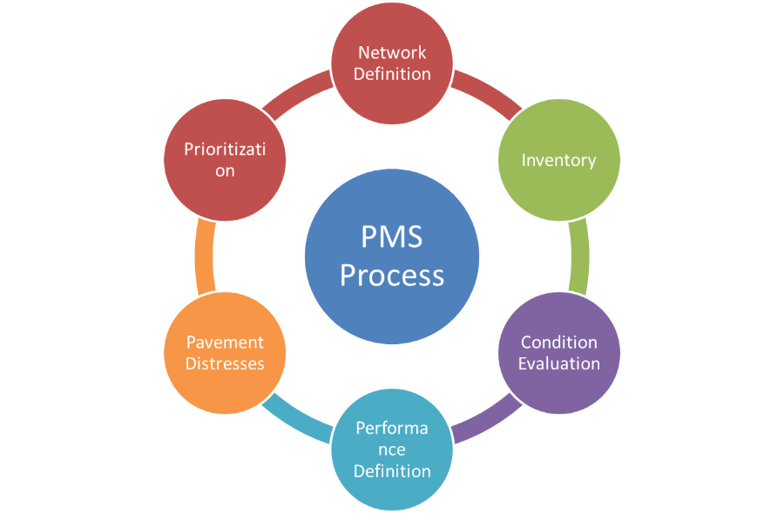

**Figure 1**: PMS Process

The evaluation of pavement conditions includes consideration of specific problems that exist in the pavement. This requires a determination of the types of causes and distresses, as well as the extent of pavement deterioration. It is also important that condition surveys be conducted after new construction or rehabilitation work. Such monitoring is a tool for network assessment and provides information regarding the rate of distress buildup (AASHTO, 2001). Pavement condition index (PCI) is one of the most widely used performance measurement of pavements; it has been used as an indicator of the pavement condition (Tighe et al., 2004; Uglova and Saenko, 2016, ASTM, 2007). Following the literature, the PCI in this paper is calculated quantitively by considering both the density and severity for each type of distress.

**2.2 Prioritization**

Priority ranking, as used in PMS, is a process used to rank the pavement sections in an order of urgency for maintenance and repair. The prioritization process is the main step of PMS, before the decision makers take the final decision on execution of maintenance program.

Priority setting techniques as used in the PMS cover a wide spectrum of methods and approaches ranging from simple priority lists—based on engineering judgment—to complex network optimization models—based on sophisticated computer algorithms (Haas et al., 1994). These prioritization methods can be further divided as: (1) Ranking Methods, (2) Optimization Methods, (3) Artificial Intelligence Techniques, and (4) Analytical Hierarchy Process Method.

The priority technique we use in this paper is the Composite Index Ranking (CIR) Method. The CIR is commonly used in prioritizing road maintenance activities due to its simplicity and applicability. The authors were motivated to use the CIR method also because the database needed is available, and the results can be easily illustrated to the decision makers. This method was used in the Operation and Maintenance Manual (O&M Manual) for the benefit of the Municipal and Lending Fund (MDLF) and the relevant Palestinian municipalities in order to rank their roads for maintenance activities.

**2.3 Paper Contribution**

Although the methodology adopted by the MDLF (as presented in the previous section) in calculating the priority index (PI) is included in the paper, it is worth to mention that the pavement condition index (PCI) which is considered the main indicator in the PI linear model is calculated in a descriptive procedure. However, in our paper, the PCI is calculated based on performing detailed visual inspection by considering both severity and extent for each type of existing pavement distresses (quantitative procedure) in the targeted sections.

1. Methodology

The following sections illustrate the followed methodology in the paper.

**3.1 Simplified Pavement Condition Index (PCI) Calculation**

PCI is defined as a numerical index ranges from zero representing the worst pavement condition for a given road section to 100 representing the best ideal condition. The PCI survey procedure and calculation method has been standardized by ASTM for roads and parking lots pavements (ASTM, 2007). The terminology defined by ASTM standards is also used in developing automated PCI calculations. The following paragraphs provide some basic definitions for PCI calculations used in the ASTM procedure and considered in this paper:

**Pavement Section**: A contiguous pavement area with a uniform structure, maintenance, usage history, and condition. A section should have similar traffic volume, structure and geometric characteristics. The length of the section in our paper is 100 m.

**Pavement Distress**: External indicators of pavement condition deterioration caused by loading, environmental factors, or a combination of both. Typical distresses are cracks, rutting, and weathering of the pavement surface. Each distress, based upon its effect on pavement performance and riding quality, is classified into three severity levels: Low (L), Moderate (M), and High (H).

Depending on the type of distress density and severity, the amount of distresses within the pavement section is measured in either in area/length units (square meters (square feet), meters (feet)) or the number of occurrences. For instance, fatigue and block cracking are measured in square meters or square feet, whereas the longitudinal and transverse cracking, are measured in linear unit.

**Distress Density**: The percentage to indicate the ratio of distress within an area. It is obtained by dividing the total quantity of each type of distress at each level of severity to the total area of the pavement section.

**Deduct Value (DV):** Statistical weight number of distresses to determine a combined condition index for pavement sections. According to ASTM 6433-07, for each distress type and severity level, there is a distress deduct value curves for deduct value determination (ASTM, 2007).

**Corrected Deduct Value (CDV)**: Adjustment of the cumulative deduct value or the total deduct value (TDV). The CDV adjusts the TDV to fit for a range of 0-100 by using a set of CDV-TDV adjustment curves. The maximum value of CDV (CDVmax) is used to calculate PCI (PCI = 100 - CDVmax). If there is only one deduct value, the TDV is used in place of the CDVmax in determining the PCI (ASTM, 2007).

**3.2 Simplified Priority Index (PI) Calculation**

In prioritizing maintenance works for the road network, the O&M Manual identified the priority indicator (PI) which is composing of five declared indicators of different weights. The dominant indicator in terms of weight is the pavement condition, set to 0.45. Through literature, the status of the pavement is also ranked first in terms of weight among other indicators ranging from 0.2 (the worst) to 0.7 (the best); the pavement conditions weights were 0.2, 0.33, 0.45 and 0.7, respectively. The estimated weight in Palestine is 0.45 because of the accumulation of road maintenance. All of the target municipalities have adopted this weight, with the exception of one municipality. For each indicator, the remaining weight is less as shown in equation (1) shown below (Issa & Abu-Eisheh, 2017).

The PI is calculated using the following equation, as defined in the O&M Manual:

$$PI=0.13×F1+0.45×F2+0.12×F3+0.20×F4+0.10×F5 ( SEQ Equation \backslash * ARABIC \backslash s 1 1)$$

Where:

F1: functional classification of roads; F2: pavement condition; F3: average daily traffic; F4: importance of road to community; and F5: citizen’s complaints.

**3.4 Deductive Values (DV) Curves [Nonlinear Math Functions]**

The family of DV curves provides a reference for manually determining the deduct values. However, this research will use mathematical equations derived through two international studies (Aravalli, 2015) and (Wu, 2015). A total of 91 nonlinear (multinomial) functions and plots were developed to be used for the determination of the DVs. The same approach was followed to determine the CDVs and the regression analysis shows the polynomial function between DV and logarithm of density with high degree of accuracy.

**3.5 Developing an Electronic Database for PCI and PI Calculation**

The PMD provides user-friendly transformation of regions to PCI and PI values for each data set collected from the corresponding road sections. The format developed was made compatible with the dataset available in Microsoft Excel. In addition, a number of Visual Basic (VB) codes have been used to connect the sheet and the mathematical equations to automate the calculation of the required values. A screenshot of the PMD is shown in Figure 2 below.

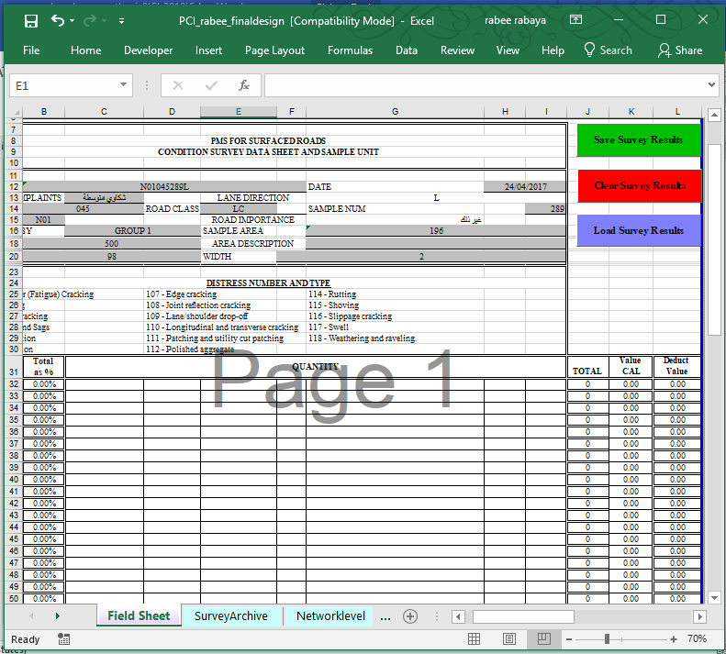

**Figure 2**: A Screenshot of the PMD

The first sheet (titled as "Field Sheet ") includes the type, quantity, severity level of each distress, section ID, survey date, and other basic inventory data is illustrated in Figure 3 below.

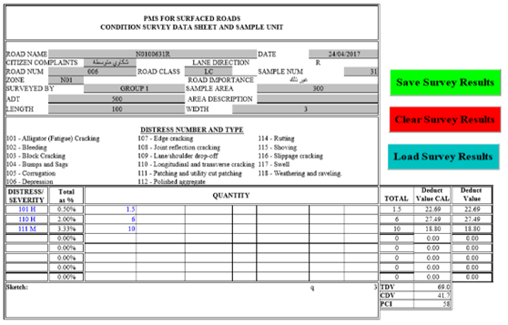

**Figure 3**: The first Excel sheet "field sheet "

The second sheet is shown in Figure 4 and titled as "Survey Archive ", which contains all the data that was already entered in the Field Sheet prepared to be the main resource of data needed in PCI and PI calculations. In this sheet there is a column named ROADName, which contains a unique code for each road section. Where the method of coding used in the O&M manual of the municipalities in Palestine was adopted with the addition of some modifications to encoding roads and road sections in this research. The value of this field is obtained by associating the order of the elements used in the encoding process. As explained in Tables 1 and 2, respectively.

|  |  |  |  |  |
| --- | --- | --- | --- | --- |
| **Table 1**. The method of coding in O&M manual of the municipalities in Palestine,2014 | | | | |
| Items | Zone | Road Classification | Road Number | Road Segment |
| number of digits | xx | Xx | xxx | xx |
| Value | 01-99 | AR=Arterial Road CR=Collector Road LR=Local Road | 001-999 | 01-99 |

|  |  |  |  |  |  |
| --- | --- | --- | --- | --- | --- |
| **Table 2.** The method of coding in this research | | | | | |
| Items | Governorate | Zone | Road Number | Road Segment | Direction of lane |
| Number of digits | x | Xx | xxx | xx | x |
| Value | The first letter from Gov name | 01-99 | 001-999 | 01-99 | R=Right  L=Left |

**Figure 4**: The second sheet "Survey Archive "

The third sheet (titled as "Project level"). In this sheet the project level pavement management approach was applied by obtaining the PCI and PI values for all road section. Figure 5 shows the third sheet "Project level ".

**Figure 5:** The third sheet "Project Level"

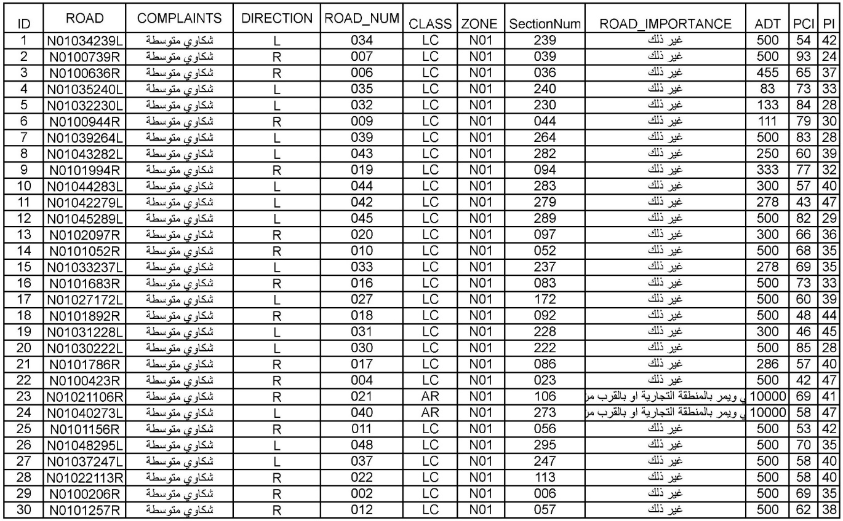The fourth sheet (titled as" Network Level ") is covering the network level pavement management approach which was applied in this sheet by obtaining the PCI and PI values for the roads by using the weighted mean method. In this method, the PCI value from each section in the road is calculated considering the area of the sections and not only the length as the width of sections is variable. The PCI for all sections is calculated considering the sample size to achieve the highest accuracy as presented in Equation 2. Figure 6 shows the fourth sheet "Network level".

**Figure 6:** The Fourth Sheet “Network level”

$$PCIroad=\frac{Area1*PCI1+Area2*PCI2+Area3*PCI3+….+Area(i)*PCI(i)}{Total Area for road} (2)$$

Where:

Area(i)=width(i)*length(i)

The length of the section equals 100 m based on the PCI standard calculation. Accordingly, the width is the main variable in PCI calculation and this value is taken into consideration in data collection and in building the PMS database stages. In addition, PI value for the road in general is calculated using the same method as in PCI as presented in equation 3:

$$PIroad=\frac{Area1*PI1+Area2*PI2+Area3*PI3}{Total Area for road} (3)$$

The fifth and sixth sheets are defined as ("PCI Equations." and "Detective value Equations."). These sheets include all mathematical equations and used in DV calculation Table 3 shows the fifth sheet "PCI Equations." and Figure 7 shows the sixth sheet "Detective Value Equations."

The seventh sheet (titled as" CDV "). It contains the mathematical Equations used to determine Corrective Detective Value. Figure 7 shows the seventh sheet (" CDV Equations ").

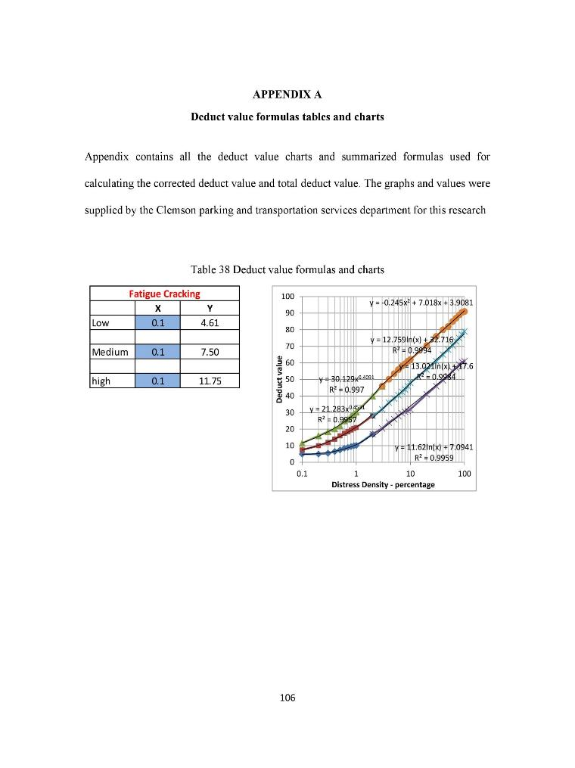

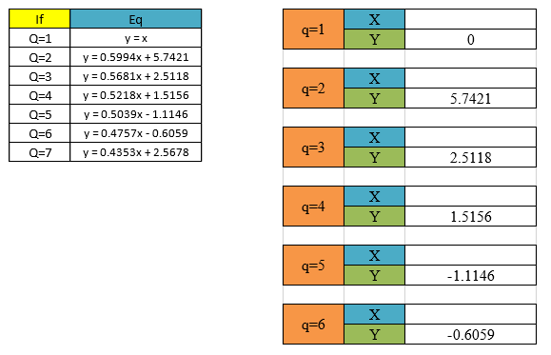

**Figure** 7**:** The sixth sheet " Detective value Equations

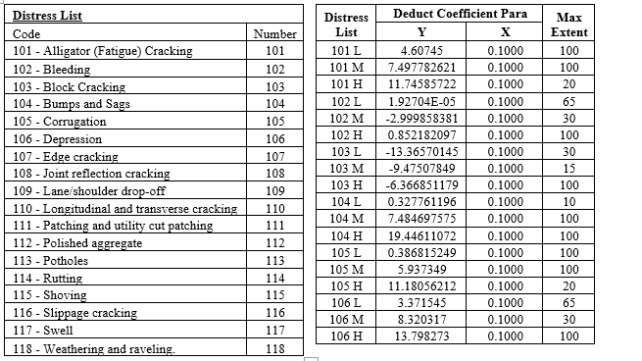

**Figure 8:** The seventh sheet (" CDV ")

The eighth sheet (titled as" PI Equations "). This sheet includes all mathematical equations limits, and coefficients that are used in PI calculation. Figure 9 shows the tables in eighth sheet (" PI Equations ").

|  |  |  |
| --- | --- | --- |
| **Road Class Parameter (Fi)** | | |
| **Parameter** | **Road Class** | **No.** |
| 100 | Arterial | 1 |
| 75 | Collector | 2 |
| 50 | Local | 3 |
| 25 | Parking | 4 |

|  |  |  |
| --- | --- | --- |
| **Road Compliance Parameter (Fc)** | | |
| **Parameter** | **Road Class** | **No.** |
| 100 | Severe Complains | 1 |
| 66 | Mid Complains | 2 |
| 33 | Little Complains | 3 |
| 0 | No Complains | 4 |

|  |  |  |
| --- | --- | --- |
| **PCI Parameter (FP)** | | |
| **PCI** | **Pavement Evaluation** | **No.** |
| 10 | Excellent | 1 |
| 20 | Excellent | 2 |
| 30 | Very Good | 3 |
| 40 | Good | 4 |
| 50 | Good | 5 |
| 60 | Fair | 6 |
| 70 | Fair | 7 |
| 80 | Poor | 8 |
| 90 | Very Poor | 9 |
| 100 | Failure | 10 |

|  |  |  |
| --- | --- | --- |
| **Road Importance Parameter (Fi)** | | |
| **Parameter** | **Road Class** | **No.** |
| 100 | Arterial road passing through the commercial area or near important places | 1 |
| 75 | Collector road passing through the commercial area or near important places | 2 |
| 50 | Local road passing through the commercial area or near important places | 3 |
| 25 | Other | 4 |

|  |  |
| --- | --- |
| **Priority Index (PI)** | |
| **Weight (WI)** | **Item** |
| 0.13 | Functional Classification |
| 0.45 | PCI Pavement Condition |
| 0.12 | ADT Average Daily Traffic |
| 0.2 | Importance of Road to Community |
| 0.1 | Citizens Satisfaction |

|  |  |  |  |
| --- | --- | --- | --- |
| **Priority Index (PI) Calculation** | | | |
| **Fi*Wi** | **Wi** | **Fi** | **Item** |
| 2.6 | 0.13 | 20 | Functional Classification |
| 22.5 | 0.45 | 50 | PCI Pavement Condition |
| 7.2 | 0.12 | 60 | ADT Average Daily Traffic |
| 16 | 0.2 | 80 | Importance of Road to Community |
| 4.3 | 0.1 | 43 | Citizens Satisfaction |
| 52.6 |  |  | PI |

**Figure 9:** The eighth sheet ("PI Equations ")

The whole process of the PMD is summarized in the flowchart shown in Figure 10. The flowchart shows each step included in the process starting from feeding the database with the pavement conditions and the different properties of the road, calculating the different indicators and ending with the loop of entering a list of road sections one-by-one.

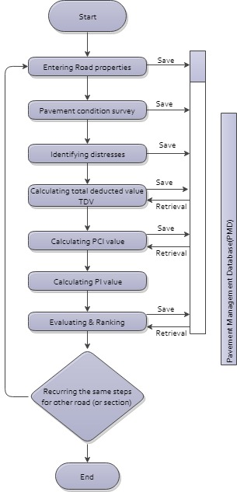

**Figure 10:** The flow chart of PMD

1. Results and Discussion

The authors apply the developed model considering the roads nearby the new campus of An-Najah National University. The results show that the percentages of paved surface area are classified at the project level based on the road conditions for the data collected in 2017. It can be seen that 14.2 % of the pavement surface area are in (Excellent) condition, 48.2 % are in (Very Good), 24.8 % are ranked as (Fair), 12.1 % are ranked as (Poor), and 0.7% are ranked as (Fail) condition, as shown in Figure 11. At network level, it is noticed that 17 % of the pavement surface area are in (Excellent) condition, 40 % are in (Very Good), 43 % are classed as (Fair), finally there are no (Poor) and (Fail) conditions, as shown in Figure 12.

**Figure 11:** Road section condition at project level

**Figure 12:** Road section condition at network level

The importance of these results lies in its ability of the developed model to assist decision-makers in the process of determining the proper treatment and maintenance for the proper section and at the proper time. The results also contribute in maintaining the level of road network at an acceptable condition to maintaining good level of service. Accordingly, through the data resulted from the PMD, it is noticed that there were a number of sections of road sections that suffer from poor conditions, which means that these sections are on the top priority for maintenance in order to improve their conditions and performance.

However, the pavement condition index alone is insufficient to determine whether the road section needs maintenance or not. This is because the prioritization process is subjected to a specific methodology explained in the previous section. The methodology is based mainly on assessing the pavement condition of the section and other factors are included such as citizens' complaints, road classification, road importance, and average daily traffic. The PMD model calculates the value of the priority index for each road and for each section of the road as an evidence of the priority of maintenance. Table 4 shows the calculation of priority index and ranking in descending order for all roads included in the study area considering the roads section by section in both directions.

|  |  |  |  |  |
| --- | --- | --- | --- | --- |
| **Table 4:** Prioritization value for road of study area LANE_DIRECTION  ROAD_NUM  PCI  PI | | | | |
| Rank | LANE_DIRECTION | ROAD_NUM | PCI | PI |
| 1 | R | 4 | 42 | 47.2 |
| 2 | L | 42 | 43 | 46.7 |
| 3 | L | 40 | 58 | 46.6 |
| 4 | L | 31 | 46 | 45.5 |
| 5 | R | 18 | 48 | 44.4 |
| 6 | R | 11 | 53 | 42.3 |
| 7 | L | 34 | 54 | 41.5 |
| 8 | R | 21 | 69 | 41.2 |
| 9 | R | 17 | 57 | 40.3 |
| 10 | L | 44 | 57 | 40.2 |
| 11 | L | 37 | 58 | 40.0 |
| 12 | R | 22 | 58 | 40.0 |
| 13 | L | 27 | 60 | 38.9 |
| 14 | L | 43 | 60 | 38.9 |
| 15 | R | 12 | 62 | 38.3 |
| 16 | R | 6 | 65 | 36.8 |
| 17 | R | 20 | 66 | 36.2 |
| 18 | R | 10 | 68 | 35.2 |
| 19 | L | 33 | 69 | 35.0 |
| 20 | R | 2 | 69 | 35.0 |
| 21 | L | 48 | 70 | 34.7 |
| 22 | R | 16 | 73 | 33.0 |
| 23 | L | 35 | 73 | 32.9 |
| 24 | R | 19 | 77 | 31.5 |
| 25 | R | 9 | 79 | 30.4 |
| 26 | L | 45 | 82 | 29.2 |
| 27 | L | 39 | 83 | 28.5 |
| 28 | L | 32 | 84 | 28.1 |
| 29 | L | 30 | 85 | 27.7 |
| 30 | R | 7 | 93 | 24.2 |

.

1. **Conclusions and Recommendations**

The study developed a computerized database model (PMD) for Pavement Management which has the ability to store all information related to pavement conditions. The proposed PMD mainly aims at assisting the decision-makers and project managers in road agencies in reviewing all information needed to implement maintenance works. Furthermore, this program can insert all road sections that need maintenance works within a list, and then rank them according to the value of their priority indices. At the last stage, the PMD model assists in selecting the roads with the highest priority based on the PI values. The PMD was successfully applied in a real case study in Nablus city and the results showed promising opportunities to adopt and apply it in more cases.

Finally, it is highly recommended to go further in this research to include the special aspects of prioritizing road maintenance. The proposed PMD needs can be integrated, in future search, within a special analysis system like the Geographic Information Systems (GIS) that allows the engineers to map the roads based on their maintenance priorities and to conduct the corresponding spatial analysis.

1. References

Wang, K. C. (2007). Automated survey and visual database development for airport and local highway pavement (No. MBTC-2042).

Shahin, M. Y. (2005). Pavement management for airports, roads, and parking lots (Vol. 501). New York: Springer.

AASHTO. (2001). Pavement management guide. Washington DC: American Association of State Highway and Transportation Officials.

Tighe, S., Eng, P., Karim, M., Herring, A., Chee, K., Moughabghab, M., & Eng, P. (2004, April). An Evaluation of Various Prioritization Methods for Effective Pavement Management: A Canadian Airport Case Study. In Federal Aviations Administration World Wide Airport Technology Transfer Conference, Atlantic City, New Jersey, USA..

Uglova, E. V., and Saenko S. S., (2016), Review of longitudinal pavement roughness prediction tools, Russian journal of transport engineering, Vol. 3, no. 4.

ASTM. (2011). Standard practice for roads and parking lots pavement condition index surveys.

Haas, R., Hudson, W. R., & Zaniewski, J. P. (1994). Modern pavement management (Vol. 1). Malabar, FL: Krieger Publishing Company.

Issa, A., & Abu-Eisheh, S. (2017). Evaluation of implementation of municipal roads’ maintenance plans in Palestine: A pilot case study. International Journal of Pavement Research and Technology, 10(5), 454-463.

Wu, Kan. Development of PCI-based Pavement Performance Model for Management of Road Infrastructure System. Arizona State University, 2015.

Aravalli, Y.S. (2015). Condition Assessment Of Clemson University's Parking Network And Development Of A Framework To Support Pavement Management.