Effect of Processing Methods on Antioxidant Activity, Phenol and Flavonoid Content of Urtica kioviensis Leaves

Nidal Amin Jaradat¹, Iyad Ali^{2*}, Abdel Naser Zaid¹, Murad Abualhasan¹, Fatima Hussen¹, Linda Isa¹

¹ Department of Pharmacy, Faculty of Medicine and Health Sciences, An-Najah National University, Nablus, 7, Palestine.
² Department of Biochemistry and Genetics, Faculty of Medicine and Health Sciences, An-Najah National University, Nablus, 7, Palestine.

----------------------------------------------------------------------------------------------------*Corresponding author: iyadali@najah.edu
Department of Biochemistry and Genetics, Faculty of Medicine and Health Sciences, An-Najah National University, Nablus. 7, Palestine.
ABSTRACT
The cooking method may affect antioxidant capacity and total phenol and flavonoid content in many fruits and vegetables. These effects may cause degradation of anti-oxidant compounds, formation of new products or destruction of active metabolites. The aim of this study is to measure the antioxidant activity, total phenol and flavonoid contents of fresh Urtica kioviensis (U. kioviensis) leaves after being subjected to different cooking method. Antioxidant activity was assayed by using 2, 2-diphenyl-1-picryl-hydrazyl-hydrate, flavonoid content was determined by using Rutin reference standard method, and the total phenol content was determined by Folin-Ciocalteu method. Fresh U. kioviensis showed to possess the highest antioxidant capacity (IC₅₀ value 19.95±0.21mg/ml) and the highest content of phenol (78.27±0.16mg GA/g) and flavonoid (43.3±0.00mg RU/g), followed by shade-dried extracts (70.19±0.22mg GA/g for phenol and 43.3±0.21mg RU/g for flavonoid). While the oven dried extracts and boiled possessed lower antioxidant capacity (IC₅₀ value 28.18±0.18mg/ml and IC₅₀ value 31.62±0.11mg/ml respectively) and reduced phenolic (42.2±0.12 and 41.13±0.13mg GA/g respectively) and flavonoid contents (15.6±24mg RU/g extract and 7.2±0.24mg RU/g extract respectively). Fresh and shade dried U. kioviensis leaves have high antioxidant activity and are rich in phenol and flavonoid. Boiled or roasted leaves did not cause complete loss of their nutritional values. The fresh and shade dried U. kioviensis leaves remained preferred over boiled or oven-dried extracts as a nutrient and for preparing nutraceutical, cosmeceuticals and pharmaceutical supplements
Keywords: Urtica kioviensis; Antioxidant Activity; Phenol; Flavonoid; Cooking methods.

- INTRODUCTION
One of the exciting research in the last decade has been the discovery of a group of nutrients, which have protective effects against cell oxidation ¹. These naturally occurring compounds impart bright color to fruits and vegetables and act as antioxidants in the body by scavenging harmful free radicals, which are implicated in most degenerative diseases ².
Since ancient times Urtica kioviensis Rogow (U. kioviensis) are used by human beings as a diet and as a medication. Urtica kioviensis young leaves are nutritionally rich plants since they possess high contents of crude fibers, essential fats, proteins, vitamins, micronutrients and carotenoids . In Palestine and many neighboring countries, fresh U. kioviensis leaves are used as salad after boiling or soaking them with salty water while, shade dried and roasted leaves are more often used as spices ⁵⁻⁷ (Fig. 1).
Moreover, different parts of U. kioviensis are used as medicine in various dosage forms like powders, capsules, tablets, ointments and gel ⁸. Urtica kioviensis possess anti-inflammatory, antiviral, antioxidant, antidandruff, anti-hemorrhoid, antiulcer, antimicrobial, antihypertension, and analgesic properties, and its use for the treatment of benign prostate hyperplasia have been approved ⁹⁻¹³. Therefore, in many Mediterranean countries, U. kioviensis is used for the treatment of various diseases such as, prostatic enlargement, anemia, cancer, liver cirrhosis, hemorrhage, kidney stones, rheumatism, gout, diabetes mellitus, hypertension, hair loss and eczema .
The present investigation was carried to evaluate the antioxidant activity and to estimate the total phenol and flavonoid content of U. kioviensis leaves under different conditions of processing.

- MATERIAL AND METHODS
  - Chemical Reagents
2, 2-Diphenyl-1-picrylhydrazyl (DPPH); Trolox (6-hydroxy-2,5,7,8-tetramethylchroman-2-carboxylic acid); Folin-Ciocalteu reagents were purchased from Sigma-Aldrich (Denmark); Rutin hydrate was purchased from MP-Biomedical (USA). All other chemicals used were of the highest purity grade available commercially.
  - Collection of U. kioviensis leaves
Urtica kioviensis leaves were collected during March 2015 from the Jenin region of the North West Bank of Palestine. Voucher specimen was deposited in the Herbarium of the Pharmaceutical Chemistry and Technology Division Laboratory and its voucher specimen code was (Pharm-PCT-2559).
  - Preparation of fresh U. kioviensis leaves
The leaves were washed several times using distilled water, cut in small slices and kept in the refrigerator for further use.
  - Preparation of shade dried U. kioviensis leaves
The leaves were washed several times using distilled water and then dried in the shade at room temperature. The dried leaves were powdered well by using mechanical grinder.
  - Preparation of roasted U. kioviensis leaves (oven-dried method)
The leaves were washed several times using distilled water and then roasted in the oven at 150 ºC for 5min. Then the leaves were powdered well by using grinder and placed into a well closed container.
  - Preparation of boiled U. kioviensis leaves (boiling method)
The leaves were washed several times using distilled water and then cut in small pieces. Ten gram of leaves were placed in a beaker with 100ml Milli-Q water and boiled for 30 min. Then the mixture was dried under the hood and kept in a well closed container for further use.
  - Preparation of U. kioviensis extracts for antioxidant evaluation
Ten grams of each grounded U. kioviensis leaves samples were soaked in 1 liter methanol (99%), placed in a shaker for 72 hours at room temperature, and stored in refrigerator for 4 days. Then the reaction mixture was filtered using filter papers and concentrated under vacuum using a rotator evaporator. The crude extract was stored in amber dark bottles at ⁻4 ºC for further use.
A stock solution of 1mg/ml methanol was prepared for all samples extracts. The working solutions of different extract concentrations (1, 2, 3, 5, 7, 10, 20, 30, 40, 50, 80, 100 mg/ml) were prepared by serial dilution with methanol.
  - Determination of Antioxidant Activity Using the DPPH Radical Scavenging Method
The antioxidant activity was determines using the DPPH method ²¹. The DPPH was freshly prepared and mixed with methanol and the working solution. All reactions were carried in dark to avoid oxidation. The antioxidant half-maximal inhibitory concentration (IC₅₀) was calculated using Bio-Data Fit program (edition 1.02).
  - Determination of total phenolic content in the plant extracts
The concentration of phenol in plant extracts was determined using spectrophotometric method . Methanolic solution of the extract 1mg/ml was used in the analysis. The reaction mixture was prepared by mixing 0.5ml of methanolic solution of extract, 2.5ml of 10% Folin-Ciocalteu’s reagent dissolved in water and 2.5ml 7.5% NaHCO₃. Blank was concomitantly prepared, containing 0.5ml methanol, 2.5ml 10% Folin-Ciocalteu’s reagent dissolved in water and 2.5ml of 7.5% of NaHCO₃. The samples were thereafter incubated in a thermostat at 45ºC for 45 min. The absorbance was determined using spectrophotometer at λ_{max} = 765 nm. The samples were prepared in triplicate for each analysis and the mean value of absorbance was obtained. The same procedure was repeated for the standard solution of gallic acid and the calibration line was construed. Based on the measured absorbance, the concentration of phenolics was read (mg/ml) from the calibration line; then the content of phenolics in extracts was expressed in terms of gallic acid equivalent (mg of GA/g of extract).
  - Determination of total flavonoid content in the plant extracts
The content of flavonoid in the examined plant extracts was determined using spectrophotometric method (Quettier et al., 2000). The sample contained 1ml of methanol solution of the extract in the concentration of 1mg/ml and 1ml of 2% AlCl₃ solution dissolved in methanol. The samples were incubated for an hour at room temperature. The samples were prepared in triplicate for each analysis and the mean value of absorbance was obtained. The absorbance was determined using spectrophotometer at λ_{max} = 415 nm. The same procedure was repeated for the standard solution of Rutin and a dilution series of Rutin of concentration 0.01, 0.02, 0.03, 0.04 and 0.05mg/ml was prepared and the calibration line was construed. Based on the measured absorbance, the concentration of flavonoid was read (mg/ml) on the calibration line; then, the content of flavonoid in the extracts was expressed in terms of Rutin equivalent (mg of RU/g of extract).
Statistical package for social science version 17.0 was used to analyze the results.

- RESULTS
  - Estimation of Total Antioxidative Capacity of Extracts of U. kioviensis leaves
The DPPH is utilized to estimate the antioxidant activity of the phytochemicals ²¹. As shown in (Fig. 2) all U. kioviensis leave extracts retain their scavenging properties against free radicals. The fresh U. kioviensis leave extracts possessed maximum antioxidant capacity with IC₅₀ value 19.95±0.21mg/ml. However, the oven-dried samples possessed the lowest antioxidant capacity with IC₅₀ value 31.62±0.11mg/ml.
  - Estimation of total phenol in extracts of U. kioviensis leaves
Different U. kioviensis leaves extracts have exhibited high phenolic contents as presented in Fig. 3. The highest phenol contents were found in the fresh leaves followed by shade dried extracts (78.27±0.16mgGA/g and 70.19±0.22mgGA/g respectively). While the oven dried and boiled extracts possess lower phenolic content (42.2±0.12mgGA/g, 41.13±0.13mgGA/g extract respectively).
  - Estimation of total flavonoid in extracts of U. kioviensis leaves
The highest flavonoid contents were found in both, the fresh U. kioviensis leaves and in the shade dried leaves (43.3±0, 43.3±0.21mg RU/g respectively), while the total flavonoid contents were lower in oven-dried and boiled U. kioviensis extracts (15.6±24, 7.2±0.24mg RU/g extract) (Fig. 4).

- Discussion
Natural products and their derivatives represent more than 50% of all the drugs in modern therapeutics ²⁴. In addition to their use in alternative medicine, wild plants are eaten freshly or after cooking by different communities around the world. Moreover, the antioxidant capacity of different plants, in addition to their phenol and flavonoid content, gives the plant significant nutritional and therapeutic values.
Urtica kioviensis is an annual herbaceous plant that belongs to the Urticaceae family ²⁵. It is spread throughout the world, especially in temperate regions or in mountainous areas of tropical regions. This plant is rich of nutrients and phytochemical compounds that showed valuable and important pharmaceutical and cosmetic activities ²⁵. In addition, it is considered as an edible plant that is usually consumed as fresh herbs, in salad or used in the preparation of some folkloric Italian food ²⁶. However, most of the U. kioviensis species have many hollow stinging hairs called trichomes on the leaves and stems, which act like hypodermic needles, injecting histamine and other chemicals that produce a stinging sensation when contacted by humans and other animals ²⁷. Accordingly, especial care should be performed in order to collect and eat this plant. Therefore, cooking or subjecting U. kioviensis to high temperature is considered an appropriate method in order to decrease its itching effect. However, these processing conditions may cause a deleterious effect on the phytochemical and nutritional value of this plant. This study aimed to assess the effect of different cooking methods on the antioxidant capacity, phenol and flavonoid contents of U. kioviensis leaves.
The effect of cooking conditions on different plants extracts was investigated by Zhang and Hamauzu ²⁸. They found that the antioxidant capacity in broccoli stem and floret decreased with increased duration of heat processing. Similarly the antioxidant capacity decreased in spinach, shallots and cabbage after cooking ²⁹, in agreement with our results on U. kioveinsis. In fact, the antioxidant capacity gradually decreases when the leaves were exposed to high temperature during boiling, roasting or even drying as shown in Fig 3. This could be due to the degradation of antioxidant compounds, or production of redox metabolites or due to the formation of new compounds. In direct contradiction with our findings, some studies indicated that the antioxidant activity of plant extracts was significantly enhanced by heating, and the heating process can be used as a tool to increase the antioxidant activity of plant extract .
Accordingly, the evaluation of total phenol and flavonoid in U. kioveinsis leaves extracts after heat exposure could be an additional marker in this regard. Our study showed that the phenol and flavonoid content is markedly decreased after heat exposure. Different studies have reported different effect of thermal treatment on the total phenol and flavonoid contents of different plants³². These contradicting reports is due to various factors, such as the solvent used for the extraction, the processing method (boiling, heating and roasting), duration of heating, surface area exposed to water and oxygen, and the pH of the media. In addition, each plant in nature contains unique phytochemicals with different degree of thermal-sensitivity ³³. Other factors that may be taken in consideration are the cultivation conditions or geographic location where these herbs have been grown and collected. Therefore, educational programs about all these factors including cooking conditions are recommended in order to minimize any negative effect on the nutritional and therapeutic value of these plants.

- CONCLUSION
The preparation method of U. kioviensis leaves, clearly affects its nutritional and therapeutic values as indicated by their antioxidant capacity, and total phenol-flavonoid content. Different types of plants respond differently to thermal exposure. The nutritional and therapeutic values of individual plants may increase, decrease or not affected after the exposure to heat. In general, the use of fresh plants leaves is nutritionally and therapeutically preferred and this is in agreement with previous reports. As the availability of fresh plant leaves are not always possible, the dried/cooked plant leaves can be used. The nutritional and therapeutic values of these processed plant leaves are not totally lost. Therefore, educational programs about the best cooking method may be recommended in order to minimize any unwanted effect on the nutritional and therapeutic value of different plant preparations.

Competing interest:
The authors declare that they have no competing interests.
REFERENCES
1. Kaur C, Kapoor HC. Antioxidants in fruits and vegetables–the millennium’s health. INT J FOOD SCI TECH. 2001;36(7):703-725.
2. Beckman KB, Ames BN. The free radical theory of aging matures. Physiol Rev. 1998;78(2):547-581.
3. Guil-Guerrero J, Rebolloso-Fuentes M, Isasa MT. Fatty acids and carotenoids from Stinging Nettle (Urticadioica L.). J Food Compost Anal. 2003;16(2):111-119.
4. Pradhan S, Manivannan S, Tamang J. Proximate, mineral composition and antioxidant properties of some wild leafy vegetables. J Sci Ind Res. 2015;74(3):155-159.
5. Abu-Rabia A. Herbs as a food and medicine source in Palestine. Asian Pacific journal of cancer prevention : APJCP. 2005;6(3):404-407.
6. Moore DM. Flora Europaea check-list and chromosome index. Vol 1: Cambridge University Press; 1982.
7. Saad B, Azaizeh H, Abu-Hijleh G, Said O. Safety of traditional Arab herbal medicine. Evidence-based complementary and alternative medicine : eCAM. 2006;3(4):433-439.
8. Cavero RY, Calvo MI. Medicinal plants used for musculoskeletal disorders in Navarra and their pharmacological validation. J Ethnopharmacol. 2015;168:255-259.
9. Gulcin I, Kufrevioglu oI, Oktay M, Buyukokuroglu ME. Antioxidant, antimicrobial, antiulcer and analgesic activities of nettle (Urtica dioica L.). J Ethnopharmacol. 2004;90(2):205-215.
10. Manganelli RU, Zaccaro L, Tomei P. Antiviral activity in vitro of Urtica dioica L., Parietaria diffusa M. et K. and Sambucus nigra L. J Ethnopharmacol. 2005;98(3):323-327.
11. Roschek B, Fink RC, McMichael M, Alberte RS. Nettle extract (Urtica dioica) affects key receptors and enzymes associated with allergic rhinitis. Phyt Res. 2009;23(7):920-926.
12. Testai L, Chericoni S, Calderone V, et al. Cardiovascular effects of Urtica dioica L.(Urticaceae) roots extracts: in vitro and in vivo pharmacological studies. J Ethnopharmacol. 2002;81(1):105-109.
13. Wilt TJ, Ishani A, Rutks I, MacDonald R. Phytotherapy for benign prostatic hyperplasia. Public Health Nutr. 2000;3(4):459-472.
14. Abo-Elmatty DM, Essawy SS, Badr JM, Sterner O. Antioxidant and anti-inflammatory effects of Urtica pilulifera extracts in type2 diabetic rats. J Ethnopharmacol. 2013;145(1):269-277.
15. Asmaa M. Medicinal herbs and methodologies for their pharmaceutical compounding in the West Bank/Palestine. Complement Ther Clin Pract. 2014;30:1-5.
16. Auda MA. An ethnobotanical uses of plants in the Middle Area, Gaza Strip, Palestine. Adv Environ Biol. 2011;5(11):3681-3687.
17. Jaradat N. Ethnopharmacological survey of natural products in Palestine. Naj Univ J Res. 2005;19:13-67.
18. Jaradat NA. Medical plants utilized in Palestinian folk medicine for treatment of diabetes mellitus and cardiac diseases. J Aqsa Univ. 2005;9:1-28.
19. Jaradat NA, Abualhasan M, Ali I. Comparison of Anti-Oxidant Activities and Exhaustive Extraction Yields between Wild and Cultivated Cyclamen persicum, Malva sylvestris and Urtica pilulifera Leaves. J App Pharm Sci. 2015;5(04):101-106.
20. Tahri A, Yamani S, Legssyer A, et al. Acute diuretic, natriuretic and hypotensive effects of a continuous perfusion of aqueous extract of Urtica dioica in the rat. J Ethnopharmacol. 2000;73(1):95-100.
21. Blois MS. Antioxidant determinations by the use of a stable free radical. 1958.
22. Singleton V, Orthofer R. LAMUELA 22. RAVENTOS, RM Análise de fenóis totais e outros substratos de oxidação e antioxidantes por meio de Folin-Ciocalteu. Methods Enzymol. 1999;299:152-178.
23. Stanković MS. Total phenolic content, flavonoid concentration and antioxidant activity of Marrubium peregrinum L. extracts. Kragujevac J Sci. 2011;33(2011):63-72.
24. Pan SY, Zhou SF, Gao SH, et al. New Perspectives on How to Discover Drugs from Herbal Medicines: CAM's Outstanding Contribution to Modern Therapeutics. Evidence-based complementary and alternative medicine : eCAM. 2013;2013:627375.
25. Jaradat NA. Standardization the Crude Extracts of all Urtica plant Species Growing in Palestine for Quality Control of Cosmeceutical and Pharmaceutical Formulations.
26. Sansanelli S, Tassoni A. Wild food plants traditionally consumed in the area of Bologna (Emilia Romagna region, Italy). Journal of ethnobiology and ethnomedicine. 2014;10:69.
27. Pashazadeh M, Rahbani M, Zakhireh S. Effect of Nettle oil (Urtica dioica) Consumption on levels of Blood Glucose and Lipids in Alloxan-induced Diabetic rats. Bull. Env. Pharmacol. Life Sci. 2013;2(10):84-89.
28. Zhang D, Hamauzu Y. Phenolics, ascorbic acid, carotenoids and antioxidant activity of broccoli and their changes during conventional and microwave cooking. Food Chemistry. 2004;88(4):503-509.
29. Ismail A, Marjan ZM, Foong CW. Total antioxidant activity and phenolic content in selected vegetables. Food Chem. 2004;87(4):581-586.
30. Jeong SM, Kim SY, Kim DR, et al. Effect of heat treatment on the antioxidant activity of extracts from citrus peels. J Agric Food Chem. Jun 2 2004;52(11):3389-3393.
31. Dewanto V, Wu X, Adom KK, Liu RH. Thermal processing enhances the nutritional value of tomatoes by increasing total antioxidant activity. J Agric Food Chem. May 8 2002;50(10):3010-3014.
32. Roy MK, Takenaka M, Isobe S, Tsushida T. Antioxidant potential, anti-proliferative activities, and phenolic content in water-soluble fractions of some commonly consumed vegetables: Effects of thermal treatment. Food Chem. 2007;103(1):106-114.
33. Rakholiya K, Kaneria M, Chanda S. Physicochemical and Phytochemical Analysis of Different Parts of Indian Kesar Mango–A unique variety from Saurashtra Region of Gujarat. chemical analysis. 2016;13:15.

Figures
Fig. 1: Urtica kioviensis plant
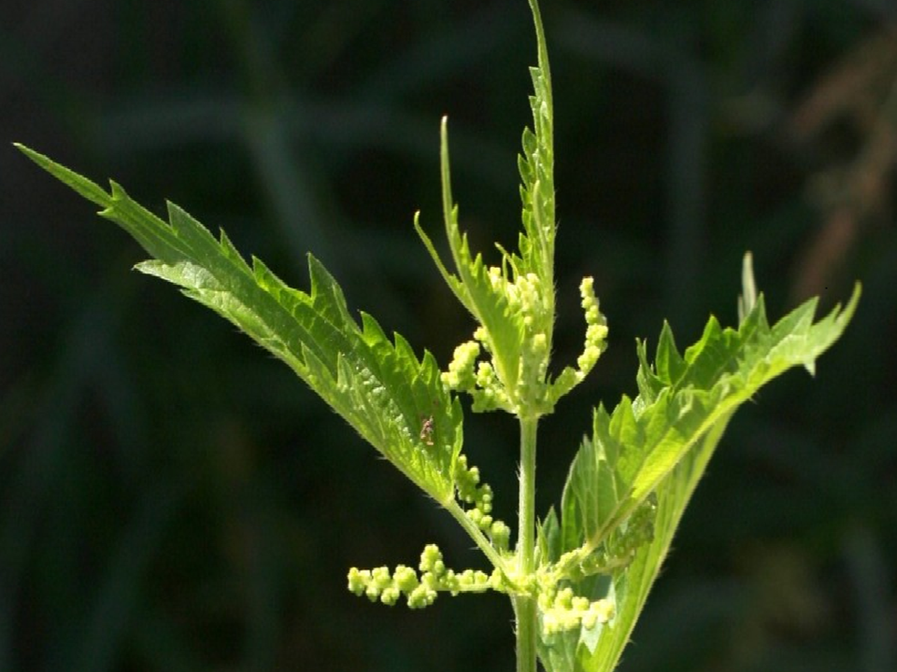
Fig. 2: Inhibitory Concentration (IC₅₀) values for different U. kioviensis extracts
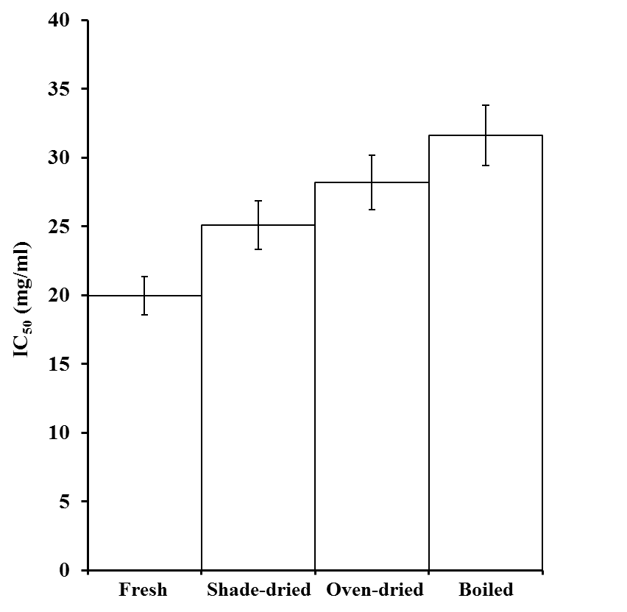
Fig. 3: Total phenol content in different U. kioviensis extracts
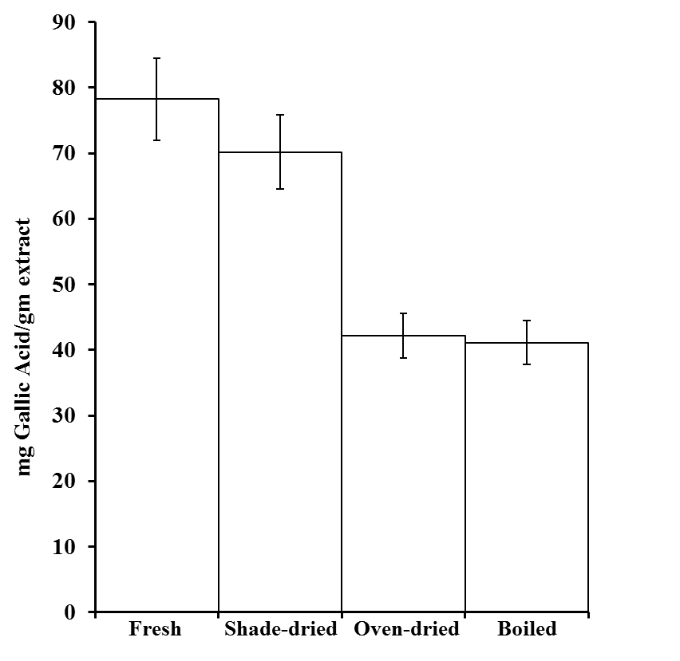

Fig. 4: Total flavonoid contents in different U. kioviensis extracts


