https://www.cambridge.org/core/journals/clays-and-clay-minerals/article/adsorption-of-tetracycline-from-contaminated-water-using-zno-montmorillonite-and-znomontmorillonite-composites-adsorption-kinetics-and-the-role-of-phzcp-in-adsorption-capacity/F993260E0D962B71252C28FA4155B211

Clays and Clay Minerals , Volume 73 , 2025 , e29

DOI: https://doi.org/10.1017/cmn.2025.10016

Adsorption of tetracycline from contaminated water using ZnO, montmorillonite, and ZnO/montmorillonite composites: adsorption kinetics and the role of pH_{zcp} in adsorption capacity
Published online by Cambridge University Press: 01 October 2025
Rola Tweir,
Ahed H. Zyoud[Opens in a new window],
Shaher H. Zyoud,
Hiba Nassar,
Samer H. Zyoud,
Naser Qamhieh,
Muath H.S. Helal and
Hikmat S. Hilal [Opens in a new window]
Show author details

- Article
- Figures
- Supplementary materials
- Metrics
Save PDF
Share
CiteRights & Permissions[Opens in a new window]

Abstract
The increasing pollution of water bodies by tetracycline (TC) has emerged as a looming threat to both environmental sustainability and human health, and the development of novel and effective remediation techniques is essential. The purpose of the present research was to explore the potential of montmorillonite (Mnt) and ZnO/Mnt composites as cost-effective and eco-friendly adsorbents for the removal of TC from polluted water sources. Batch adsorption experiments were carried out under controlled laboratory conditions, where adsorption isotherms, kinetic studies, and zero-charge point (pH_{zcp}) determinations were performed systematically to evaluate the performance of ZnO, Mnt, and ZnO/Mnt composites. The results highlighted the underlying importance of surface charge to adsorption by establishing pH_{zcp} for ZnO, Mnt, and the ZnO/Mnt composite. The effects of pH on the surface charge of adsorbents (ZnO, Mnt, and the ZnO/Mnt) and the equilibrium structure of TC were measured systematically and trends that are imperative for understanding the dynamics of adsorption were identified. The removal efficiencies of TC at the optimal pH of 5 were 100% for Mnt, 70% for ZnO/Mnt, and 4% for ZnO. Mnt exhibited the greatest adsorption capacity (125 mg g–1), particularly effective within the pH range of 3–7, demonstrating its strong potential for pollutant removal. However, the ZnO/Mnt composite, although showing a lower adsorption capacity (72 mg g–1), offers additional advantages due to the photocatalytic properties of ZnO. Under light irradiation, ZnO promotes the mineralization of adsorbed TC into harmless products such as CO₂ and H₂O, thereby reducing the risk of secondary pollution. While Mnt alone efficiently captures TC, the lack of degradation may pose environmental challenges. By integrating adsorption with photocatalysis, the ZnO/Mnt composite provides a more sustainable, dual-functional approach, highlighting the significance of coupling pollutant capture with degradation for effective and eco-friendly water treatment.

Keywords
adsorption kineticsmontmorillonitepHzcptetracyclineZnO/Mnt

Information
Type
Original Paper
Information
Clays and Clay Minerals , Volume 73 , 2025 , e29
DOI: https://doi.org/10.1017/cmn.2025.10016[Opens in a new window]

Creative Commons

This is an Open Access article, distributed under the terms of the Creative Commons Attribution licence (http://creativecommons.org/licenses/by/4.0), which permits unrestricted re-use, distribution and reproduction, provided the original article is properly cited.
Copyright
© The Author(s), 2025. Published by Cambridge University Press on behalf of The Clay Minerals Society

Introduction
In modern medicine, antibiotics help to combat bacterial infections and save millions of lives (Danner et al., Reference Danner, Robertson, Behrends and Reiss2019). However, their increased application raises serious concerns regarding impact. These pharmaceuticals are used widely by humans and for animals, and large amounts are released into the environment because of discharge through wastewater, improper disposal, and agricultural run-off (Danner et al., Reference Danner, Robertson, Behrends and Reiss2019). Improper disposal practices are particularly alarming, and these include landfilling or incineration of pharmaceuticals, which too often eventually contribute to their entry into bodies of water. The detoxification of pharmaceuticals in water, accordingly, has become a persistent issue with large repercussions for human health, aquatic ecosystems, and agricultural production. Among these pharmaceuticals, tetracycline (TC) is extremely important because of its very broad applications against gram-positive and gram-negative bacteria (Rowan, Reference Rowan2011; Wang et al., Reference Wang, Chen, Ge, Liu and Meng2023; Zhou et al., Reference Zhou, Cheng, Komarneni and Ma2023). As illustrated in Fig. 1, TC is one of the simplest members of this series and is still widely applied in human and veterinary medicine because of its relatively low cost, outstanding adsorption properties, and clinical efficiency (Ahmad et al., Reference Ahmad, Zhu and Sun2021). Unfortunately, heavy use has been accompanied by a considerable increase in environmental residues of TC and the inadvertent exceeding of safety standards (Scaria et al., Reference Scaria, Anupama and Nidheesh2021). Current research indicates that inappropriate disposal of drugs may result in its persistence in aquatic systems, thereby posing a threat to the health of humans, animals, fish, and the growth of plants (Bilal et al., Reference Bilal, Mehmood, Rasheed and Iqbal2020). For example, studies have confirmed a relationship between inadvertent exposure to pharmaceuticals and health problems in humans. One well-documented case is hearing damage in children caused by aminoglycoside antibiotics, which are known to induce irreversible ototoxicity (Fu et al., Reference Fu, Wan, Li, Wang, Guo, Zhang, An, Ye, Liu and Gao2021; Earl et al., Reference Earl, Sleight, Ashfield and Boxall2024). In addition, the presence of pharmaceuticals in soil and irrigation water has been shown to affect negatively the normal growth of crops such as wheat, leading to reduced germination, biomass, and altered physiological functions (Nguyen et al., Reference Nguyen, Lin, Nguyen, Hung, La, Nguyen, Chang, Chung and Nguyen2023; Castaño-Trias et al., Reference Castaño-Trias, Rodríguez-Mozaz, Verlicchi and Buttiglieri2024). Consequently, pharmaceutical residues may impair agricultural productivity and pose risks to food safety (Okocha et al., Reference Okocha, Olatoye and Adedeji2018; Izah et al., Reference Izah, Nurmahanova, Ogwu, Toktarbay, Umirbayeva, Ussen, Koibasova, Nazarbekova, Tynybekov and Guo2025). Other such sources of antibiotics include wastewater-treatment plants (Mohy-u-Din et al., Reference Mohy-u-Din, Farhan, Wahid, Ciric and Sharif2023), the manufacturing of chemicals, and aquaculture activities.
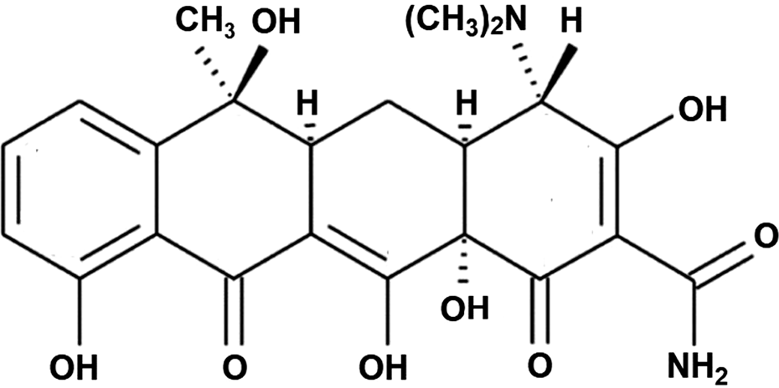
Figure 1. Structure of tetracycline.
The exceptional properties of TC, including its molecular structure, biologically active nature, and stability, hinder bacterial protein synthesis by disrupting the connection between aminoacyl-tRNA and ribosomal acceptor sites (Griffin et al., Reference Griffin, Ceballos and Villarreal2011). These properties have made TC indispensable in the treatment of infections. However, the complexity of its behavior in various pH environments and its low solubility in water underscore the need to address its environmental fate.
The environmental fate of TC is influenced by its ionic form, which varies with changes in pH (Colaizzi and Klink, Reference Colaizzi and Klink1969). This pH dependence is governed by the pKa values, which represent the pH at which a chemical species donates or accepts a proton (H⁺), thus determining its charge state. Under acidic conditions (pH<3), the TC molecules are fully protonated (TCH³⁺). As the pH increases, deprotonation occurs at specific pKa values, leading to different TC ionic forms. At the first pKa (3.3), TC adopts a zwitterionic form resulting from deprotonation of the hydroxyl group on carbon 3 of the structural formula of TC (Fig. 2) (Liu et al., Reference Liu, Hou, Yu, Xi, Zhao and Xia2013; Souza et al., Reference Souza, Silva, Santos, de Oliveira, do Carmo and Botero2016). At a higher pKa of 7.7, TC binds with negatively charged molecules (TCH–), which occurs due to the removal of a proton from the diketone system (O₁₁ and O₁₂). At the third pK_{a} of 9.7, TC exists as two negatively charged ions (TC^{2–}), formed by the deprotonation of the dimethylamino group (Degenkolb et al., Reference Degenkolb, Takahashi, Ellestad and Hillen1991; Liu et al., Reference Liu, Huang, Lai, Zeng, Qin, Zhang, Yi, Li, Deng and Liu2018) (Fig. 2). Understanding these pKa values is crucial for predicting how TC behaves under different pH conditions, especially in natural waters with variable pH. The behavior of TC in the aquatic environment is further influenced by its interactions with solid materials, including adsorbents (Liu et al., Reference Liu, Hou, Yu, Xi, Zhao and Xia2013; Souza et al., Reference Souza, Silva, Santos, de Oliveira, do Carmo and Botero2016; Shao and Wu, Reference Shao and Wu2020).
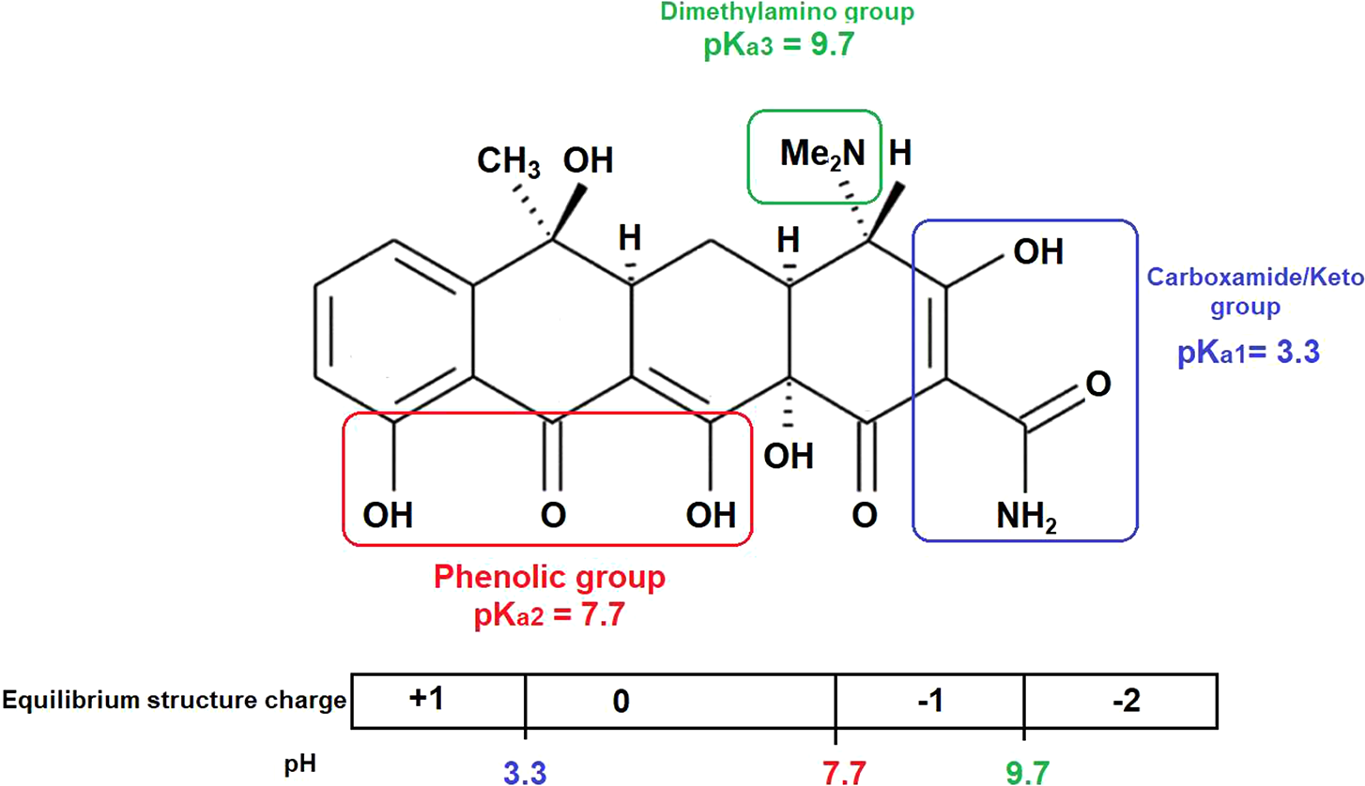
Figure 2. Equilibrium structure of TC with pH variation (Liu et al., Reference Liu, Hou, Yu, Xi, Zhao and Xia2013).
Adsorption, a basic surface phenomenon, is considered to be a process of accumulation of molecules on the surface of a solid material (Parolo et al., Reference Parolo, Savini, Valles, Baschini and Avena2008; Zyoud et al., Reference Zyoud, Jondi, AlDaqqah, Asaad, Qamhieh, Hajamohideen, Helal, Kwon and Hilal2017; Zyoud et al., Reference Zyoud, Zyoud and Amireh2024). Among several other purification techniques considered, adsorption has become a cost-effective, simple, and effective method for the removal of contaminants from water (Gao et al., Reference Gao, Li, Zhang, Huang, Hu, Shah and Su2012). Given the persistence of pharmaceuticals such as TC in water, adsorption has become an indispensable technique in environmental protection. Researchers have developed various adsorbent materials such as Myriophyllum aquaticum (Guo et al., Reference Guo, Mu, Zhong, Li, Zhang, Wei and Zhao2019), Cu-alginate (Li et al., Reference Li, Du, Liu, Sun, Wang, Wu, Wang, Xia and Xia2013), activated carbon (Sellaoui et al., Reference Sellaoui, Abdulaziz, Chebaane, Manai, Azhary, Alsehli, Alsowayigh, Piscitelli and Erto2023a; Yanan et al., Reference Yanan, Ali, Sellaoui, Dhaoudi, Franco, Georgin, Erto, Vieillard and Badawi2023), multi-walled carbon nanotubes (MWCNTs) (Wabaidur et al., Reference Wabaidur, Khan, Siddiqui, Otero, Jeon, Alothman and Hakami2020), nanomagnetic copper ferrite/drumsticks (Khan et al., Reference Khan, Otero, Kazi, Alqadami, Wabaidur, Siddiqui, Alothman and Sumbul2019), jack fruit peel (Alqadami et al., Reference Alqadami, Wabaidur, Jeon and Khan2024), kaolinite (Zyoud et al., Reference Zyoud, Zorba, Helal, Zyoud, Qamhiya, Hajamohideen, Zyoud and Hilal2019a), and alginate-graphene-ZIF67 aerogel (Kong et al., Reference Kong, Zhuang, Han and Shi2020).
Montmorillonite (Mnt) is a valuable 2:1 clay mineral composed of an octahedral sheet situated between two tetrahedral sheets, and is characterized by a thickness of ~1 nm and dimensions of 200–300 nm (Guo et al., Reference Guo, Liu, Gates and Zhou2020). The negative charge on the Mnt surface arises from isomorphic substitutions of ions within its octahedral and tetrahedral sheets (Zango et al., Reference Zango, Garba, Garba, Zango, Usman and Lim2022). Owing to their large cation exchange capacity, large surface area, and low cost, Mnts have attracted significant interest as adsorbents for various contaminants (Zango et al., Reference Zango, Garba, Garba, Zango, Usman and Lim2022). Although pure montmorillonite-rich soils require quarrying and processing, montmorillonite remains an affordable and readily available material because of its abundant natural occurrence and relatively low extraction costs compared with other materials, making it a popular choice for various applications (Thuc et al., Reference Thuc, Grillet, Reinert, Ohashi, Thuc and Duclaux2010; Ciftci, Reference Ciftci2021). In addition, ZnO nanoparticles (ZnO-NPs), which possess a wide band gap of 3.3 eV, demonstrate remarkable piezoelectric and photocatalytic attributes, rendering them highly efficient at both adsorption and in photodegradation applications. Upon light irradiation, ZnO-NPs generate reactive oxygen species that increase the breakdown of organic pollutants significantly, including TC, surpassing the effectiveness of conventional adsorbents. Furthermore, ZnO-NPs exhibit outstanding stability, broad accessibility, and cost efficiency, confirming their potential as viable materials for environmental remediation. By combining ZnO with the inorganic substrate Mnt to produce the composite ZnO/Mnt, the photocatalyst adsorption capacity is enhanced while also enhancing the photocatalytic properties of ZnO (Zyoud et al., Reference Zyoud, Jondi, AlDaqqah, Asaad, Qamhieh, Hajamohideen, Helal, Kwon and Hilal2017; Zyoud et al., Reference Zyoud, Zyoud and Amireh2024). This dual functionality is important because adsorption alone merely transfers pollutants to the adsorbent surface without degrading them, creating a secondary pollution hazard upon disposal. The ZnO/Mnt hybrid overcomes this limitation by facilitating post-adsorption photocatalytic degradation, whereby the adsorbed TC is completely mineralized to non-toxic by-products such as CO₂ and H₂O. This integrated approach presents a more sustainable and effective means for TC removal in aqueous systems.
The objective of this study was to investigate the adsorption behavior and efficiency of ZnO, Mnt, and ZnO/Mnt composites in removing TC from contaminated water, with a particular focus on the influence of the zero-charge point (pH_{zcp}) and the equilibrium structure of TC at different pH values. A further objective was a thorough characterization of the adsorbent materials, along with an analysis of the adsorption kinetics and isotherms, and the effects of the TC concentration and shaking time on the adsorption capacity. A significant aim of this study was also to address the gap in earlier research (Zyoud et al., Reference Zyoud, Jondi, AlDaqqah, Asaad, Qamhieh, Hajamohideen, Helal, Kwon and Hilal2017), which did not fully explore the role of pH_{zcp} and the TC equilibrium structure with pH in influencing both the adsorption capacity and the subsequent photodegradation process. By determining the pH_{zcp} for each material, this study should provide a comprehensive understanding of how surface charge characteristics affect the adsorption efficiency of the ZnO, Mnt, and ZnO/Mnt composites under various pH conditions.

Materials and methods

Chemicals
Commercial zinc oxide (CAS no. 1314–13-2) and montmorillonite (Mnt) clay powders (CAS no. 1318-93-0) were obtained from Sigma-Aldrich (Darmstadt, Germany). Sodium chloride (CAS no. 7647-14-5), sodium hydroxide (CAS no. 1310-73-2), and hydrochloric acid (CAS no. 7647-01-0) were obtained from Frutarom (Emmerich, Germany). Additionally, tetracycline hydrochloride was provided in its pure form by Birzeit-Palestine Pharmaceutical Company.

ZnO/Mnt composite preparation
A mixture consisting of 20 g of ZnO and 60 g of Mnt was stirred with 200 mL of distilled water in a 250 mL conical flask. This mixing ratio is based on previously reported composite preparations for applications in aqueous TC photodegradation (Zyoud et al., Reference Zyoud, Jondi, AlDaqqah, Asaad, Qamhieh, Hajamohideen, Helal, Kwon and Hilal2017). The colloidal solution was heated at 25°C and subjected to sonication for 10 h. Next, the mixture was allowed to stand undisturbed for one week. The combination was subsequently decanted, and the residual slurry was stirred magnetically on a hotplate to eliminate any remaining water. The resulting ZnO/Mnt composite was then calcined in an oven at 450°C for 1.5 h. Finally, the solid material was stored in a desiccator for subsequent use.

Determination of the zero-charge point (pH_{zcp}) of different solid systems
The pH_{zcp} values of ZnO, Mnt, and ZnO/Mnt were determined via the pH-drift technique. Initially, six vials were filled with 50 mL of a previously boiled solution of 0.01 M NaCl. The preliminary pH of each vial was then adjusted to various values, ranging from approximately pH 2 to pH 12, by adding dilute HCl (0.10 M) or dilute NaOH (0.10 M). Following pH adjustment, N₂ gas was introduced to each vial for a brief period, and the initial pH was recorded. Subsequently, 0.1 g of the specific adsorbent was added to each solution at the adjusted pH. After shaking and allowing the solutions to equilibrate for 24 h, the final pH of each solution was measured. The complete pH_{zcp} measurement process was replicated three times for every adsorbent sample, and the mean pH_{zcp} was determined by plotting ΔpH (pH_{f}–pH_{i}) against the initial pH value (pH_{i},) with the pH_{zcp} value identified at the x-axis intercept, indicating the point where the solid surface carried no net charge. Below this value, the solid surface bears a positive charge, whereas above it, the solid surface becomes negatively charged.

Adsorption experiments
The adsorption efficiency of TC onto ZnO, Mnt, and their composites was investigated by means of a series of batch adsorption experiments. Each run was carried out in 100 mL conical flasks, where 0.1 g of each corresponding adsorbent was added to 50 mL solutions containing known concentrations of TC. The range for each adsorbent was selected on the basis of its specific adsorption and surface characteristics. Low concentrations, such as 100, 130, 160, and 190 ppm for ZnO, were chosen because of their relatively small adsorption capacity, whereas high concentrations, such as 150, 250, 300, and 350 ppm, were chosen for Mnt to provide a large adsorption capacity owing to their relatively large surface area and ion-exchange capability. The ZnO/Mnt composite was thus treated with several intermediate concentrations, namely, 130, 160, 190, and 210 ppm, by balancing the properties of both components. These differences in concentration ranges ensure that the adsorption potential of each material is tested under conditions that best suit their respective characteristics.
The suspensions were thermostated at 25±2°C and shaken continuously at 200 rpm to ensure good contact between the adsorbents and TC molecules. This was adjusted, if necessary, by the addition of drops of diluted NaOH or HCl solutions. Equilibrium was attained within 2 h of continuous shaking. In this process, aliquots were taken at intervals and used to determine the rate of adsorption. These mixtures were centrifuged at 5000 rpm (≈2800×g) for 6 min, and the supernatant was analyzed spectrophotometrically to calculate the residual concentration of TC in the solution.
Each of the various adsorbents was tested under optimum conditions concerning its respective adsorption behavior and surface interaction with TC.

Adsorption kinetics and models
Adsorption isotherms were constructed using the Langmuir and Freundlich models (Freundlich, Reference Freundlich1906; Langmuir, Reference Langmuir1918). The Langmuir adsorption isotherm presumes monolayer adsorption at equilibrium, rendering it appropriate for systems with low coverage and binary adsorption. The Langmuir equation in its linear form is expressed in Eqn (1):
(1)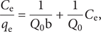
where C _{e} represents the equilibrium concentration of the adsorbate (mg L^{–1}), q _{e} represents the mass of adsorbate per unit mass of adsorbent (mg g^{–1}), Q ₀ represents the equilibrium adsorption capacity constant (mg g^{–1}), and b denotes the Langmuir constant associated with the adsorption affinity (L mg^{–1}) (Sellaoui et al., Reference Sellaoui, Gómez-Avilés, Dhaouadi, Bedia, Bonilla-Petriciolet, Rtimi and Belver2023b). Conversely, the Freundlich isotherm is expressed by Eqn (2):
(2)
where q _{e} represents the mass of adsorbate per unit mass of adsorbent (mg g^{–1}), C _{e} denotes the equilibrium concentration of the adsorbate (mg L^{–1}), K_{F} is the Freundlich constant associated with the adsorption capacity of the adsorbent (mg g^{–1}), and the slope (1/n) reflects the surface heterogeneity. A smaller slope indicates greater surface heterogeneity. The value of 1/n determines the favorability of the adsorption process. Langmuir adsorption is favorable when 1/n is <1, whereas Freundlich adsorption occurs when 1/n is >1.
In addition to these isotherm models, the experimental adsorption capacity (q _{e}) can be calculated directly from the mass balance equation: q _{e}=(C ₀–C _{e})V/W, where C ₀ and C _{e} (mg L^{–1}) represent the initial and equilibrium concentrations of the TC solution, respectively. V represents the volume of the solution (L), and W represents the mass of the adsorbent (g).
Kinetics plays a vital role in adsorption studies, providing a comprehensive understanding of adsorption mechanisms and the performance of adsorbents, which are essential for practical applications. The kinetics of adsorption include the rate at which the adsorbate interacts with the adsorbent and the time essential to reach the adsorption termination (Qiu et al., Reference Qiu, Lv, Pan, Zhang, Zhang and Zhang2009; Ali et al., Reference Ali, Alharbi, ALOthman, Al-Mohaimeed and Alwarthan2019; Khan et al., Reference Khan, Wabaidur, Siddiqui, Alqadami and Khan2020). To understand these features, several kinetic models have been employed to help identify the adsorption mechanism and rate-limiting step.
The commonly used kinetic models include the pseudo-first and pseudo-second order rate models, the Adam-Bohart-Thomas relation, the intraparticle diffusion model, the Weber–Morris sorption model, the first-order equation proposed by Bhattacharya and Venkobachar, the external mass transfer model, and the first-order reversible reaction model (Sridev and Rajendran, Reference Sridev and Rajendran2009; Sellaoui et al., Reference Sellaoui, Dhaouadi, Taamalli, Louis, Bakali, Badawi, Bonilla-Petriciolet, Silva, da Boit Martinello and Dotto2022). In this research, we examined TC adsorption onto three adsorbents via pseudo-first and pseudo-second order, and intraparticle diffusion models.
The pseudo-first order model, suggested by Lagergren (Lagergren, Reference Lagergren1898), is defined by Eqn (3):
(3)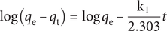
where q _{e} and q _{t} denote the masses of the adsorbate per unit mass of adsorbent at equilibrium (in units of mg g^{–1}) and at time t (in min), respectively, whereas k₁ (min^{–1}) denotes the rate constant attributed to the pseudo-first order model.
The pseudo-second order model (Ho and McKay, Reference Ho and McKay1999) operates under the assumption that the rate-limiting step involves the chemical adsorption of the adsorbate onto the adsorbent and is formulated as Eqn (4):
(4)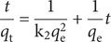
where q _{e} and q _{t} (mg g^{–1}) denote the masses of adsorbate per unit mass of adsorbent at equilibrium (mg g^{–1}) and at time t (min), respectively. k₂ (g mg^{–1} min) represents the pseudo-second order rate constant of adsorption.
The intraparticle diffusion model, proposed by Weber Jr and Morris (Reference Weber and Morris1963), is represented by Eqn (5):
(5)
where q _{t} (mg g^{–1}) represents the mass of adsorbate per unit mass of adsorbent at time t (min), k_{p} (mg g^{–1} min^{0.5}) represents the rate constant of intraparticle diffusion, and b is a constant indicating the thickness of the boundary layer.

Results and Discussion

Adsorbent solids characterization
The agreement observed between the XRD patterns of commercial ZnO in this investigation and those reported in the literature (Zyoud et al., Reference Zyoud, Jondi, AlDaqqah, Asaad, Qamhieh, Hajamohideen, Helal, Kwon and Hilal2017; Zyoud et al., Reference Zyoud, Zubi, Zyoud, Hilal, Zyoud, Qamhieh, Hajamohideen and Hilal2019b) confirmed the consistency of the ZnO compounds utilized. The XRD pattern of the commercial ZnO powder revealed diffraction peaks at 73.45, 69.94, 76.95, 66.36, 62.85, 56.58, 47.53, 36.25, 34.42, and 31.71°2θ (Fig. 3). These peaks correspond to reflections from the (202), (201), (112), (200), (103), (110), (102), (101), (002), and (100) Bragg planes, respectively (Arefi and Rezaei-Zarchi, Reference Arefi and Rezaei-Zarchi2012). The consistency of the identity of the ZnO compounds was further confirmed by the contrast between the XRD patterns of the commercial ZnO used in this study and those reported in the literature (Zyoud et al., Reference Zyoud, Jondi, AlDaqqah, Asaad, Qamhieh, Hajamohideen, Helal, Kwon and Hilal2017; Zyoud et al., Reference Zyoud, Zubi, Zyoud, Hilal, Zyoud, Qamhieh, Hajamohideen and Hilal2019b). The average particle size of ZnO was determined via the Scherrer equation to be 52 nm.
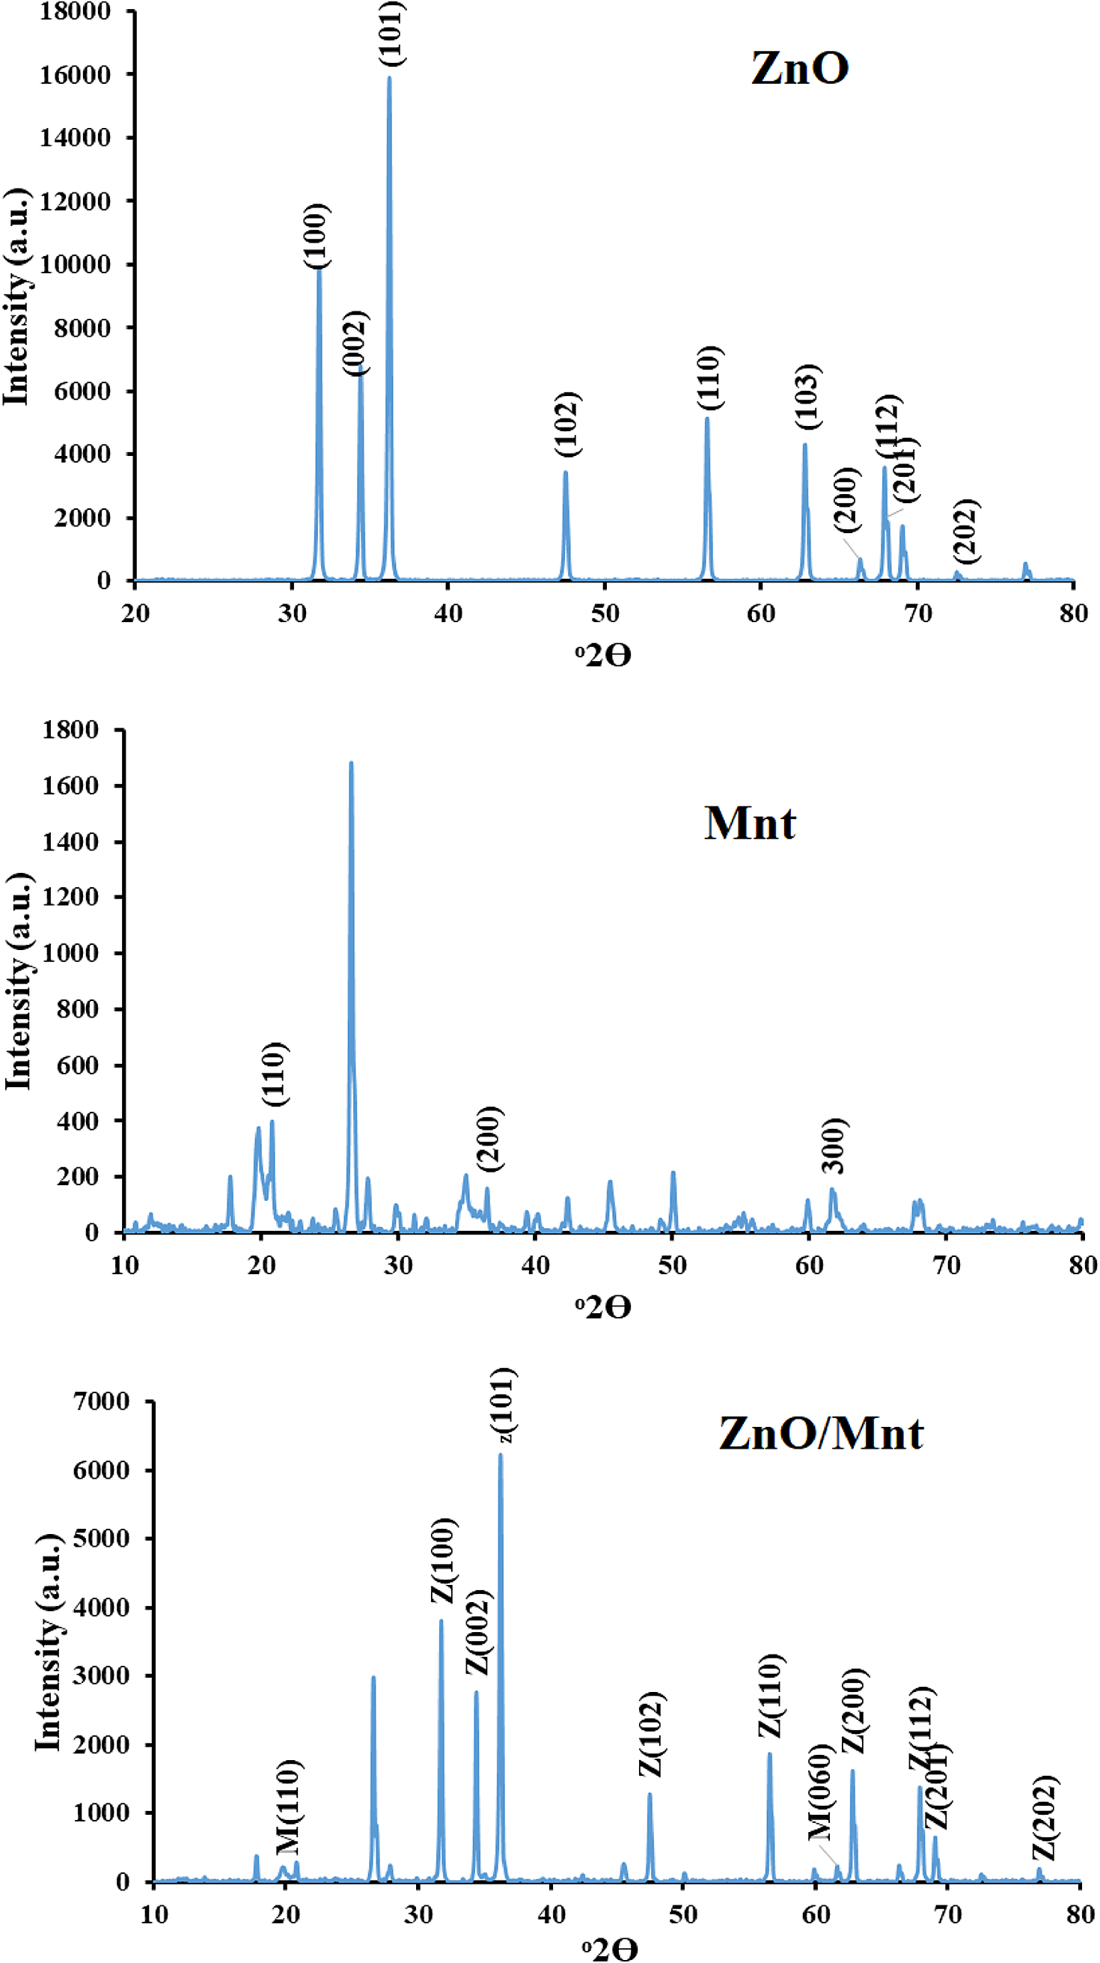
Figure 3. XRD patterns of commercial ZnO powder, Mnt, and ZnO/Mnt.
The XRD pattern of the Mnts revealed reflections corresponding to the (110), (200), and (060) planes at 20.8, 36.5, and 62.2°2θ angles, respectively, which aligned with reported findings in the literature (Zyoud et al., Reference Zyoud, Jondi, AlDaqqah, Asaad, Qamhieh, Hajamohideen, Helal, Kwon and Hilal2017). The average particle size of the Mnts calculated via the Scherrer equation was 41.5 nm.
The XRD pattern of the ZnO/Mnt composite confirmed the successful deposition of ZnO onto the surface of Mnt within the composite system (Fig. 3). Distinct diffraction peaks corresponding to ZnO (31.74, 34.41, and 36.22°2θ) and Mnt (20.8°2θ and 62.2°2θ) appeared without any noticeable shift, suggesting that ZnO was attached to the external surface of Mnt rather than intercalating between its layers. This observation aligns with previous studies (Zyoud et al., Reference Zyoud, Jondi, AlDaqqah, Asaad, Qamhieh, Hajamohideen, Helal, Kwon and Hilal2017). According to the Scherrer equation, the calculated particle sizes of ZnO and Mnt within the composite were 56.7 nm and 50.3 nm, respectively (31.74° and 20.8°2θ). Notably, the incorporation of ZnO did not alter the particle size significantly, as the values for pure ZnO and Mnt were 51.89 nm and 41.45 nm, respectively.
According to Bragg’s law, the interplanar distance for the (110) plane, labeled d ₁₁₀, is 0.45 nm for both the Mnt and ZnO/Mnt samples. Annealing the ZnO/Mnt composite at 450°C did not affect the peak position or the d ₁₁₀ value (Zyoud et al., Reference Zyoud, Jondi, AlDaqqah, Asaad, Qamhieh, Hajamohideen, Helal, Kwon and Hilal2017). Although heating montmorillonite at 450°C may cause physical changes such as a reduction in surface area and the loss of interlayer water, no significant chemical alterations were observed in this study. The heating process may induce slight structural modifications, but it did not alter the core chemical composition of Mnt. XRD analysis confirmed that no phase transformations or decomposition occurred, and the overall crystallinity of Mnt remained stable, as indicated by the consistent peak positions before and after heating.
The SEM image revealed the presence of ZnO in the form of agglomerates with an average diameter of ~800 nm (Fig. 4). These agglomerates were composed of smaller nanoparticles, each ~52 nm in diameter, as determined from the XRD pattern of pristine ZnO.
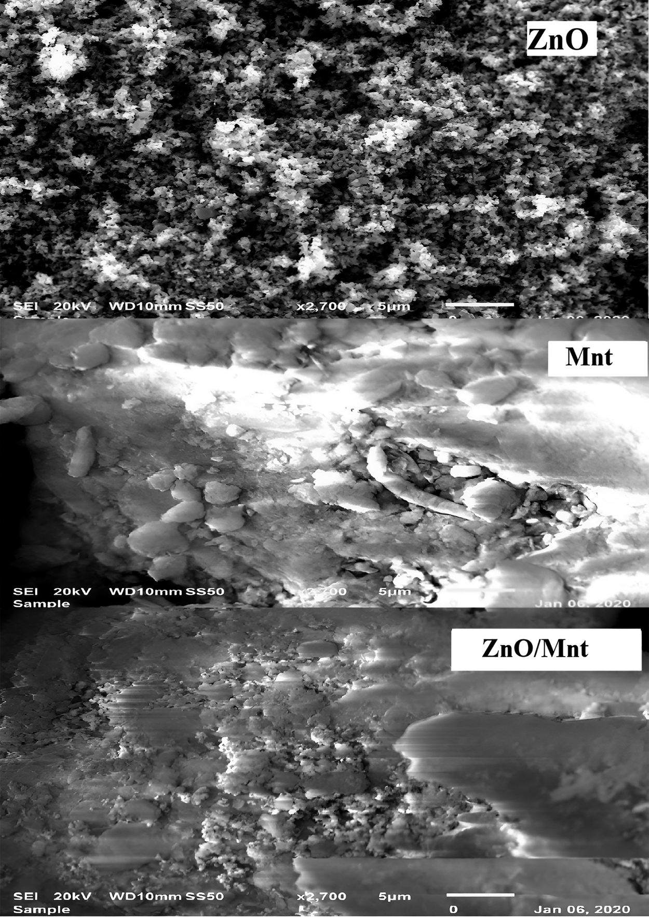
Figure 4. SEM images showing commercial ZnO, Mnt, and ZnO/Mnt.
The SEM image of Mnt with an average diameter of ~3000 nm consisted of agglomerates composed of smaller Mnt nanoparticles, each with a diameter of ~40 nm, as indicated by the XRD data for the Mnts (Fig. 4).
The SEM image of the ZnO/Mnt composite revealed a distinct morphology of the Mnts within the composite, resembling a flower shape, in contrast to the flaky shape of the bare Mnts (Fig. 4). This contrast confirmed the formation of the ZnO/Mnt composite. The average size of the ZnO and Mnt agglomerates is ~1100 nm, ranging between ~800 and 2700 nm. Within these agglomerates, ZnO nanoparticles (~57 nm) and Mnt and composite Mnt nanoparticles (~50 nm) were identified, as measured from the composite XRD pattern.
Complementary surface area measurements, conducted via the BET method, revealed specific surface area values of 27, 330, and 310 m² g^{–1} for ZnO, Mnt, and the ZnO/Mnt composite, respectively. The total specific surface area (both internal and external) was calculated via the ethylene glycol monoethyl ether (EGME) adsorption method (Carter et al., Reference Carter, Mortland and Kemper1986). The total specific surface area was found to be 32, 670, and 620 m² g^{–1} for ZnO, Mnt, and ZnO/Mnt, respectively.
Montmorillonite (Mnt) has one of the largest cation exchange capacities (CEC) among natural clays, reaching up to 150 mg equiv per 100 g (Boeva et al., Reference Boeva, Bocharnikova, Belousov and Zhigarev2016). This high CEC is mainly due to isomorphic substitution within its crystal structure and the presence of interlayers that can expand and allow the exchange of ions (Mejri et al., Reference Mejri, Oueslati and Amara2023). Compared with other clays, montmorillonite swells extensively when water molecules move into the interlayer spaces and adsorb onto the clay surfaces. However, earlier studies by P.F. Low and colleagues showed that the swelling behavior is not controlled primarily by the hydration of interlayer cations, as was once thought (Low, Reference Low1980). Instead, the large specific surface area of the basal surfaces plays the dominant role in determining how much water can be adsorbed. Interlayer cations still play a role, but mainly by controlling how many interlayers are open to water molecules. For example, montmorillonite samples in which sodium and calcium are the main exchangeable cations often swell much more, sometimes expanding to several times their original volume (Sanqin et al., Reference Sanqin, Zepeng, Yunhua, Libing and Jiansheng2014; Mejri et al., Reference Mejri, Oueslati and Amara2023).

Tetracycline adsorption experiments
The adsorption results for TC on different adsorbents were examined at a pH of 5, with a shaking duration of 120 min at 20°C. ZnO exhibited very little adsorption capacity, capturing only 4% of a 50 mL 100 ppm TC solution. In contrast, Mnt demonstrated impressive adsorption, resulting in 100% adsorption of a 50 mL 100 ppm TC solution and 67% adsorption of a 50 mL 200 ppm TC solution. Additionally, the ZnO/Mnt composite material exhibited a significant adsorption rate of 70% for the 50 mL solution with 100 ppm TC (Fig. 5). This notable increase in the adsorption capacity of ZnO when combined with Mnt highlights the synergistic effect of the composite and highlights its potential for further investigation of ZnO as an effective photocatalyst in subsequent photodegradation studies, as previously reported by Zyoud et al. (Reference Zyoud, Jondi, AlDaqqah, Asaad, Qamhieh, Hajamohideen, Helal, Kwon and Hilal2017).
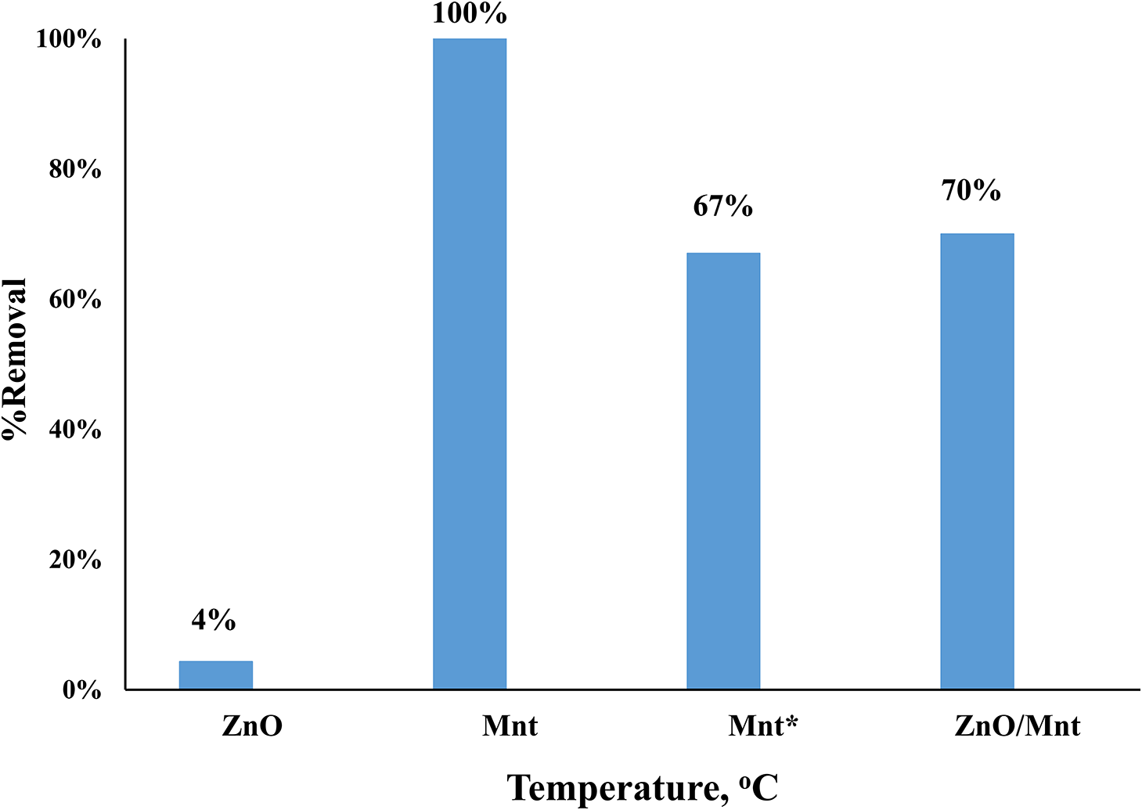
Figure 5. The impact of adsorbent variation on the percentage of tetracycline removed under the following conditions: initial concentration of 100 mg L^{–1}, Mnt* dose of 200 mg L^{–1}, pH of ~5, temperature maintained at 25°C, contact duration of 120 min, and solid/liquid ratio of 0.1 g/50 mL.
Pristine Mnt exhibited a larger surface area and, consequently, a greater adsorption capacity for TC than the ZnO/Mnt composite. The reduced capacity of the composite can be attributed in part to the partial blocking of active Mnt sites by deposited ZnO. However, differences in adsorption cannot be explained by surface area alone, as electrostatic interactions play a decisive role in the adsorption process. The point of zero charge (pH_{zcp}) provides essential insight into these interactions because it defines the pH at which the surface carries no net charge. Below the pH_{zcp}, the surface becomes positively charged, while above it, the surface is negatively charged.
From the pH-drift experiments (Fig. 6), the pH_{zcp} values were determined to be 9.5 for ZnO, 4.5 for Mnt, and 7.2 for the ZnO/Mnt composite. For Mnt, the relatively low pH_{zcp} reflects the dominance of permanent negative charges originating from isomorphic substitution at the basal surfaces, which are largely independent of pH (Bourg et al., Reference Bourg, Sposito and Bourg2007) A smaller contribution arises from particle edges, where hydroxyl groups undergo protonation or deprotonation depending on solution pH. At acidic pH, limited protonation of edge hydroxyl groups yields a weak positive charge (Tombacz and Szekeres, Reference Tombacz and Szekeres2004; An and Dultz, Reference An and Dultz2007), but because edge sites represent a minor fraction of the total surface, this contribution remains relatively small (Hao et al., Reference Hao, Flynn, Alessi and Konhauser2018; Gao et al., Reference Gao, Liu, Guo and Tournassat2023). In contrast, ZnO develops a much higher pH_{zcp} of ~9.5, indicating that its surface is strongly positively charged under acidic to near-neutral conditions, which promotes electrostatic attraction with negatively charged species.
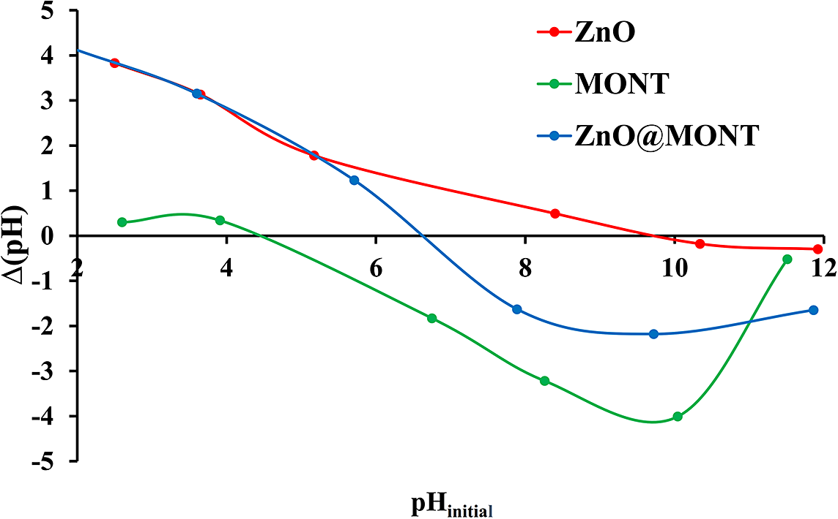
Figure 6. Graph illustrating the variation in ∆(pH) versus initial pH for ZnO, Mnt, and ZnO/Mnt. The intercept denotes the value of pH_{zcp} for the solid. The data were collected at room temperature.
When ZnO is combined with Mnt, the resulting composite exhibits an intermediate pH_{zcp} of 7.2. This value reflects the combined contributions of both materials: the permanent basal charge of Mnt and the strongly pH-dependent charge of ZnO. Importantly, the composite develops a more pronounced positive surface charge at low pH compared with pristine Mnt, due to the influence of ZnO. This enhanced positivity strengthens electrostatic interactions with neutral or cationic TC species in acidic media, thereby helping to account for the composite’s adsorption performance despite the partial blocking of Mnt active sites.
Overall, the trends observed in Fig. 6 confirm that surface charge characteristics, as expressed by the pH_{zcp}, critically govern adsorption behavior. By integrating the high positive surface charge of ZnO with the large surface area and permanent basal charge of Mnt, the composite achieves a balance that provides insight into the observed adsorption differences relative to the individual components (Sanqin et al., Reference Sanqin, Zepeng, Yunhua, Libing and Jiansheng2014; Mejri et al., Reference Mejri, Oueslati and Amara2023).
It should also be noted that montmorillonite may undergo partial dissolution under strongly acidic or alkaline conditions, as highlighted in the studies of Komadel and coauthors (Komadel et al., Reference Komadel, Bujdák, Madejová, Šucha and Elsass1996; Komadel and Madejová, Reference Komadel and Madejová2006). Such dissolution can alter surface charge distribution and reduce the availability of active sites, potentially influencing adsorption behavior. In this study, the pH range of 3–11 was investigated in order to evaluate the adsorption mechanisms comprehensively; however, for practical water-treatment applications, the operation is typically carried out under moderately acidic, moderately basic, and near-neutral pH conditions, where montmorillonite maintains its structural integrity. Under these more relevant conditions, dissolution effects are minimal, and the interpretations presented here reflect primarily electrostatic interactions and surface area contributions rather than structural degradation.
The adsorption of TC onto three distinct adsorbent solids (raw ZnO, Mnt, and ZnO/Mnt) was examined across a pH range of 3–11. Each experiment employed 0.1 g of the respective adsorbent solid, which was shaken continuously for 120 min with 50 mL of a 100 ppm TC solution. Additionally, a supplementary experiment was specifically conducted for Mnt utilizing 50 mL of TC solution at 200 ppm. This additional experiment was prompted by the complete adsorption of 100 ppm TC solution by Mnt under specific pH conditions, providing comparative insights. The adsorption efficiency was influenced by pH, and the surface charge of ZnO, represented by pH_{zcp}, along with the equilibrium TC structure at a given pH, elucidates how the surface charge of ZnO and TC changes with varying pH (Fig. 7).
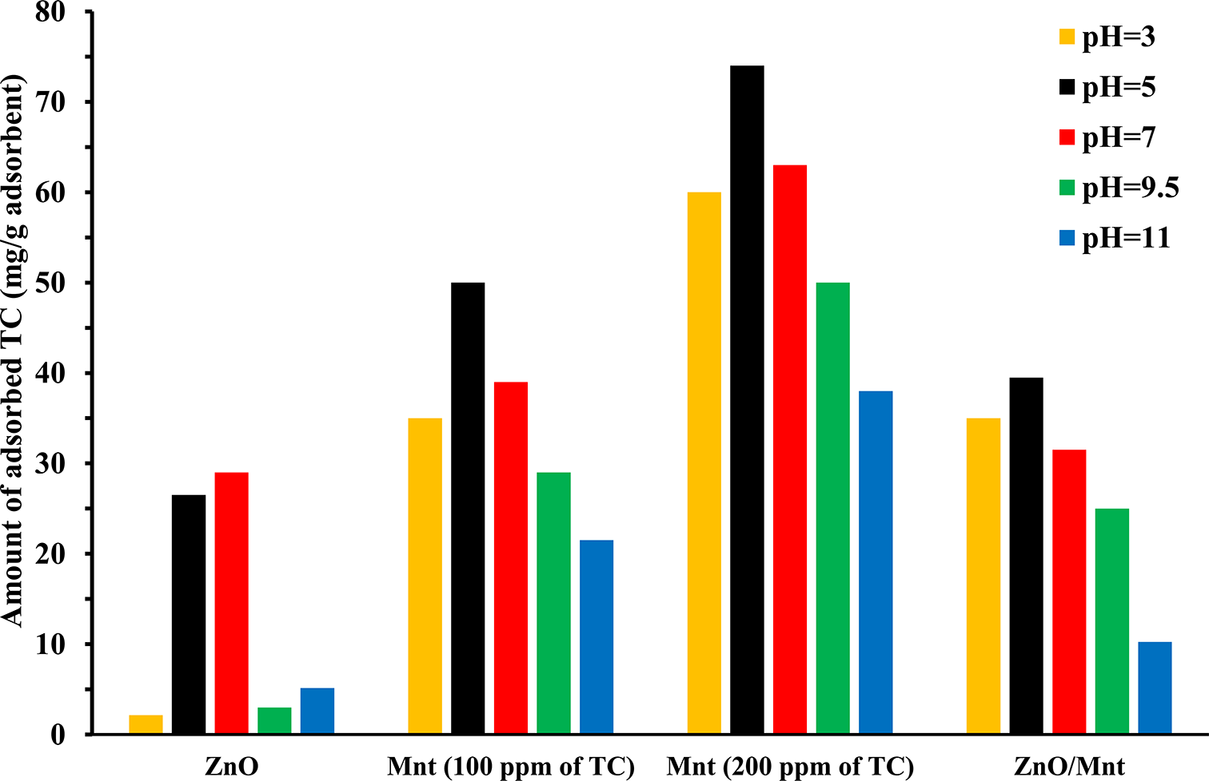
Figure 7. Adsorption of TC (mg g^{–1}) on ZnO, Mnt, and ZnO/Mnt at various pH values. Mnt data are presented for initial TC concentrations of 100 ppm (comparable to ZnO and ZnO/Mnt) and 200 ppm (reflecting its greater adsorption capacity).
The maximum adsorption capacity of ZnO was observed at pH 7, followed by pH 5. At pH ~7, ZnO has a positive charge, creating electrostatic attraction with the negatively charged TC, thereby enhancing adsorption. However, at pH ~5, both ZnO and TC are positively charged, limiting electrostatic attraction. The significant removal efficiency is attributed to the strong attraction between ZnO and the ketol group in the TC molecule (Zyoud et al., Reference Zyoud, Saleh, Helal, Shawahna and Hilal2018). This attraction of neutral TC species shifts the positive equilibrium structures toward neutral structures as a result of Le Chatelier’s principle, subsequently increasing the adherence of neutral species to the ZnO surface.
At pH 3 (Fig. 8a), TC is in equilibrium with its cationic (TCH₃⁺) and neutral (TCH₂) forms, represented by the following equilibrium: TCH₃⁺ ⇌ TCH₂ + H⁺. Owing to its large specific surface area and the presence of hydrophilic sites on the negatively charged Mnt surface, Mnt can interact with and adsorb neutral TCH₂ molecules through hydrogen bonding and van der Waals interactions. This adsorption process shifts the equilibrium towards the production of more neutral TCH₂ molecules, as per Le Chatelier’s principle, as shown in Fig. 2. As the neutral TC species continue to adsorb onto the positively charged surface of Mnt, this shift results in sustained adsorption. This explains the large adsorption capacity observed for both the unaltered Mnt and the ZnO/Mnt composite, despite the positively charged surface of Mnt. The system leverages the equilibrium dynamics of TC, where the continuous adsorption of neutral species drives further conversion of cationic TCH₃⁺ into neutral TCH₂, facilitating adsorption even when electrostatic repulsion might be expected. This interaction underscores the effectiveness of both adsorbent systems under these conditions and highlights the role of shifts in equilibrium in enhancing TC adsorption.
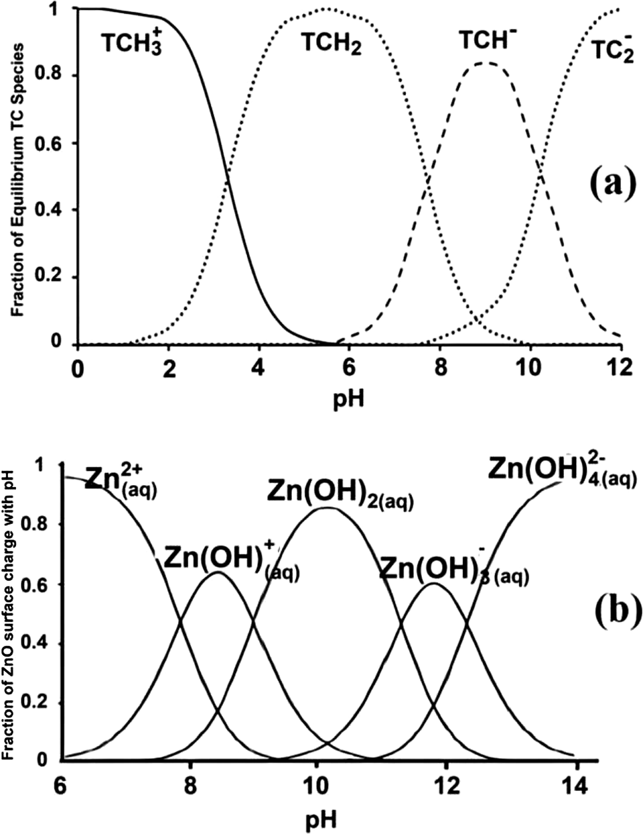
Figure 8. (a) Effects of pH on the TC structure and (b) effects of pH on the ZnO surface structure (Zyoud et al., Reference Zyoud, Zubi, Zyoud, Hilal, Zyoud, Qamhieh, Hajamohideen and Hilal2019b).
At a pH of ~9.5, which is close to its zero-point charge (pH_{zcp}=9.5), the ZnO surface has a neutral to negative charge, whereas the TC molecules have negatively charged equilibrium structures, causing repulsion and decreased sorption and removal. At pH 11, the negative surface charge of ZnO leads to electrostatic repulsion and decreased adsorption efficiency. The optimal adsorption efficiency of ZnO occurs between pH 5 and 7, with a reduced efficiency at more extreme pH values. In conclusion, the ideal pH for TC adsorption on both unaltered Mnt and the ZnO/Mnt composite ranges from slightly acidic to neutral, specifically between pH 3 and 9.5.
The adsorption capacity of TC onto Mnt varied depending on the pH of the solution, with the efficiency decreasing in the order of pH 5>3>7>9>11, as depicted in Fig. 7. The optimal pH for TC adsorption onto Mnt was determined to be ~pH 5. At this pH, Mnt effectively adsorbed 100% of the TC from a 100 ppm solution and ~74% from a 200 ppm solution. This behavior is attributed to the negative surface charge of Mnt at pH 5 (which is above its point of zero charge, pH_{zcp}=4.5), allowing for electrostatic attraction between the negatively charged Mnt surface and the positively charged TC species, leading to enhanced adsorption.
The surface charge of Mnt is heavily dependent on the pH of the surrounding solution, which affects the protonation or deprotonation of its edge surface hydroxyl groups. Below a pH_{zcp} of 4.5, Mnt has a positively charged surface due to the protonation of the hydroxyl groups. However, as the pH increases beyond pH_{zcp}, deprotonation occurs, and the surface becomes negatively charged. These pH-dependent charge variations affect the electrostatic interactions between Mnt and adsorbates such as TC. At lower pH values, the positive charge on Mnt enhances the adsorption of neutral or positively charged TC species, whereas at higher pH values, the negative charge on Mnt leads to electrostatic repulsion between similarly charged TC species, reducing the adsorption efficiency.
At pH 3, the Mnt surface has a positive charge, which allows it to adsorb the neutral and positively charged equilibrium species of TC. The interaction between the metal oxide on the Mnt surface and the ketal group of TC molecules leads to increased adsorption of neutral TC species. This shift in equilibrium, following Le Chatelier’s principle, enhances TC adsorption on both the Mnt and ZnO/Mnt composites, despite the positively charged surface of Mnt.
At pH values higher than pH_{zcp} (e.g. pH 7 and 9.5), the Mnt surface remains negatively charged, resulting in reduced TC adsorption due to electrostatic repulsion between the negatively charged TC species and the negatively charged Mnt surface. However, the interaction between the ketal functional groups in TC and the metal oxides within Mnt still allows for some degree of adsorption. This interaction shifts the equilibrium towards neutral TC species, enabling continued adsorption at these relatively high pH values.
At pH 11, the negatively charged Mnt surface and the entirely negative charge on TC led to reduced adsorption efficiency due to repellent charge similarity. In summary, the adsorption behavior of Mnt for TC is intricately influenced by the interplay of pH-dependent surface charges and electrostatic interactions, suggesting that TC removal via the Mnt adsorbent is most effective at pH 3–7 for maximum capacity.
ZnO/Mnt has gained recognition as a photocatalyst for contaminant removal (Fatimah et al., Reference Fatimah, Wang and Wulandari2011; Zyoud et al., Reference Zyoud, Jondi, AlDaqqah, Asaad, Qamhieh, Hajamohideen, Helal, Kwon and Hilal2017) and understanding the pH-dependent TC adsorption on ZnO/Mnt is crucial for studying its photocatalytic behavior. This composite, which combines ZnO with Mnt, is a promising adsorbent because of its excellent adsorption ability. The adsorption capacity of ZnO/Mnt for TC exhibited a pH-dependent trend, with optimal performance observed at pH 5, where 80% of TC was adsorbed. At pH ~3, ~70% of TC is adsorbed primarily through interactions with the negatively charged basal surfaces of montmorillonite within the composite, where neutral TC species can engage in hydrogen bonding and van der Waals interactions, while any cationic TC may also adsorb via cation exchange, facilitating strong attachment, particularly between the ketol group and metal oxides.
At pH 7, substantial adsorption of ~63.2% TC occurred, albeit less than at acidic pH values of 3 and 5. ZnO/Mnt is nearly neutral at pH 7, enhancing the adsorption efficiency of the ketol group with metal oxides. However, adsorption decreases at pH 9 and 11, which is attributed to repulsion between the negatively charged Mnt surface and the predominantly negative TC equilibrium structure. Adsorption at pH 9.5 is still acceptable (~50%) owing to the strong attachment of the ketol group to metal oxides, resulting in neutral TC species, whereas a reduction in adsorption (20.49%) at pH 11 is linked to the similarity in surface charge between ZnO/Mnt and the negatively charged TC equilibrium, as depicted in Fig. 8.
The impact of the initial TC concentration on adsorption was explored via three different adsorbents (ZnO, Mnt, and ZnO/Mnt) under constant conditions: a pH of 7, a temperature of 25°C, and a contact time of 120 min. Table 1 displays the percentage of TC adsorbed and the quantity of adsorbed TC for each experiment. These findings indicate that with increasing initial TC concentration, the percentage of TC removed decreased, whereas the amount of adsorbed TC increased with increasing initial TC concentration.
Table 1. Percentage removal and amount of TC adsorbed on three adsorbent solids with various initial concentrations
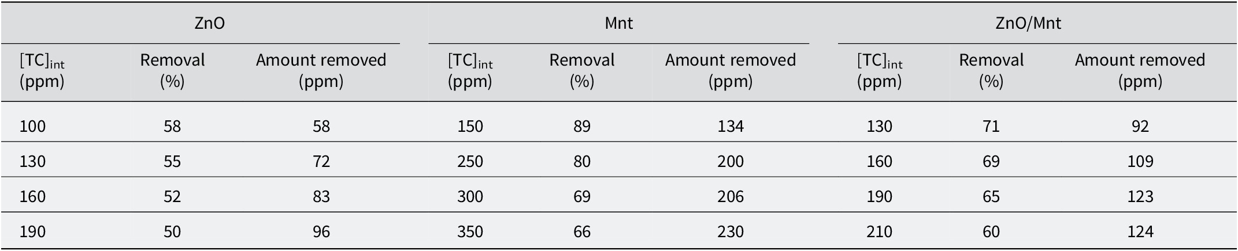
The impact of shaking time on the percentage of TC removed through adsorption onto various adsorbents was measured. The experiments involved initial TC concentrations of 100 ppm for ZnO and ZnO/Mnt and 200 ppm for Mnt at a pH of ~7 and a temperature of 25°C. A solid/solution ratio of 0.1 g/50 mL was maintained. Maximum TC adsorption was achieved within 15 min of shaking for ZnO and Mnt, whereas it reached its peak within 60 min for ZnO/Mnt, as illustrated in Fig. 8.
The impact of shaking time on the percentage removal of TC through adsorption onto various adsorbents was measured. The experiments involved initial TC concentrations of 10 ppm for ZnO, 100 ppm for ZnO/Mnt, and 200 ppm for Mnt at a pH of ~5 and a temperature of 25°C. A solid/solution ratio of 0.1 g/50 mL was maintained. The maximum TC adsorption was achieved within 30 min of shaking for all the solids (Fig. 9).
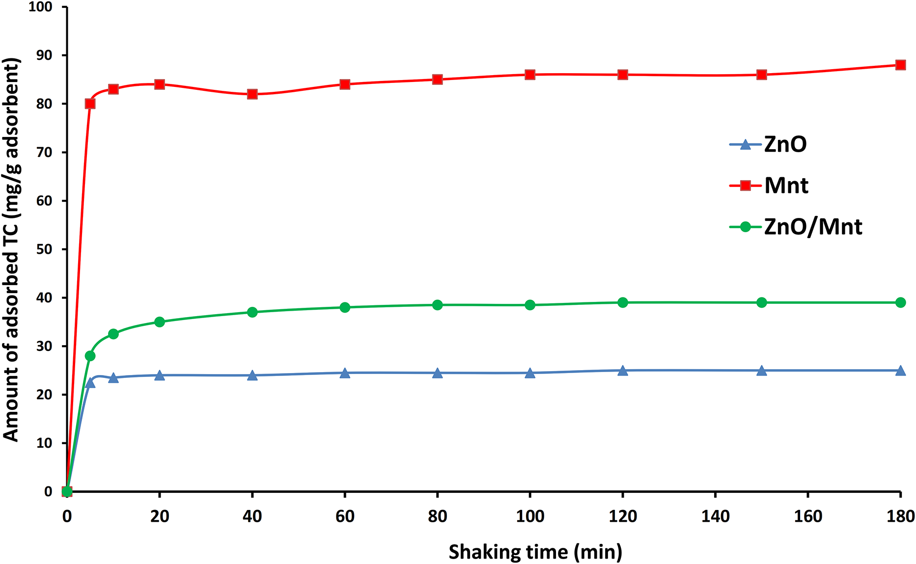
Figure 9. Effects of shaking time on the adsorption of TC on ZnO (10 ppm), ZnO/Mnt (100 ppm), and Mnt (200 ppm) at a pH of ~5 and a temperature of 25°C.
This dual function is necessary as adsorption merely transfers pollutants onto the surface of the adsorbent without decomposing them, which is a secondary pollution risk. Mnt by itself can adsorb 100% of TC but cannot decompose the adsorbed pollutants; thus, the pollutants are still attached to the material and can be released at a later stage. In comparison, the ZnO/Mnt composite with a lower starting adsorption of 70% possesses an improved overall removal mechanism. The degradation of TC via photocatalytic degradation guarantees that the composite constantly degrades the adsorbed TC to harmless products such as CO₂ and H₂O, as shown in a previous study (Zyoud et al., Reference Zyoud, Jondi, AlDaqqah, Asaad, Qamhieh, Hajamohideen, Helal, Kwon and Hilal2017). In addition to eliminating the retained pollutant, the adsorption sites are also regenerated for the adsorption of more TC molecules from the surrounding solution. Thus, the ZnO/Mnt composite establishes a self-sustaining removal process that guarantees long-lasting removal of tetracycline, while Mnt by itself becomes saturated and inoperative after its adsorption capacity is reached. This two-pronged strategy provides a more sustainable and effective means for the removal of tetracycline from aqueous solutions.

Adsorption isotherm results
Adsorption isotherms elucidate the adsorption processes and capacities of various materials (Freundlich, Reference Freundlich1907; Langmuir, Reference Langmuir1918; Brunauer et al., Reference Brunauer, Emmett and Teller1938). The equilibrium adsorption isotherms of TC onto ZnO were investigated using initial TC concentrations of 100, 130, 190, and 210 ppm at 25°C, pH=7, shaking time of 120 min, and solid/solution ratio of 0.1 g/50 mL. For Mnt, similar experiments were conducted at initial TC concentrations of 150, 250, 300, and 350 ppm under the same conditions. For the ZnO/Mnt composite, measurements were made using initial TC concentrations of 120, 130, 190, and 210 ppm while maintaining the same conditions.
The adsorption isotherms (Fig. S1a–c in the Supplementary material) depict the relationship between the equilibrium concentration (C _{e}) and the amount adsorbed per unit mass (q _{e}). These results were fitted to the Langmuir and Freundlich isotherm models. The plots of C _{e}/q _{e} versus C _{e} for the Langmuir equation and log q _{e} versus log C _{e} for the Freundlich equation are shown in Fig. S1d–f and S1g–i, respectively.
The slope and intercept from these graphs were used to determine the Langmuir and Freundlich isotherm parameters via their respective equations. The resulting values and correlation coefficients for TC adsorption (Table 2) revealed that ZnO has a negative adsorption capacity, indicating non-compliance with the Langmuir isotherm, whereas the Freundlich isotherm proved to be a more suitable adsorption model (Meroufel et al., Reference Meroufel, Benali, Benyahia, Benmoussa and Zenasni2013). However, ZnO has an insufficient adsorption capacity for TC, as indicated by the low K_{f} and n values in Table 2. The K_{f} Freundlich constant provides insights into the adsorption capacity, whereas n serves as an indicator of the adsorption process efficiency; an n value between 1 and 10 suggests an effective adsorption process. For ZnO, the K_{f} value was 0.0019, and the n value was 0.42, indicating a low adsorption capacity.
Table 2. Langmuir and Freundlich isotherm parameters and correlation coefficients for the adsorption of tetracycline onto various adsorbents
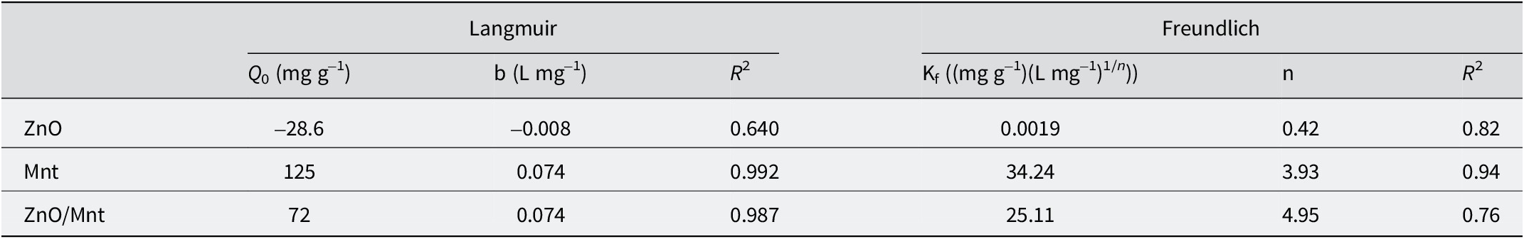
Conversely, the Langmuir isotherm was a better fit for the Mnt and ZnO/Mnt adsorbents, with Q ₀ values of 125 mg g^{–1} and 72 mg g^{–1}, respectively. These values indicate that Mnt is a superior adsorbent with a maximum adsorption capacity, whereas ZnO was found to follow the Freundlich isotherm better than the Langmuir model.

Kinetics of TC adsorption
A kinetic study is crucial for determining the optimal operating conditions and identifying the rate-determining step in the adsorption process (Meroufel et al., Reference Meroufel, Benali, Benyahia, Benmoussa and Zenasni2013). This study investigated three kinetic models for the adsorption of TC on ZnO, Mnt, and ZnO/Mnt: the pseudo-first order, pseudo-second order, and intraparticle diffusion models. For the experiments involving ZnO and ZnO/Mnt, the initial TC concentration was set at 100 ppm, whereas it was 200 ppm for Mnt. The experimental conditions included a pH of 7, a temperature of 25°C, and a solid/solution ratio of 0.1 g/50 mL.
The pseudo-first order model plot, which describes the relationship between time and log(q _{e}–q _{t}) for the three adsorbents, is presented in Fig. S1a–c. Moreover, the pseudo-second order model plot, which shows the relationship between t/q_{t} values and time (t), is displayed in Fig. S2d–f. The intraparticle diffusion model plots, which show q_{t} versus (t _{1/2}), are illustrated in Fig. S2g–i.
Table 3 presents the correlation coefficients and parameters for the second-order, pseudo-first order, and intraparticle diffusion models. It is obvious that a pseudo-second order model fits well with the adsorption mechanisms on the adsorbents, as reflected by the fact that the R ² values were closer to 1 in this model. For example, for the pseudo-first order model, the correlation coefficients were smaller than those of the other models. In addition, the calculated q _{e} values for each adsorbent were approximately equal to the experimental values, confirming that the pseudo-second order model was most suitable.
Table 3. Parameters and correlation coefficients for the pseudo-first order, pseudo-second order, and intraparticle diffusion kinetic models applied to the adsorption of tetracycline onto various adsorbents
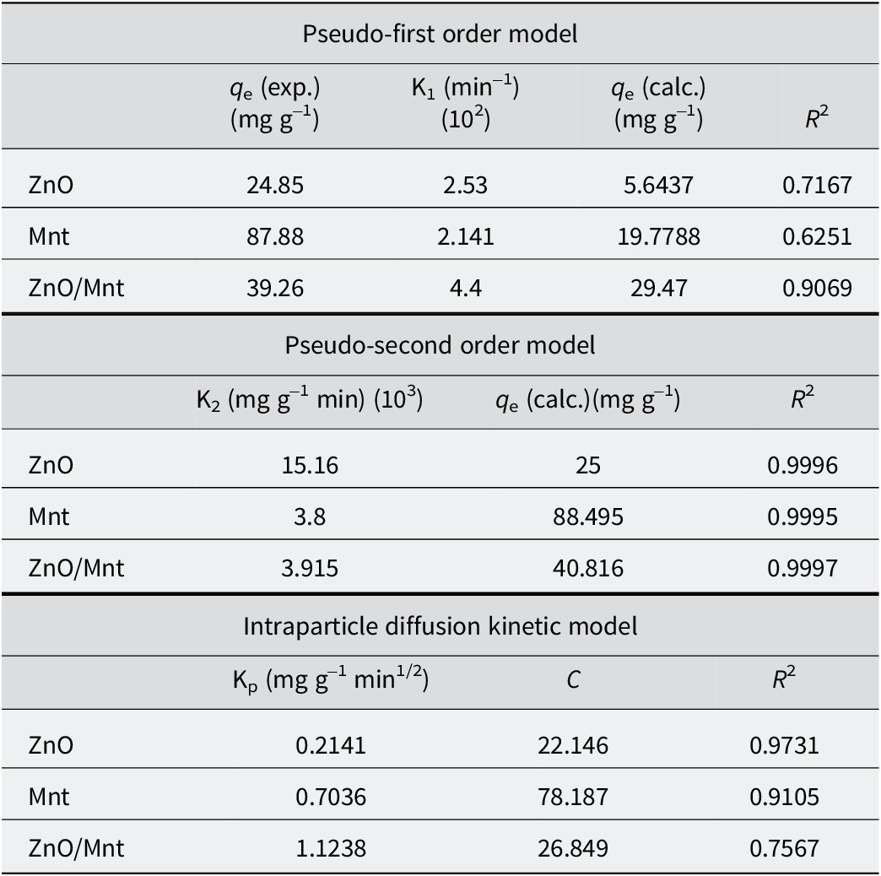
Additionally, the intraparticle diffusion model suggests that the rate of adsorption is constrained by mass transfer across the boundary layer. This is evidenced by the non-origin-passing straight line, along with the correlation coefficients, K_{p} values, and y-intercepts presented in Table 3. These findings highlight the complex kinetics involved in the adsorption process and suggest that multiple factors influence the overall adsorption rate.
While Mnt showed excellent capacity for the adsorption of TC compared with ZnO/Mnt, the combination of ZnO with Mnt confers some advantages, particularly in photocatalytic applications. Mnt has a very large surface area and large cation exchange capacity; thus, it is highly efficient at adsorbing contaminants. In the present study, pure Mnt achieved 100% TC adsorption, whereas the ZnO/Mnt composite adsorbed 70% TC. Considering the lower adsorption capacity of ZnO/Mnt, the addition of ZnO has added value due to its photocatalytic potential, a feature not available in pure Mnt.
The most significant benefit of ZnO/Mnt is that the composite opens paths to adsorb not only TC but also its complete removal owing to photodegradation processes facilitated by the photocatalytic properties of ZnO. Under irradiation, ZnO forms reactive oxygen species (ROS), which decompose the already adsorbed TC into harmless by-products such as CO₂ and H₂O. Thus, the composite is regenerated and may be reused in successive adsorption cycles. While Mnt is effective in the adsorption of TC, it lacks this capability and limits it to the process of adsorption only without further breakdown of the pollutant.
Therefore, the ZnO/Mnt composite combines the strengths of both materials: high efficiency of adsorption by Mnt and the ability of ZnO to conduct photodegradation. This dual functionality provides a continuous solution from pollutant removal to degradation and, hence, is a promising candidate for future water-treatment applications. Although this study focused on adsorption, the underlying potential for photodegradation by ZnO has been established in earlier studies.
This work, while exploring the kinetics and thermodynamics and optimization of pH_{zcp} and pH for maximum adsorption of Mnt, ZnO, and ZnO/Mnt, serves as a backdrop to further study of photodegradation by the ZnO/Mnt composite. In this respect, ZnO acts as a critical factor in the decomposition of TC into non-toxic compounds, thereby increasing the work capability of the composite through an adsorption-only mechanism by Mnt and situating the composite as an effective means for tackling photodegradable pollutants such as TC.

Limitations of the study
Despite the encouraging results derived from this study for tetracycline adsorption using ZnO, Mnt, and ZnO/Mnt composite materials, several limitations must be addressed. This study was primarily concerned with adsorption effectiveness and the resulting kinetics, which excluded a complete assessment of the long-term stability of the adsorbed TC or its susceptibility to desorption under various environmental conditions. The ZnO/Mnt composite has a bifunctional role in adsorption and photocatalysis; however, this study did not systematically examine the kinetics of TC photodegradation under different light conditions, thereby limiting the understanding of its realistic effectiveness. Furthermore, the synthesis of the ZnO/Mnt composite was conducted at a single mixing ratio of 1:3 (20 g ZnO and 60 g Mnt), which might not be the optimal composition for realizing the best balance between adsorption and photocatalytic degradation. Future research should explore various ratios of ZnO:Mnt to improve performance outcomes. Another key limitation was that the experiments were performed under controlled laboratory conditions with synthetic TC solutions, which may not replicate real wastewater environments where interfering ions and organic matter could influence the adsorption performance. In general, the synthesis of the ZnO/Mnt composite is a multi-step processing procedure involving sonication and calcination, which could pose some difficulties in terms of scale-up production and cost-effectiveness. Scalable and cost-efficient synthesis routes need to be further investigated. In addition to these constraints, this research provides a sound basis for developing ZnO/Mnt composites for sustainable water treatment applications.

Conclusions
The ZnO/Mnt composite was prepared successfully and evaluated for the removal of tetracycline using kinetic, thermodynamic, and pH_{zcp} studies. Montmorillonite exhibited the greatest adsorption capacity of 125 mg g^{–1}, while the ZnO/Mnt composite reached 72 mg g^{–1}. Although Mnt showed greater adsorption efficiency, the presence of ZnO adds significant potential for photocatalytic activity, enabling degradation of TC into harmless by-products such as CO₂ and H₂O under light irradiation. The different pH_{zcp} values recorded for ZnO, Mnt, and ZnO/Mnt (4.5, 9.5, and 7.2, respectively) demonstrated the varying surface charge properties of each material and highlighted the versatility of ZnO/Mnt for pollutant adsorption across a wide pH range. Adsorption isotherms revealed that Mnt and ZnO/Mnt fitted the Langmuir model, while ZnO followed the Freundlich model. Kinetic studies showed that adsorption on all adsorbents followed a pseudo-second order model with equilibrium reached within 120 min.
This work also emphasizes the strong link between pH_{zcp} and TC retention and shows that combining adsorption with photocatalysis provides a sustainable pathway for contaminant removal. While adsorption by Mnt ensures high uptake, ZnO contributes photocatalytic degradation that prevents secondary pollution and regenerates the adsorbent surface. This integrated adsorption–photocatalysis strategy offers a promising approach for complete mineralization of TC and similar pharmaceutical pollutants, and future studies should aim at optimizing both adsorption and photodegradation processes to achieve more efficient and environmentally friendly water purification solutions.

Supplementary material
The supplementary material for this article can be found at http://doi.org/10.1017/cmn.2025.10016.

Author Contribution
The results shown here are partly based on R.T.’s thesis (supervised by H.S.H. and A.H.Z.). H.N. performed additional experiments. S.Z. performed the SEM and XRD measurements. N.Q. performed the SEM and XRD measurements. Sh.H.Z. helped with the analysis of the results and drafted the manuscript. A.H.Z. conceptualized and designed the study, supervised the thesis, drafted and wrote the manuscript. M.H.S.H. contributed to the concept and design; H.S.H. contributed to the concept, design, and supervision of the thesis. All the authors have read and approved the manuscript. All authors have been personally and actively involved in substantial work leading to the paper. All authors take public responsibility for its content.

Acknowledgments
The authors are grateful to An-Najah National University (www.najah.edu) for the technical support provided to publish the present manuscript.

Financial support
Not applicable.

Competing interests
The authors declare that they have no competing interests.

Data availability statement
Data sharing is not applicable to this study.

References

Ahmad, F., Zhu, D., & Sun, J. (2021). Environmental fate of tetracycline antibiotics: degradation pathway mechanisms, challenges, and perspectives. Environmental Sciences Europe, 33, 64. https://doi.org/10.1186/s12302-021-00505-yGoogle Scholar

Ali, I., Alharbi, O.M., ALOthman, Z.A., Al-Mohaimeed, A.M., & Alwarthan, A. (2019). Modeling of fenuron pesticide adsorption on cnts for mechanistic insight and removal in water. Environmental Research, 170, 389–397. https://doi.org/10.1016/j.envres.2018.12.066Google Scholar

Alqadami, A.A., Wabaidur, S.M., Jeon, B.-H., & Khan, M.A. (2024). Co-hydrothermal valorization of food waste: process optimization, characterization, and water decolorization application. Biomass Conversion and Biorefinery, 14, 15757–15768. https://doi.org/10.1007/s13399-022-03711-7Google Scholar

An, J.-H., & Dultz, S. (2007). Adsorption of tannic acid on chitosan-montmorillonite as a function of pH and surface charge properties. Applied Clay Science, 36, 256–264. https://doi.org/10.1016/j.clay.2006.11.001Google Scholar

Arefi, M.R., & Rezaei-Zarchi, S. (2012). Synthesis of zinc oxide nanoparticles and their effect on the compressive strength and setting time of self-compacted concrete paste as cementitious composites. International Journal of Molecular Sciences, 13, 4340–4350. https://doi.org/10.3390/ijms13044340Google Scholar

Bilal, M., Mehmood, S., Rasheed, T., & Iqbal, H.M. (2020). Antibiotics traces in the aquatic environment: persistence and adverse environmental impact. Current Opinion in Environmental Science & Health, 13, 68–74.https://doi.org/10.1016/j.coesh.2019.11.005Google Scholar

Boeva, N., Bocharnikova, Y.I., Belousov, P., & Zhigarev, V. (2016). Determining the cation exchange capacity of montmorillonite by simultaneous thermal analysis method. Russian Journal of Physical Chemistry A, 90, 1525–1529. https://doi.org/10.1134/S0036024416080057Google Scholar

Bourg, I.C., Sposito, G., & Bourg, A.C. (2007). Modeling the acid–base surface chemistry of montmorillonite. Journal of Colloid and Interface Science, 312, 297–310. https://doi.org/10.1016/j.jcis.2007.03.062Google Scholar

Brunauer, S., Emmett, P.H., & Teller, E. (1938). Adsorption of gases in multimolecular layers. Journal of the American Chemical Society, 60, 309–319. https://doi.org/10.1021/ja01269a023Google Scholar

Carter, D., Mortland, M., & Kemper, W. (1986). Specific surface. Methods of Soil Analysis: Part 1 Physical and Mineralogical Methods, 5, 413–423. https://doi.org/10.2136/sssabookser5.1.2ed.c16Google Scholar

Castaño-Trias, M., Rodríguez-Mozaz, S., Verlicchi, P., & Buttiglieri, G. (2024). Selection of pharmaceuticals of concern in reclaimed water for crop irrigation in the Mediterranean area. Journal of Hazardous Materials, 466, 133538. https://doi.org/10.1016/j.jhazmat.2024.133538Google Scholar

Ciftci, H. (2021) An introduction to montmorillonite purification. Montmorillonite Clay. IntechOpen. doi: 10.5772/intechopen.98188Google Scholar

Colaizzi, J.L., & Klink, P.R. (1969). pH-partition behavior of tetracyclines. Journal of Pharmaceutical Sciences, 58, 1184–1189. https://doi.org/10.1002/jps.2600581003Google Scholar

Danner, M.-C., Robertson, A., Behrends, V., & Reiss, J. (2019). Antibiotic pollution in surface fresh waters: occurrence and effects. Science of the Total Environment, 664, 793–804. https://doi.org/10.1016/j.scitotenv.2019.01.406Google Scholar

Degenkolb, J., Takahashi, M., Ellestad, G., & Hillen, W. (1991). Structural requirements of tetracycline-Tet repressor interaction: determination of equilibrium binding constants for tetracycline analogs with the Tet repressor. Antimicrobial Agents and Chemotherapy, 35, 1591–1595. https://doi.org/10.1128/aac.35.8.1591Google Scholar

Earl, K., Sleight, H., Ashfield, N., & Boxall, A.B. (2024). Are pharmaceutical residues in crops a threat to human health? Journal of Toxicology and Environmental Health, Part A, 87, 773–791. https://doi.org/10.1080/15287394.2024.2371418Google Scholar

Fatimah, I., Wang, S., & Wulandari, D. (2011). ZnO/montmorillonite for photocatalytic and photochemical degradation of methylene blue. Applied Clay Science, 53, 553–560. https://doi.org/10.1016/j.clay.2011.05.001Google Scholar

Freundlich, H. (1906). Uber die adsorption in losungen. Zeitschrift Fur Physikalische Chemie-international J Res In P, 57, 85–470. https://doi.org/10.1515/zpch-1907-5723Google Scholar

Freundlich, H. (1907). Über die adsorption in lösungen. Zeitschrift für physikalische Chemie, 57, 385–470. https://doi.org/10.1515/zpch-1907-5723Google Scholar

Fu, X., Wan, P., Li, P., Wang, J., Guo, S., Zhang, Y., An, Y., Ye, C., Liu, Z., & Gao, J. (2021). Mechanism and prevention of ototoxicity induced by aminoglycosides. Frontiers in Cellular Neuroscience, 15, 692762. https://doi.org/10.3389/fncel.2021.692762Google Scholar

Gao, P., Liu, X., Guo, Z., & Tournassat, C. (2023). Acid–base properties of cis-vacant montmorillonite edge surfaces: a combined first-principles molecular dynamics and surface complexation modeling approach. Environmental Science & Technology, 57, 1342–1352. https://doi.org/10.1021/acs.est.2c07171Google Scholar

Gao, Y., Li, Y., Zhang, L., Huang, H., Hu, J., Shah, S.M., & Su, X. (2012). Adsorption and removal of tetracycline antibiotics from aqueous solution by graphene oxide. Journal of Colloid and Interface Science, 368, 540–546. https://doi.org/10.1016/j.jcis.2011.11.015Google Scholar

Griffin, M.O., Ceballos, G., & Villarreal, F.J. (2011). Tetracycline compounds with non-antimicrobial organ protective properties: possible mechanisms of action. Pharmacological Research, 63, 102–107. https://doi.org/10.1016/j.phrs.2010.10.004Google Scholar

Guo, X., Mu, Q., Zhong, H., Li, P., Zhang, C., Wei, D., & Zhao, T. (2019). Rapid removal of tetracycline by myriophyllum aquaticum: evaluation of the role and mechanisms of adsorption. Environmental Pollution, 254, 113101. https://doi.org/10.1016/j.envpol.2019.113101Google Scholar

Guo, Y.X., Liu, J.H., Gates, W.P., & Zhou, C.H. (2020). Organo-modification of montmorillonite. Clays and Clay Minerals, 68, 601–622. https://doi.org/10.1007/s42860-020-00098-2Google Scholar

Hao, W., Flynn, S.L., Alessi, D.S., & Konhauser, K.O. (2018). Change of the point of zero net proton charge (pH_{PZNPC}) of clay minerals with ionic strength. Chemical Geology, 493, 458–467. https://doi.org/10.1016/j.chemgeo.2018.06.023Google Scholar

Ho, Y.-S., & McKay, G. (1999). Pseudo-second order model for sorption processes. Process Biochemistry, 34, 451–465. https://doi.org/10.1016/S0032-9592(98)00112-5Google Scholar

Izah, S.C., Nurmahanova, A., Ogwu, M.C., Toktarbay, Z., Umirbayeva, Z., Ussen, K., Koibasova, L., Nazarbekova, S., Tynybekov, B., & Guo, Z. (2025). Public health risks associated with antibiotic residues in poultry food products. Journal of Agriculture and Food Research, 21, 101815. https://doi.org/10.1016/j.jafr.2025.101815Google Scholar

Khan, M.A., Otero, M., Kazi, M., Alqadami, A.A., Wabaidur, S.M., Siddiqui, M.R., Alothman, Z.A., & Sumbul, S. (2019). Unary and binary adsorption studies of lead and malachite green onto a nanomagnetic copper ferrite/drumstick pod biomass composite. Journal of Hazardous Materials, 365, 759–770. https://doi.org/10.1016/j.jhazmat.2018.11.072Google Scholar

Khan, M.A., Wabaidur, S.M., Siddiqui, M.R., Alqadami, A.A., & Khan, A.H. (2020). Silico-manganese fumes waste encapsulated cryogenic alginate beads for aqueous environment de-colorization. Journal of Cleaner Production, 244, 118867. https://doi.org/10.1016/j.jclepro.2019.118867Google Scholar

Komadel, P., Bujdák, J., Madejová, J., Šucha, V., & Elsass, F. (1996). Effect of non-swelling layers on the dissolution of reduced-charge montmorillonite in hydrochloric acid. Clay Minerals, 31, 333–345. https://doi.org/10.1180/claymin.1996.031.3.04Google Scholar

Komadel, P., & Madejová, J. (2006). Acid activation of clay minerals. Developments in Clay Science, 1, 263–287. https://doi.org/10.1016/S1572-4352(05)01008-1Google Scholar

Kong, Y., Zhuang, Y., Han, K., & Shi, B. (2020). Enhanced tetracycline adsorption using alginate-graphene-ZIF67 aerogel. Colloids and Surfaces A: Physicochemical and Engineering Aspects, 588, 124360. https://doi.org/10.1016/j.colsurfa.2019.124360Google Scholar

Lagergren, S. (1898). Zur theorie der sogenannten adsorption geloster stoffe. https://doi.org/10.1515/zpch-1907-5723Google Scholar

Langmuir, I. (1918). The adsorption of gases on plane surfaces of glass, mica and platinum. Journal of the American Chemical Society, 40, 1361–1403. https://doi.org/10.1021/ja02242a004Google Scholar

Li, Y., Du, Q., Liu, T., Sun, J., Wang, Y., Wu, S., Wang, Z., Xia, Y., & Xia, L. (2013). Methylene blue adsorption on graphene oxide/calcium alginate composites. Carbohydrate Polymers, 95, 501–507. https://doi.org/10.1016/j.carbpol.2013.01.094Google Scholar

Liu, M., Hou, L.-a., Yu, S., Xi, B., Zhao, Y., & Xia, X. (2013). MCM-41 impregnated with A zeolite precursor: synthesis, characterization and tetracycline antibiotics removal from aqueous solution. Chemical Engineering Journal, 223, 678–687. https://doi.org/10.1016/j.cej.2013.02.088Google Scholar

Liu, X., Huang, D., Lai, C., Zeng, G., Qin, L., Zhang, C., Yi, H., Li, B., Deng, R., & Liu, S. (2018). Recent advances in sensors for tetracycline antibiotics and their applications. Trends in Analytical Chemistry, 109, 260–274. https://doi.org/10.1016/j.trac.2018.10.011Google Scholar

Low, P.F. (1980). The swelling of clay: II. Montmorillonites. Soil Science Society of America Journal, 44, 667–676. https://doi.org/10.2136/sssaj1980.03615995004400040001xGoogle Scholar

Mejri, C., Oueslati, W., & Amara, A.B.H. (2023). Structure and reactivity assessment of dioctahedral montmorillonite during provoked variable sequential cation exchange process via xrd modelling approach. Applied Surface Science Advances, 15, 100403. https://doi.org/10.1016/j.apsadv.2023.100403Google Scholar

Meroufel, B., Benali, O., Benyahia, M., Benmoussa, Y., & Zenasni, M. (2013). Adsorptive removal of anionic dye from aqueous solutions by Algerian kaolin: characteristics, isotherm, kinetic and thermodynamic studies. Journal of Materials and Environmental Sciences, 4, 482–491.Google Scholar

Mohy-u-Din, N., Farhan, M., Wahid, A., Ciric, L., & Sharif, F. (2023). Human health risk estimation of antibiotics transferred from wastewater and soil to crops. Environmental Science and Pollution Research, 30, 20601–20614. https://doi.org/10.1007/s11356-022-23412-yGoogle Scholar

Nguyen, M.-K., Lin, C., Nguyen, H.-L., Hung, N.T.Q., La, D.D., Nguyen, X.H., Chang, S.W., Chung, W.J., & Nguyen, D.D. (2023). Occurrence, fate, and potential risk of pharmaceutical pollutants in agriculture: challenges and environmentally friendly solutions. Science of the Total Environment, 899, 165323. https://doi.org/10.1016/j.scitotenv.2023.165323Google Scholar

Okocha, R.C., Olatoye, I.O., & Adedeji, O.B. (2018). Food safety impacts of antimicrobial use and their residues in aquaculture. Public Health Reviews, 39, 21. https://doi.org/10.1186/s40985-018-0099-2Google Scholar

Parolo, M.E., Savini, M.C., Valles, J.M., Baschini, M.T., & Avena, M.J. (2008). Tetracycline adsorption on montmorillonite: pH and ionic strength effects. Applied Clay Science, 40, 179–186. https://doi.org/10.1016/j.clay.2007.08.003Google Scholar

Qiu, H., Lv, L., Pan, B.-C., Zhang, Q.-J., Zhang, W.-M., & Zhang, Q.-X. (2009). Critical review in adsorption kinetic models. Journal of Zhejiang University-Science A, 10, 716–724. https://doi.org/10.1631/jzus.A0820524Google Scholar

Rowan, N.J. (2011). Defining established and emerging microbial risks in the aquatic environment: current knowledge, implications, and outlooks. International Journal of Microbiology, 2011. https://doi.org/10.1155/2011/462832Google Scholar

Sanqin, W., Zepeng, Z., Yunhua, W., Libing, L., & Jiansheng, Z. (2014). Influence of montmorillonites exchange capacity on the basal spacing of cation–anion organo-montmorillonites. Materials Research Bulletin, 59, 59–64. https://doi.org/10.1016/j.materresbull.2014.06.007Google Scholar

Scaria, J., Anupama, K., & Nidheesh, P. (2021). Tetracyclines in the environment: an overview on the occurrence, fate, toxicity, detection, removal methods, and sludge management. Science of the Total Environment, 771, 145291. https://doi.org/10.1016/j.scitotenv.2021.145291Google Scholar

Sellaoui, L., Abdulaziz, F., Chebaane, S., Manai, L., Azhary, A., Alsehli, A.H., Alsowayigh, M.M., Piscitelli, A., & Erto, A. (2023a). Adsorption of pharmaceutical pollutants on activated carbon: physicochemical assessment of the adsorption mechanism via advanced modelling. Journal of Molecular Liquids, 389, 122929. https://doi.org/10.1016/j.molliq.2023.122929Google Scholar

Sellaoui, L., Dhaouadi, F., Taamalli, S., Louis, F., Bakali, A.E., Badawi, M., Bonilla-Petriciolet, A., Silva, L., da Boit Martinello, K., & Dotto, G.L. (2022). Understanding the Cu²⁺ adsorption mechanism on activated carbon using advanced statistical physics modelling. Environmental Science and Pollution Research, 29, 54882–54889. https://doi.org/10.1007/s11356-022-19795-7Google Scholar

Sellaoui, L., Gómez-Avilés, A., Dhaouadi, F., Bedia, J., Bonilla-Petriciolet, A., Rtimi, S., & Belver, C. (2023b). Adsorption of emerging pollutants on lignin-based activated carbon: analysis of adsorption mechanism via characterization, kinetics and equilibrium studies. Chemical Engineering Journal, 452, 139399. https://doi.org/10.1016/j.cej.2022.139399Google Scholar

Shao, S., & Wu, X. (2020). Microbial degradation of tetracycline in the aquatic environment: a review. Critical Reviews in Biotechnology, 40, 1010–1018. https://doi.org/10.1080/07388551.2020.1805585Google Scholar

Souza, S.O., Silva, M.D.M., Santos, J.C.C., de Oliveira, L.C., do Carmo, J.B., & Botero, W.G. (2016). Evaluation of different fractions of the organic matter of peat on tetracycline retention in environmental conditions: in vitro studies. Journal of Soils and Sediments, 16, 1764–1775. https://doi.org/10.1007/s11368-016-1364-yGoogle Scholar

Sridev, D., & Rajendran, K. (2009). Synthesis and optical characteristics of ZnO nanocrystals. Bulletin of Materials Science, 32, 165–168. https://doi.org/10.1007/s12034-009-0025-9Google Scholar

Thuc, C.-N.H., Grillet, A.-C., Reinert, L., Ohashi, F., Thuc, H.H., & Duclaux, L. (2010). Separation and purification of montmorillonite and polyethylene oxide modified montmorillonite from Vietnamese bentonites. Applied Clay Science, 49, 229–238. https://doi.org/10.1016/j.clay.2010.05.011Google Scholar

Tombacz, E., & Szekeres, M. (2004). Colloidal behavior of aqueous montmorillonite suspensions: the specific role of pH in the presence of indifferent electrolytes. Applied Clay Science, 27, 75–94. https://doi.org/10.1016/j.clay.2004.01.001Google Scholar

Wabaidur, S.M., Khan, M.A., Siddiqui, M.R., Otero, M., Jeon, B.-H., Alothman, Z.A., & Hakami, A.A.H. (2020). Oxygenated functionalities enriched mwcnts decorated with silica coated spinel ferrite – a nanocomposite for potentially rapid and efficient de-colorization of aquatic environment. Journal of Molecular Liquids, 317, 113916. https://doi.org/10.1016/j.molliq.2020.113916Google Scholar

Wang, S., Chen, Y., Ge, S., Liu, Z., & Meng, J. (2023). Adsorption characterization of tetracycline antibiotics on alkali-functionalized rice husk biochar and its evaluation on phytotoxicity to seed germination. Environmental Science and Pollution Research, 30, 122420–122436. https://doi.org/10.1007/s11356-023-30900-2Google Scholar

Weber, W.J. Jr, & Morris, J.C. (1963). Kinetics of adsorption on carbon from solution. Journal of the Sanitary Engineering Division, 89, 31–59. https://doi.org/10.1061/JSEDAI.0000430Google Scholar

Yanan, C., Ali, J., Sellaoui, L., Dhaoudi, F., Franco, D.S., Georgin, J., Erto, A., Vieillard, J., & Badawi, M. (2023). Elucidating the adsorption mechanism of herbicide Diuron onto activated carbons via steric, energetic and thermodynamic investigations. Journal of Water Process Engineering, 53, 103910. https://doi.org/10.1016/j.jwpe.2023.103910Google Scholar

Zango, Z.U., Garba, A., Garba, Z.N., Zango, M.U., Usman, F., & Lim, J.-W. (2022). Montmorillonite for adsorption and catalytic elimination of pollutants from wastewater: a state-of-the-arts review. Sustainability, 14, 16441. https://doi.org/10.3390/su142416441Google Scholar

Zhou, Z., Cheng, H., Komarneni, S. & Ma, J. (2023). MIL-101(Fe)/WS2 composites activated Na₂S₂O₈ with visible light for removal of tetracycline. Environmental Science and Pollution Research, 30, 122393–122404. https://doi.org/10.1007/s11356-023-30914-wGoogle Scholar

Zyoud, A., Jondi, W., AlDaqqah, N., Asaad, S., Qamhieh, N., Hajamohideen, A., Helal, M.H., Kwon, H., & Hilal, H. (2017). Self-sensitization of tetracycline degradation with simulated solar light catalyzed by ZnO@montmorillonite. Solid State Sciences, 74, 131–143. https://doi.org/10.1016/j.solidstatesciences.2017.09.009Google Scholar

Zyoud, A., Zorba, T., Helal, M., Zyoud, S., Qamhiya, N., Hajamohideen, A., Zyoud, S., & Hilal, H. (2019a). Direct sunlight-driven degradation of 2-chlorophenol catalyzed by kaolinite-supported ZnO. International Journal of Environmental Science and Technology, 16, 6267–6276. https://doi.org/10.1007/s13762-019-02272-zGoogle Scholar

Zyoud, A.H., Zyoud, S.H., & Amireh, A. (2024). An innovative and sustainable approach for water purification: thermal decomposition of tetracycline contaminant adsorbed on thermally stable montmorillonite. Case Studies in Chemical and Environmental Engineering, 9, 100631. https://doi.org/10.1016/j.cscee.2024.100631Google Scholar

Zyoud, A.H., Saleh, F., Helal, M.H., Shawahna, R., & Hilal, H.S. (2018). Anthocyanin-sensitized TiO₂ nanoparticles for phenazopyridine photodegradation under solar simulated light. Journal of Nanomaterials, 2018. https://doi.org/10.1155/2018/2789616Google Scholar

Zyoud, A.H., Zubi, A., Zyoud, S.H., Hilal, M.H., Zyoud, S., Qamhieh, N., Hajamohideen, A., & Hilal, H.S. (2019b). Kaolin-supported ZnO nanoparticle catalysts in self-sensitized tetracycline photodegradation: zero-point charge and pH effects. Applied Clay Science, 182, 105294. https://doi.org/10.1016/j.clay.2019.105294Google Scholar

