Curriculum Vitae

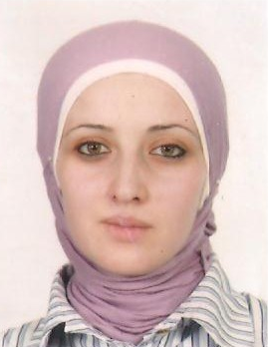
PERSONAL INFORMATION
Name: Jasmine Awni Aghba rShehadeh
Address: Nablus- Al Makhfia Street
Telephone: 09-2343514
Cell Phone: 0595202799
Email:yasmeen.aghbar@najah.edu
j-nightingale@hotmail.com/
Date of Birth:December 11, 1984
Nationality: Palestinian
Sex: Female
Marital Status:Married
EDUCATION:
- 2008-2010:MA, English Translation (GPA 87.2%). Faculty of Translation, English Department, Yarmouk University, Irbid, Jordan. Tel:0096227211111, Email:www.yu.edu.jo
- 2002-2006: BA, English Language and Literature (GPA 88.9%), Faculty of Arts, English Department, An- NajahNationalUniversity, Nablus, West bank, Tel:09-2345113 ,Email: info@najah.edu
- 2001- 2002: General Examination Board (GPA 97%), Literary Sream, Samir Sa'dDeen Secondary School, Nablus, West Bank
EMPLOYMENT HISTORY:
- September 13, 2006-2008: Instructor at HishamHijjawi College for Technology,Nablus, An Najah National University, Tel: 09-2311337
- November 1, 2006- December 1, 2006: Translator at Nippal Company for General Trade, Nablus, Hitten Street
COMPUTER SKILLS:
Windows (very good) Internet (good) Excel (good)
PROFESSIONAL QUALIFICATIONS (TRAINING):
- June 20-August 20, 2006: A Computer Course (ICDL) in Windows, WinWord, Excel and PowerPoint, Amra Center, Nablus, Tel: 09-2344305
- June 27- July 8, 2006: A special training for qualifying the graduates to be able to work, An- Najah Career Unit, An Najah National University, Tel: 09-2394960
- August 1-November 1, 2007: A training course in the Hebrew language, Project Hope, Nablus, Tel: 09-2337077

INTERESTS:
.Reading and criticizing literary works
.Traveling
.Working under the pressure
.Browsing net pages
REFEREES:
- Dr. Abed al Kareem Daraghmeh, English Department, An Najah National University, Tel: 09-2345113
- Dr.OdehOdeh: English Department, An Najah National University,
Tel:09-2345113
- Dr.Abdullah Al Shunnaq, Translation Department, Yarmouk University,
Tel: 0096227211111

