Curriculum Vitae

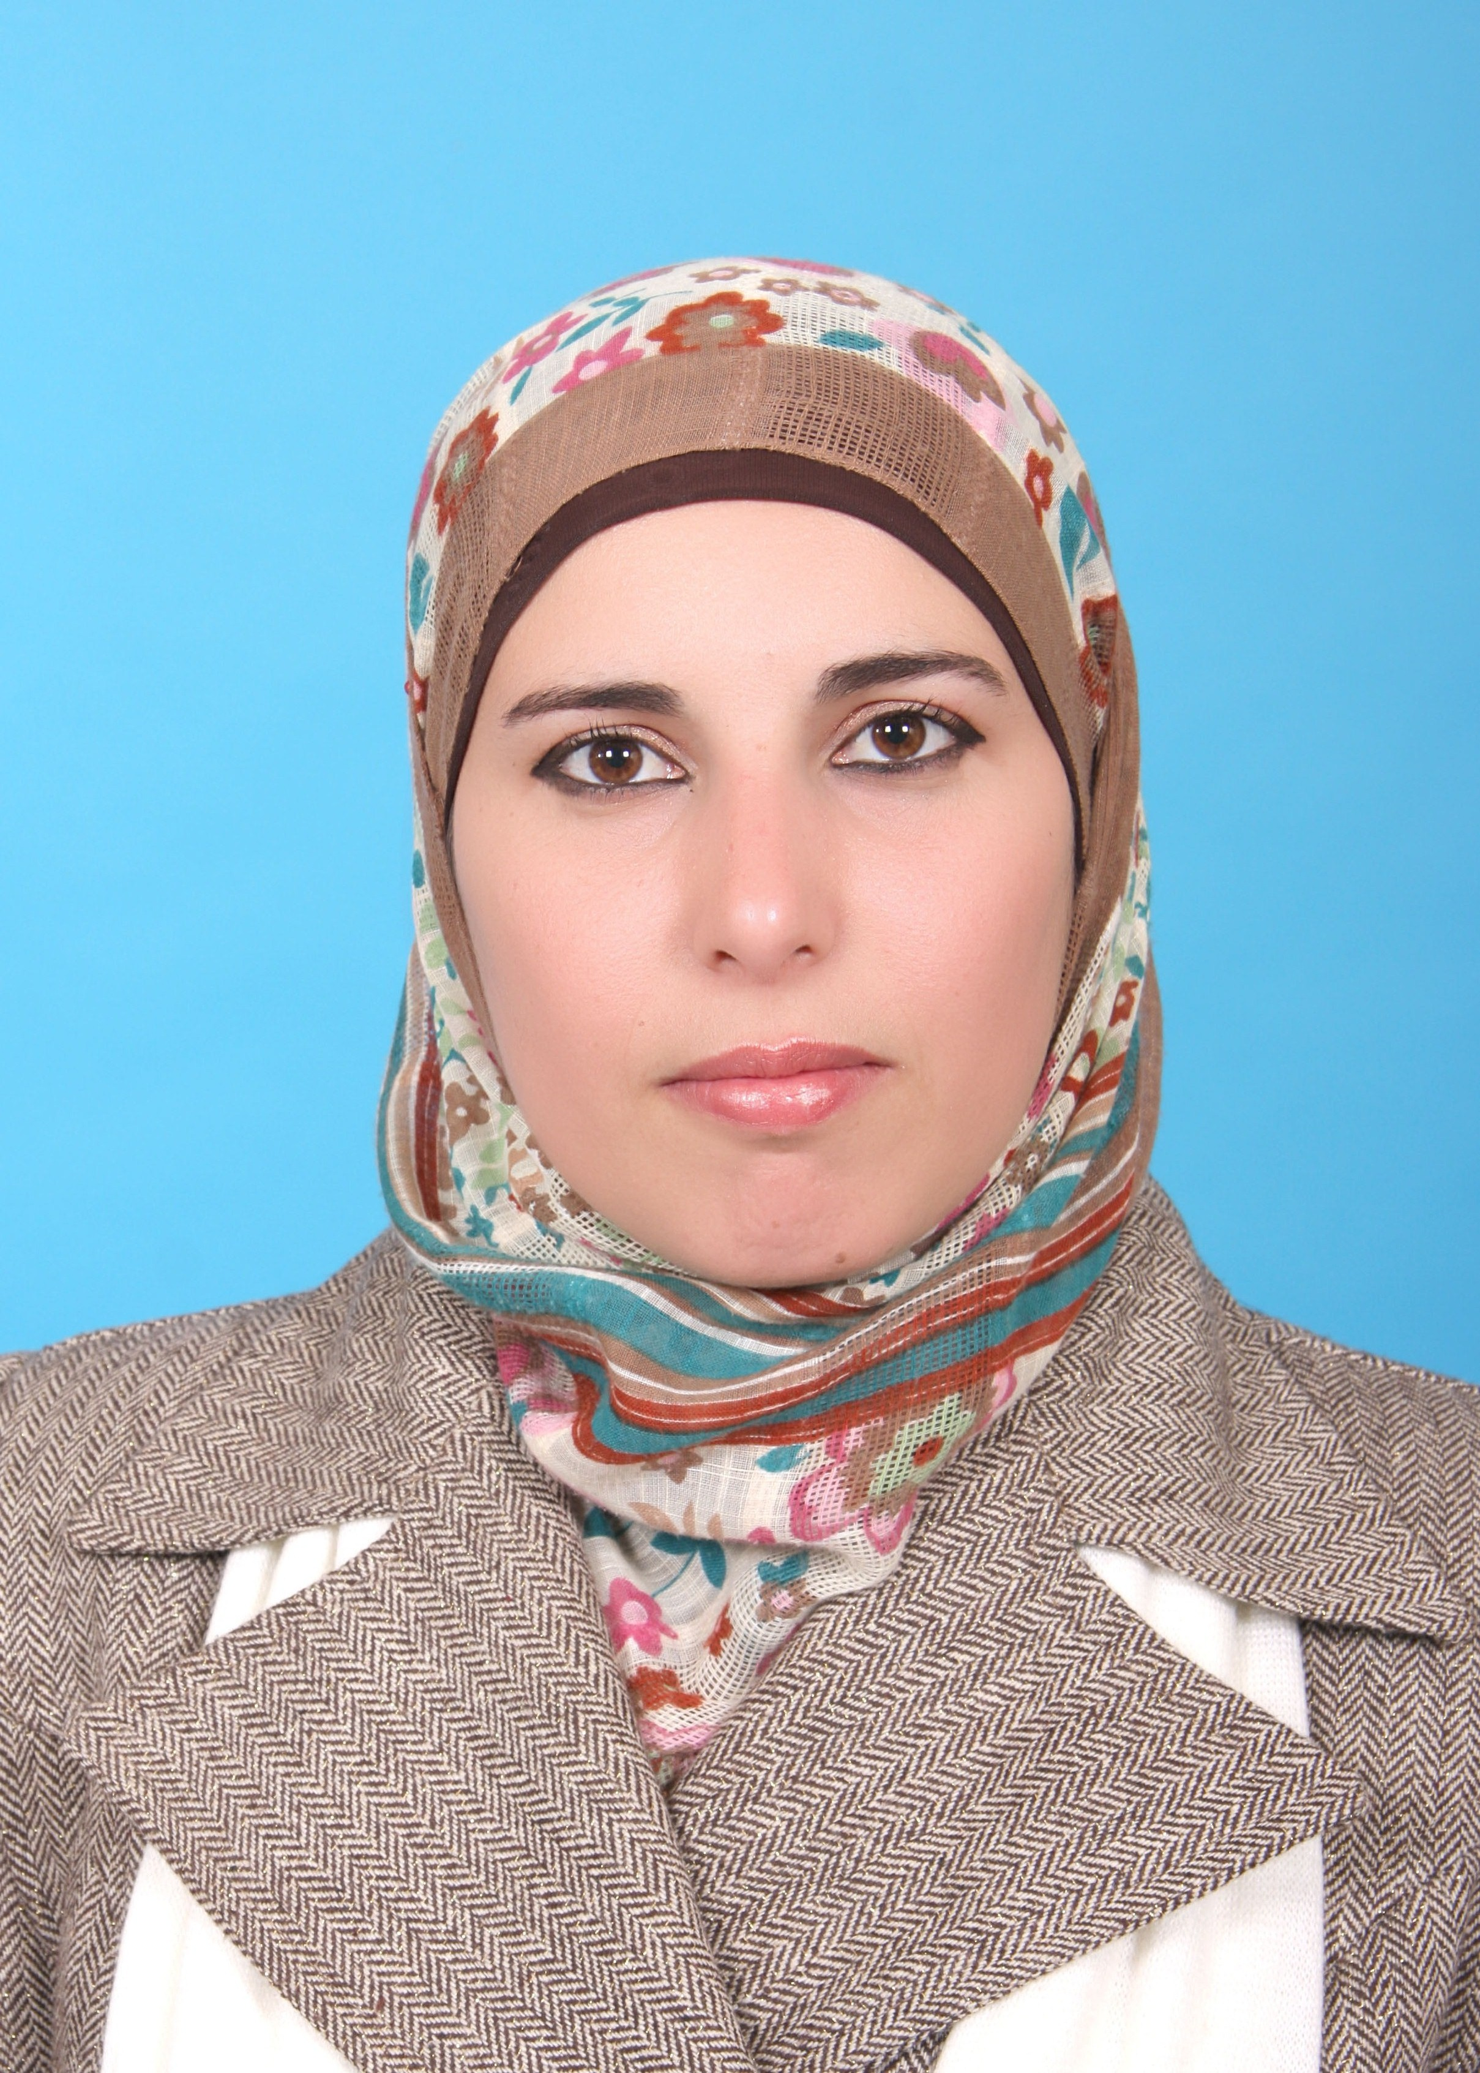

Personal Information :

Name : Fatima Mohammad Hirzallah
Date of Birth: 21\1\1981
Place of birth: Jordan
Marital status: single
I.D No: 411870603
Mobile:0599149318
Email: fatimahirzallah@najah.edu
Telephone\ Mobile:0599149318
Int number: (972) (09) 2345113-(2575)
Fax: (972) (09) 2342910
P.O. Box: 7

- CURRENT POSITION

September 2008 until now: Full time Lecturer at Department Of Nursing and Midwifery, in the Faculty of Medicine and health sciences at An- Najah National University.

- Education:

- September 2014-2018 PhD candidate, Intensive care nursing, Abel Salazar Biomedical Sciences Institute, University of Porto, Porto-Portugal.

- June 2008 M.Sc., Nursing, clinical\critical care nursing, Faculty of Higher Education ,University of Jordan, Amman – Jordan. GPA: very good 80\100

- June 2003: B.Sc. Nursing, Ibn Sina Collage for Health Sciences –Ramallah – Palestine. GPA: Excellent with honor 84.4\100

- Work experience:

- September 2009 Until now Lecturer for 2nd year nursing students of Adult health nursing, department of nursing, Faculty of Medicine and health sciences, An- Najah National University

- September 2009 Until now clinical instructor for 2nd year nursing students of Adult health nursing, department of nursing, Faculty of Medicine and health sciences, An- Najah National University

- September 2008 - September 2009 Lecturer for 3rd year nursing students of Critical care nursing, department of nursing, Faculty of Medicine and health sciences, An- Najah National University

- September 2008 - September 2009 clinical instructor for 3rd year nursing students of Critical care nursing, department of nursing, Faculty of Medicine and health sciences, An- Najah National University

- August 2007- August 2008: clinical instructor (part time) 2nd year nursing students of Adult health nursing, department of nursing, Faculty of Medicine and health sciences, An- Najah National University

- Jun 2008- September 2008 : Head Nurse in the Adult Intensive care unit(ICU), Nablus speciality hospital, Nablus –Palestine

- Jun 2005- September 2007: Staff - Nurse in the Neonate Intensive care unit (NICU), Jordan University Hospital, Amman – Jordan
- August 2003- Jan 2005: Staff – Nurse in the (acute and surgical) department, Salfeet hospital , Nablus – Palestine

- Research Thesis :

- December 2008 -December 2013: I’m supervisor the research projects for undergraduate nursing students (4th year students), Nursing and Midwifery department , in the Faculty of Medicine and Health Sciences at An-Najah National University

- I have conference paper (abstract of systematic review) in 5th Congress on Nursing Research book” at Escola Superior de Enfermagem de Coimbra, Portugal, Jun 2016.

Topics :

- Predisposing factors for stress among nurses working in critical care units in Nablus public hospitals, December 2008
- The Effect of Light on Academic Performance among Twjihi Students, December 2009

Awareness of risk factors for cancer among students at An-Najah national university, December 2010

Risk factors of osteoporosis among Palestinian women in Nablus city, December 2011

- Evaluation The Nursing Practice Of Diabetic Foot Ulcer Care In The
Unrwa Health Centres (A qualitative descriptive study), December 2011

- The Cancer patient's Perceptions of their Disease in the Northern of the west
bank.(Qualitative research _ A phenomenography study), December2012
- Application of emergency code system ( code blue ) in the Emergency departments and ICU among health care team in private and governmental hospitals in Nablus city, December2012

- Courses, Seminars and workshops in Palestine at An-Najah University 2008-2013:

- April 2008-November 2013: participant in the form of presentation in Trauma Nursing Core Course (TNCC) for nursing students, Department Of Nursing, Faculty of Medicine and Health Sciences at An-Najah National University co-ordination with Red Cresent Association.

- October 2008-: participant in the form of presentation in" infertility in Palestine Day conference", Department Of Nursing, Faculty of Medicine and Health Sciences at An-Najah National University

- December 2009: participant in the form of presentation in workshop "Towards A Palestinian centre for health sciences education" , subject about critical care in Palestine : past, current and future, IMET 2000 Pal (International Medical Education Trust-Palestine)- Ramallah

- August 2009- August 2013: participant in the form of presentation in Advance Burn Life Support course (ABLS) course for nursing students, Department Of Nursing, Faculty of Medicine and Health Sciences at An-Najah National University

- December 2008-April 2013: coordinator and participant in the form of presentation in Advance Cardiac Life Support course (ACLS) course for nursing students, Department Of Nursing, Faculty of Medicine and Health Sciences at An-Najah National University

- December 2010: participate in the form of presentation in training workshop "Evaluation o f nursing education theory and practice" , subject about assessment of written assignment Department Of Nursing, Faculty of Medicine and Health Sciences at An-Najah National University.

- Courses, Seminars and workshops in Portugal and Switzerland 2014-2016:

- On 9th of October, 2014: I attended the workshop, Thomson Reuters
entitled: " From Evaluation to Scientific Policy Implementations " organized by Virtual library University of Porto, which took place in the hall of Noble ICBAS (Abel Salazar Biomedical Sciences Institute).Virtual University of Porto library.
- On 18th of December, 2014 -: I participated in the workshop activity "Festa" organized by the faculty of Arte for international students, I submitted presentation in "Festa na Palestina e na Síria " at the Faculty of Arts (FLUP), University of Porto, Portugal.

- 16th of January, 2015: I participated in the seminar " Psychotherapeutic Interventions in Nursing " at ICBAS (Abel Salazar Biomedical Sciences Institute), University of Porto, Portugal.

- From 10th to 12th of May, 2015: I attended the international conference "IV Congresso da Ordem dos Enfermeiros" at Congress center of Lisbon, Lisbon, Portugal.

- On 15th of May: I attended the Seminar "Interdisciplinary in Palliative Care: contribution of nursing sciences" at ICBAS (Abel Salazar Biomedical Sciences institute), University of Porto, Portugal.

- From 20th to 22th of May: I attended the International Meetings of Doctorate in Nursing "Investigacao cientifica da utopia a realidade " at the University of Lisbon, Lisbon, Portugal.

- On 2nd of July,2015: I represented Palestine in the cultural activities meeting " Multiculturalism" through submit presentation about "Palestinian Culture and Traditional foods" at University of Porto/ international office; Praça Gomes Teixeira, Porto, Portugal.

- In the 6th of June2016, I participated in “ 5th Congress on Nursing Research of Ibero-American and Portuguese-speaking Countries ” in the form of presentation in my systematic review" A systematic review of nurses-led weaning protocol and impact on outcomes of mechanical ventilation for critically ill adult patientsª at Escola Superior de Enfermagem de Coimbra, Portugal.

- From 16th to 17th of September 2016, presented thesis project, title" "The impact of nurses-led weaning protocol on outcomes of mechanical ventilation for critically ill patients among Palestinian and Portuguese hospitals " in "EDCNS conference 2016 (The European Doctoral Conference in Nursing Science)", Bern, Switzerland.

- Languages:

- Arabic language: Tongue language
- English language: Very Good
- Portuguese: Very Good

