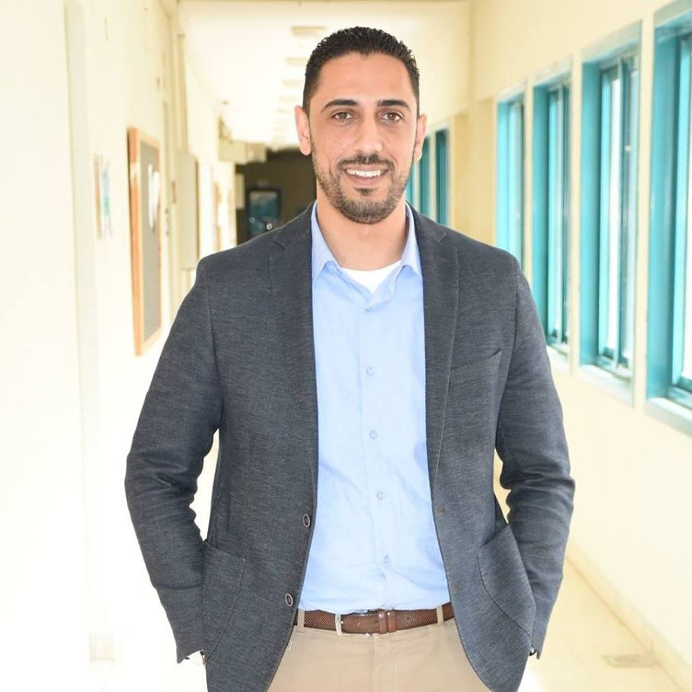 Curriculum Vitae

Ahmad H. A. Aqad

- Address : Palestine \ Westbank \ Nablus \ Al-Karmel Str

- Mobile1: 00970-599-965986

- Mobile2: 00970-9-2387934

- Email: ahmad.aqad@hotmail.com

- Facebook : https://www.facebook.com/ahmad.aqad.9

- Nationality: Palestinian

- Date of Birth: 18-07-1990

Education and Qualifications

- 2008-2009 Second Secondary (Tawjihi)
Tawjihi certificate of Al-Salaheye Secondary high school (Art Stream)

- 2009-2011 Diploma
Computer Software & Data Base programming

- 2011 Alshamel Exam
Comprehensive Examination-General of the Palestine community colleges

- 2013 Visual Studio 2013 Certificate
Dot Learning Center has a total of 80 hours of training

- 2014 C sharp Certificate
Cisco Academy has a total of 80 hours of training

Career Summary cont.

2007-2010 Volunteer Supervisors (Palestinian Counciling Centre)

Working as A volunteer animator & Supervisor And Joined all of their activities

2010- 2011 Computer maintaining (Millennium Technology M2TX)

Working as a computer maintaining And Computer Software

2011- untill now Computer Lab Technician

Working at al najah national university as Computer Lab Technician
2019-2020 Accountant

Accountant, Life Fitness Gym, Hayat Nablus
2022- untill now Accountant
Accountant, Fitness Palace Gym, Nablus Rafidia

Profile

A dedicated and results-driven senior manager with a highly successful background in

the achievement of profitable business growth through the creation and execution of

successful sales and marketing strategies. Experienced in working with leading brands

in the competitive retail and automotive industries with the primary focus on exceeding

expectations for customer service delivery while ensuring optimum brand impact.

Possesses excellent interpersonal, communication and negotiation skills and the ability

to develop and maintain mutually beneficial internal and external relationships. Enjoys

being part of, as well as managing, motivating and training, a successful and productive

team, and thrives in highly pressurised and challenging working environments.
Professional Development

- Management Development Programme | - Effective Man Management
- Marketing Management | - Appraisal Training
- Presentation Skills | - Team Building
- Finance for Non-financial Managers | - Creativity Training

IT Skills

- Word, Excel, Access, PowerPoint, Internet and Email, Photoshop , Visual Basic …..etc

- AL-Shamel Accounting Programme

Languages

- Arabic Tongue Language
- English Very good Reading , writing and listening

Personal Details

Driving Licence Available
Health Excellent
View Gentleman

Finally, hoping that my qualifications will meet your requirements.
Thank you for your time and consideration and best regards.

