Curriculum Vitae
Hana Moustafa Odeh

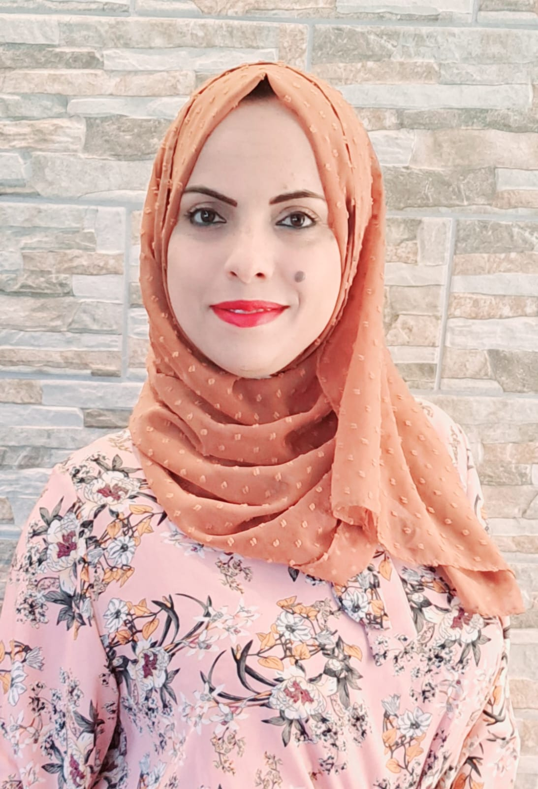

Address

Personal address | Mobile: (+972) 0598136763.  E- mail: Hana.Odeh @ Najah.edu

Personal Details

Full Name  Date of Birth  Gender  Nationality  Residence  Social Status  Religion  Telephon No.  Drvier license  Visa Status | Hana Moustafa Saleh Odeh.  10–November– 1986 .  Femal.  Palestinian.  Nablus- Qaruot  Married.  Islam.  (+ 972) 0598136763  Private.  Palestinian passport.

Academic Qualifications

2005- 2009 | AN-Najah National University | B.Sc Nursing , Faculty of Nursing , An-Najah National University.
2004- 2005 | Eqab Mufdi  Secondary School - Palestine | Certificate of scientific secondary education.
2010-2012 | AL- Makassed charitable college – Al qouds | Certificate of High Diploma in midwifery.

Seminars and Workshops during study

1.  2.  3.  4.  5.  6.  7.  8.  9.  10.  11.  12.  13.  14.  15.  16.  17.  18.  19.  20. | Wound Management, March, 2022, State Of Palestine , Palestinian Nursing and Midwifery, Association – Jerusalem .  Women’s Health and Sexual and Reproductive Health and Rights online Course , 20.10.2021- 15.11.2021, At Oslo Metropolitan University.  Basic Life Support , March, 2020, On AHA Center , . At AN-Najah university.  Breast Feeding, February/March, 2012, At the Makassed Hospital / Jerusalem.  Causes, prevention, treatment and management of Endocrine Diseases ( Presenter ) Feb 28, 2007. Dr.Aidah Alkaissi. At AN-Najah university - faculty of nursing. Nablus City- Palestine.  Prevention transporting disease in hospital and clinical health. July 18, 2007. Dr.Aidah Alkaissi.At AN-Najah university- faculty of nursing.  Nablus City-Palestine.  Trauma nursing care course (TNCC). May26- 30/2007. Dr.aidah abu eisoud alkaissi.At AN-Najah university- faculty of nursing . Nablus City- Palestine.  Basic life support. March 26-28, 2008 .Dr.Aidah Alkaissi.  At AN-Najah university - faculty of nursing. Nablus City- Palestine.  Advanced cardiac life support. January 16-18/2007. Dr.Aidah Alkaissi, .At AN-Najah university - faculty of nursing. Nablus City- Palestine.  Infertility, Causes and Management ( Presenter ). November 20, 2008. Dr. Adnan Sarhan. At AN-Najah university- Faculty of Nursing. Nablus city- Palestine.  Scientific Nursing Research , Preparation and management. March 15, 2009. Dr. Adnan Sarhan. At AN-Najah university- Faculty of Nursing. Nablus city- Palestine.  Procedures of the Intensive care nursing .( Presenter ). Feb.15, 2007. Dr. aidah abu eisoud alkaissi .At AN-Najah university- Faculty of Nursing. Nablus city- Palestine.  Narcotics Course and Time Management Course ( Presenter ) . Feb 16-17\2008. At AN-Najah university- Faculty of Nursing. Nablus city- Palestine.  Cardice Disease , Treatment and Nursing Management (Presenter).December 12,2006.Dr, Ansam Shawaleh , At AN-Najah university- Faculty of Nursing.  Advanced Life Support In Obstetric(ALSO)(Presenter).April. 28\2008. Dr. aidah abu eisoud alkaissi .At AN-Najah university- Faculty of Nursing. Nablus city- Palestine.  First Aids. 10.10.2008- 25.11.2008. At Palestine Red Crescent Society. Nablus city- Palestine.  First Responder .12.1.2009 -2.2.2009. At Palestine Red Crescent Society. Nablus city- Palestine.  اجتياز البرنامج التدريبي بكلية التمريض جامعة طنطا لعام 2007 في إطار اتفاقية تبادل التدريب الطلابي بين الجامعات العربية.  قواعد السلامة لمنع حدوث الحريق.عقدت بتاريخ 8-5 -2007 بالتعاون مع اطفائية بلدية نابلس.  Modified Basic Life Support on 24.8.2009. At Al.Makassed Islamic Charitable Hospital.

Current Working

Teaching and Research Assistant - Clinical Simulation Center Coordinator. At An-Najah National University. Faculty of Medicine and Health Science. Teaching laboratories for the Fundamental I and Fundamental II of nursing and Health Assessment.

Experience

A  B.  C.  D. | Working for three month in postpartum ward at Specialized Nablus Hospital – Nablus City.  Working for four years in labor, postpartum , and normal nursery at Al-Makassed Charitable Hospital – Al.qouds City.  Working as clinical instructor at AN-Najah university and Al-Andalleb colloge in various hospitals in the West Bank  Working at Dima IVF Center for one year

Skills

Computer  Languages | - Microsoft Office (Word, Excel, PowerPoint)  - Computer typing skills (Arabic & English).  - Arabic – Mother language.  - English – Reading, Speaking and writting .

Personal Characteristics | - Very Good nursing skills.  - Capability to work with team.  - Capability to work under pressure.  - Excellent presenter.  - Very good in using computer and internet.  - Good team worker – god communication abilities.  - Excellent activity organizer.  - I have special interests in presenting lectures and teaching.

References.
- Dr. Aidah alkaissi, dean of Nursing college, AN-Najah university, Nablus city, Palestine. Tel : 09 2394008. Mob: 0597395520. E-mail : aidah@najah.edu

- Dr. Dina Ismail, Supervisor Of Intrapartum and Postpartum Department , At Al-Makassed Charitable Hospital – Al.qouds City.Mob: 0547564945 . E-mail:

- Dr. Shurouq Qadose , Lecturer full time at An – Najah National University, Nursing &Midwifery Department. Mob: 0598170233. E-mail: sh_qadose@najah.edu

Thank you for reading my C.V, I am looking forward to have a chance with you

