Hi; my names is;
OTHMAN ABDUL RAHIM AL HANBALI

Personal Details

Date of Birth: 20th November, 1974  Nationality: Palestinian and Australian  Postal Address: Department of Pharmacy, Faculty of Medicine and Health Sciences, Nablus –West Bank, Palestinian Authority.  Mobile: 0594303070  Email: othman.hanbali@najah.edu |  | 
https://orcid.org/0000-0003-4840-5210 | ORCID Code

Education and Qualification
Name of University | Name of Degree | Year
School Of Pharmacy. University Of Brighton-Brighton-UK | PhD In Pharmaceutical NanoTechnology | May, 2006
School of Pharmaceutical Sciences  Universiti Sains Malaysia, 11800 Minden, Pulau Pinang, Malaysia | Master In Pharmaceutical Technology | June 2001
Faculty of Pharmacy-University of Karachi  Karachi-Pakistan | Bachelor of Pharmacy | Dec, 1997
Ministry of Education-Amman-Jordan | General Secondary Education (GCSE) -Science | 1992/93

Career History
Name of company | Name of your role | Start Date - Present
Pharmatechno  www.pharmatechno.com | Founder and Manager for company (Australia) | Sept 2013- ongoing
Faculty of Pharmacy, Al-Zaytoonah Private University. Amman-Jordan | Lecturer and Scientific Researcher | Sept, 2012- Sept, 2013
Faculty of Pharmacy - Montpellier 1 University (UM1)  Service Communication 5 bd Henri IV - CS 19044 - 34967 Montpellier Cedex 2 – France. | Scientific Researcher | Sept, 2011—1st Aug, 2012
Faculty of Pharmacy, Philadelphia University. Amman-Jordan. | Lecturer and Scientific Researcher | Sept, 2010- Sept, 2011
Faculty of Pharmacy and Biomedical Sciences, Al-Ahlyyia Amman University. Amman-Jordan. | Lecturer and Scientific Researcher | Sept, 2007-Sept, 2010
Faculty of Pharmacy, Al-Zaytoonah Private University. Amman-Jordan. | Lecturer and Scientific Researcher | Sept, 2006 – Sept, 2007
School Of Pharmacy, University of Brighton, Brighton,BN2 4GJ – UK. | Lecturer and Laboratory Demonstrator | Sept, 2002 – May, 2006
GlaxoSmithKline (GSK) and Bayer-Pakistan Pharmaceutical Industries.  Karachi – Pakistan. | Pharmacist in Production Areas | Feb, 1998 – Aug, 1998

PATENTS

1- Granted Patent Number 2014256440 - IP Australia in 2015, Title of the invention: Adhesive Material For Bonding Of Glass To Glass

2- Granted Patent Number 2016200283 - IP Australia 2016, Title of the invention:
Levia : A New Injectable Parasiticidal Veterinary Formulation Of Levamisole Hcl And Ivermectin Solution.

3- Granted Patent Number 2016210773 - IP Australia 2016, Title of the invention:
An Anti-Parasitic Formulation And A Method For Treating Parasitic Infestations In An Animal.

4*- Granted, Patent Number 2017201991- IP Australia 2018, Title of the invention:
System and method for drug dosage medicament regime adherence monitoring.

4*- Granted, Patent Number 10478119 B2 –USPTO 2019,
Title of the invention: System and method for drug dosage medicament regime adherence monitoring.

5- Granted, Patent Number 2017203330 - IP Australia 2017, Title of the invention: Formulations for baby Animals.

6- Granted, Patent Number 2018201611 - IP Australia 2019, Title of the invention: A Navigational Device.

6*- Granted, Patent Number 11034284 B2 –USPTO June, 2021 Title of the invention: A Navigational Device.

Research Gate Link
https://www.researchgate.net/profile/Othman_Al-Hanbali

List of Publications
(Complete Article available on Research Gate website)

1- Mosab Arafat, Molham Sakkal, Mohammad F. Bostanudin, Othman Abdulrahim Alhanbali, Priya Yuvaraju, Rami Beiram, Bassem Sadek, Amal Akour, Salahdein AbuRuz. Enteric-coating film effect on the delayed drug release of pantoprazole gastro-resistant generic tablets [version 1; peer review: awaiting peer review]. F1000Research 2023, 12:1325 (https://doi.org/10.12688/f1000research.140607.1)

2- Al-Shukri, Salah Mahdi; Mahmood, Ayad Tarik; Al Hanbali, Othman A. (July,2021). Spiro-cyclotriphosphazene with three functional end groups: synthesis and structural characterization of new polycyclotriphosphazenes with Schiff-base groups. Polimery . Vol. 66 Issue 6, p341-349.

3- Mosab Arafat , Khairi M Fahelelbom , Muhammad K Sarfraz , Mohammad F Bostanudin , Qurat-ul-Ain Sharif , Anna Esmaeil , Othman A AL Hanbali , Salahdein Aburuz. (Oct 2020). Comparison between branded and generic furosemide 40 mg tablets using thermal gravimetric analysis and Fourier transform infrared spectroscopy. Journal of Pharmacy and Bioallied Sciences 12(4):489-498.

4- Alaa Shaban, Salah Mahdi Al-Shukri, Hussein Ismail Kahlaf and Othman A. Al Hanbali (2019). Synthesis, characterization, thermal and fire retardant properties of new homo- and block copolymers of polyacrylate and epoxy resin with cyclotriphosphazene core. Polimery. 64, Pages 9 - 22.
http://en.www.ichp.pl/Synthesis-and-fire-retardant-properties-of-new-homo--and-block-copolymers

5- Othman A. Al Hanbali , Haji Muhammad Shoaib Khan, Muhammad Sarfraz, Mosab Arafat, Shakeel Ijaz and Abdul Hameed. (2019). Transdermal patches: Design and current approaches to painless drug delivery. Acta Pharmaceutica, 69. Pages. 197–215. (Review Article).

6- Othman A Al Hanbali, Rania Hamed, Mosab Arafat, Youssef Bakkour, Hisham Al-Matubsi, Randa Mansour, Yazan Al-Bataineh, Mohammad Aldhoun, Muhammad Sarfraz, Abdel Khaleq Yousef Dardas (2018). Formulation and evaluation of diclofenac controlled release matrix tablets made of HPMC and Poloxamer 188 polymer: An assessment on mechanism of drug release. Pak J Pharm Sci 2018; 31: 1 (Suppl), p 345-351.

7- Boukhary R, Aboul-ElA M, Al-Hanbali O and El-Lakany A. (2018) Chemical Constituents from Salvia fruticosa libanotica. Pharmacognosy Journal. 2017; 9(1):73-82.

8- Rima Boukhary, Maha Aboul-ElA, Othman Al-Hanbali, Abdalla El-Lakany. (2017). Phenolic Compounds from Centaurea horrida L Growing in Lebanon. International Journal of Pharmacognosy and Phytochemical Research 9(1); 1-4.

9- Hisham Y. Al-Matubsi, Ghaleb Oriquat, Mahmood Abu-Samak, Othman Al Hanbali, and Maher Salim . (2016). Research Article: Effects of Lipoic Acid Supplementation on Activities of Cyclooxygenases and Levels of Prostaglandins E2 and F2? Metabolites, In the Offspring of Rats with Streptozotocin-Induced Diabetes. Journal of Diabetes Research, USA. In press. Journal of Diabetes Research, USA. Volume 2016, Article ID 9354937, 12 pages. http://dx.doi.org/10.1155/2016/9354937

10- Youssef Bakkour, Ahmad El Douhaibi, Nassim El-Achi, Fatima Al-Houmayssi,Othman Al Hanbali, Hanna El-Nakat and Fawaz El-Omar. (2013). Chemical composition and Antioxidant activities of the ethanolic extract of Salvia libanotica growing in Lebanon. International Journal of Phytopharmacy. 3 (4). 76-80.

11- Salah Mahdi Al-Shukri, Ayad Tariq Mahmood, Othman A. Al Hanbali. (2011). Thermal Properties, Adhesive Strength, and Optical Transparency of Cyclolinear Poly(aryloxycyclotriphosphazenes. Journal of Applied Polymer Science. 122. 1058-1065.

12- Hisham Y. Al-Matubsi , Farqad Hamdan , Othman Al Hanbali , Ghaleb A. Oriquat , Maher Salim. (2011). Diabetic hand syndromes as a clinical and diagnostic tool for diabetes mellitus patients. Diabetes Research and Clinical Practice. UK. Volume 94, Issue 2 , Pages 225-229.

13- Hisham Y. Al-Matubsi, Reem A. Kanaan, Farqad Hamdan, Maher Salim, Ghaleb A. Oriquat, Othman A. Al Hanbali (2011 ). Smoking practices in Jordanian people and their impact on semen quality and hormonal levels among adult men. Central European Journal of Public Health (CEJPH). 19 (1). 54-59.

14- Islam Hamad, Othman Al Hanbali, A. Christy Hunter, Kenneth J. Rutt, Thomas L. Andresen, and S. Moein Moghim. (2010). Distinct Polymer Architecture Mediates Switching of Complement Activation Pathways at the Nanosphere-Serum Interface: Implications for Stealth Nanoparticle Engineering. 4 (11). 6629-6638.ACS . Cited in news and views nature 2011.

15- Maswadeh M Hamzah, Kanaan A Reem, Aljarbou N Ahmad and Al Hanbali A Othman. (2010). Effect of Different Biological Membranes on In Vitro Bioadhesion Property&rdquo; Drug Invention Today. 2 (2). 155-159.

16- Hamzah A. Maswadeh, Othman A. Al Hanbali, Reem A. Kanaan , Ashok K. Shakya And Anwar Maraqa. (2010). Testing Lyoeuivalency for three commercially sustain release tablets containg Diltiaem HCl&rdquo;. Acta Poloniae Pharmaceutica-Drug Research. 67 (1). 93-97.

17- H. M. Hammoda, M. A. Aboul Ela, A. M. El-Lakany, O. Al Hanbali, C. S. Zaki, N. M. Ghazy. (2008). New constituents of Artemisia monosperma Del. Pharmazie. 63 (8). 611-614.

18- Rupa Mukhopadhyay, Othman Al Hanbali, Saju Pillai, Anne Gry Hemmersam, Rikke Louise Meyer, Alan Christy Hunter, Kenneth John Rutt, Flemming Besenbacher, Seyed Moein Moghimi, and Peter Kingshott. (2007). Ordering of Binary Polymeric Nanoparticles on Hydrophobic Surfaces Assembled from Low Volume Fraction Dispersions. Journal Of American Chemical Society (JACS) COMUNICATIONS. 129 (44). 13390 -13391. USA.

19- Georgi As. Georgiev , Dipak K. Sarker , Othman Al Hanbali ,Georgi D. Georgiev and Zdravko Lalchev. (2007). Effects of poly (ethylene glycol) chains conformational transition on the properties of mixed DMPC/DMPE-PEG thin liquid films and monolayer. Colloids and Surfaces B: Biointerfaces. 59 (2).184-193. USA. www. Sciencedirect.com

20- S. S. Sazhin, T. Kristyadi, W. A. Abdelghaffar, S. Begg, M. R. Heikal, S. V. Mikhalovsky, S. T. Meikle and O. Al Hanbali. (2007). Approximate analysis of thermal radiation absorption in fuel droplets. ASME Journal of Heat Transfer (IEEE). 129 (9). 1246-1255. USA.

21- Othman Al Hanbali , Nneka M. Onwuzo , Kenneth J. Rutt , Christopher M. Dadswell , S. Moein Moghimi and A. Christy Hunter. (2007). Modification of the Stewart biphasic colorimetric assay for stable and accurate quantitatitive determination of Pluronic and Tetronic block copolymers for application in biological systems". Analytical Biochemistry Journal. 361. 287-293. USA.

22- Reem A. Kanaan, Mohammad Aldwaik and Othman A. Al Hanbali. (2006). Connective Tissue Growth Factor, Bone Connection. Medical Science Monitor. (Review article) Med Sci Monit. 12 (12). 277-281. USA.

23- O. Al Hanbali, K. J. Rutt, D. K. Sarker, A. C. Hunter, and S. M. Moghimi. (2006). Concentration dependent structural ordering of poloxamine 908 on polystyrene nanoparticles and their modulatory Role on complement consumptio. Journal of Nanoscience and Nanotechnology. 6 (8). 3126-3133. USA.

24- Yvonne Tze Fung Tan, Kok Khiang Peh and Othman Al Hanbali. (2001). Invistigation of interpolymer complexation Between Carbopol and various grades of Polyvinylpyrolidone and effects on Adhesion strength and swelling properties. International Journal of Pharmaceutics. 4 (1). 7-14. Canada.

25- Yvonne Tze Fung Tan, Kok Khiang Peh and Othman Al Hanbali. (2000). Effect of Carbopol and Polyvinylpyrolidone on Mechanical, Rheological and Release Properties of Bioadhesive Polyethylene Glycol Gels. AAPS PharmSciYech. 1 (3). 24. USA.

Published Book Chapters

SM Moghimi, E Vega, ML Garcia, O. Al Hanbali and KJ Rutt. (2006). Polymeric nanoparticles as drug carriers and controlled release implant devices. In: Nanoparticulates as Drug Carriers (V. P. Torchilin, ed.). Imperial College Press, London. pp. 2942. [ISBN 1-86094-630-5]. https://books.google.co.in/books?id=bXOHg-xMx_wC&printsec=frontcover&source=gbs_atb#v=onepage&q&f=false

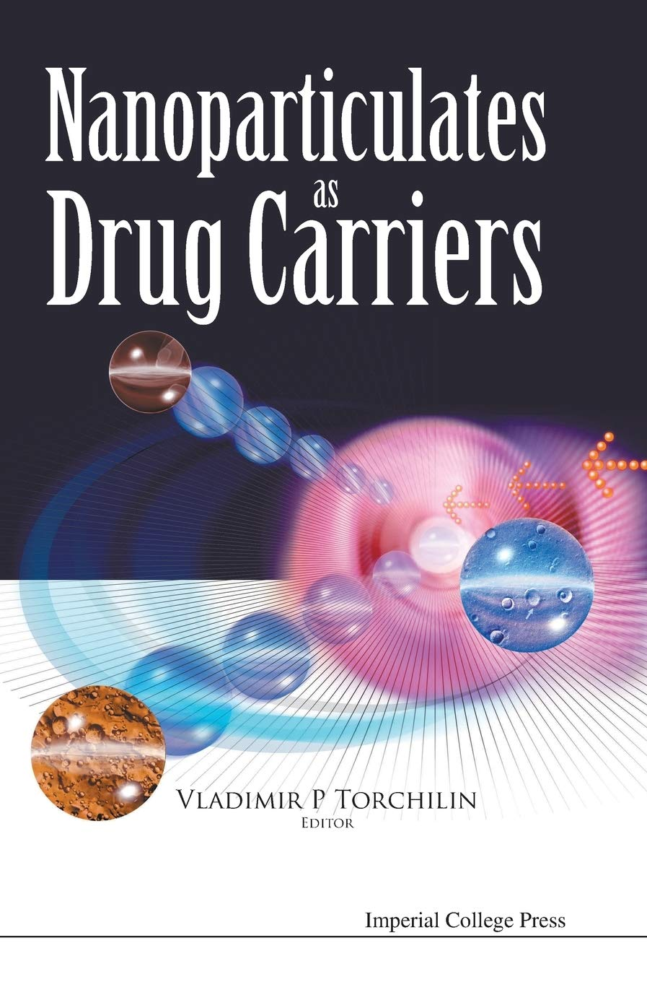

Personal Statement
I am a PhD graduated from Brighton University-UK May 2006 with a Bachelor Degree of Pharmacy. My PhD field was engineering surface for nanotparticles. In addition to meeting the demands of a full-time academic schedule, six years of university teaching experience. I have also accumulated fairly good number of international research articles one of which has been cited in news and views nature 2011. I have pretty good Laboratory experience that gave me the opportunity to work closely with a team of chemists, bioengineers and pharmacist.

Relevant Knowledge / Relevant Experience/ Summary of Skills
I did six months internship at GlaxoSmithKline (GSK) and Bayer-Pakistan Pharmaceutical Industries followed by ten years (4 during PhD and 6 after PhD) teaching pharmaceutical industry and quality control courses (Theory and Practical).
These experiences gave me a clear understand and follows for cGMPs, CFRs, SOPs, Work Instructions, BMRs and Safety requirements.
I have the capability of performing all basic functions associated with pharmaceutical industrial operations, operates general pharmaceutical equipment. Handles raw materials and intermediate or finished products. Mixes compound ingredients for liquid products or blends for tablet granulations and capsule powders. Performs general maintenance as required on blenders, high-shear granulators, fluid-bed systems, automated encapsulators, tablet compression machines, etc. Further, I can performs in-process testing and sampling as required, performs documentation as required for manufacturing batch records, manufacturing forms, maintenance, cleaning and housekeeping logs. Ability to write and articulate observations with clarity.

Achievements
*One of my research articles published in The Journal of the American Chemical Society (JACS) Impact Factor of 9.907 (2011).

*Another article published in ACS Nano reports an Impact Factor of 11.421 (2011). Cited in news and views nature 2011.

*Nominated and invited as Visiting Scientist (Nanomedicine) Centre for Pharmaceutical Nanotechnology and Nanotoxicology - Copenhagen University- Denmark. http://www.farma.ku.dk/index.php/Staff/8314/0/

Software Applications
I am capable of using the different kinds of software’s including statistical (SPSS), analytical and mathematical modeling (Mathmetica) and normal Microsoft package.

Referees
SM Moghimi; PhD, FIoN Professor of Nanomedicine  Director, Centre for Pharmaceutical Nanotechnology and Nanotoxicology | University of Copenhagen  Universitetsparken 2  DK-2100 Copenhagen Ø  Denmark  Direct Line: ++45 35 33 65 28  E.Mail: momo@farma.ku.dk  E.Mail: moghiminanomed.partners@europe.com
Dr. Christy AC Hunter | School of Pharmacy and Bimolecular Sciences-Brighton University-Brighton-BN2 4GJ-UK. Tel:++44(0)1273-642088. C.Hunter@bton.ac.uk
Dr. Ken Rutt | School of Pharmacy and Bimolecular Sciences-Brighton University-Brighton-BN2 4GJ-UK. Tel:++44(0)1273-642088 . K.Rutt@bton.ac.uk
Dr. Gassan Abu Shakeh | Faculty of Pharmacy, Al-Zaytoonah University--Amman-Jordan. Tel: 00962795803339
Dr Kinza Mansoor | Head of the Department /Faculty of Pharmacy /Al-Ahlyya Amman University ---Amman-Jordan. Tel: 00962796083095

