PERSONAL INFORMATION
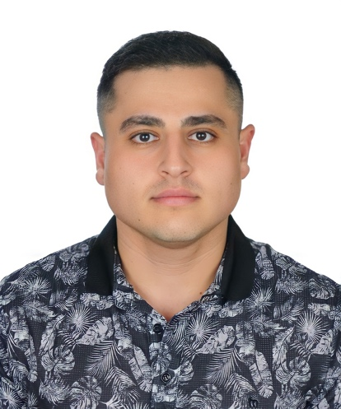
EDUCATION

Sep 2021– Present

Sep 2018–Aug 2019

Anas Amos

Nablus. Palestine +970595068031
+905528754298
anasamos.1996@gmail.com
 https://www.linkedin.com/in/anasamos1996/

PhD Finance & Banking
Süleyman Demirel University (Türkiye)

MSc Accounting & Finance
University of Dundee, Dundee (United Kingdom)

Jun 2015–Apr 2017 The Honor College Degree
An-Najah National University, Nablus (Palestine) 15 credit hours; includes:
- Communication Skills.
- Leadership Skills.
- Skills Enhancement.
- Learning and Research Resources.

Aug 2014–Dec 2017

Aug 2013–Jun 2014

TRAINING AND WORKSHOBS

BSc Accounting
An-Najah National University, Nablus (Palestine)
- Developed my knowledge in accounting, providing the foundations of accounting theory and practical skills necessary to meet the current and future market requirements.
- Established my professional skills of accounting in particular and business in general.
- Instilled moral values and professional ethics

General Secondary Education Examination
Ministry of Education and Higher Education (Palestine)

21 Jan 2019–25 Jan 2019 Specialist Business Skills: Challenging yourself and others
University of Dundee, Dundee (United Kingdom)
- Increased my skills in working with teams.
- Developed my communication skills

21 Jan 2019–22 Jan 2019 Level 1 Future Thinker
Scottish Innovative Student Award Programme, Dundee (United Kingdom) Increased my skills in the following areas:
•Self-awareness and self-efficacy

- Flexible and adaptable, seeing alternative perspectives
- Opportunity recognition
- Creative problem solving
- Collaboration
- Communication

23 Feb 2019–24 Feb 2019 Level 2 Innovation Catalyst
Scottish Innovative Student Award Programme, Glasgow (United Kingdom) Developed my skills in the following areas:
- Able to cope with ambiguity and uncertainty.
- Able to draw on views of others to develop and enhance work.
- Influencing, communication, negotiation.
- Ethical and sustainable thinking.
- Civic and social responsibility.

WORK EXPERIENCE

Jan 2018–Jun 2018

Sep 2019-Present

Accounting and Bookkeeping Clerk
Beauty Car for Cars Accessories, Tulkarem (Palestine)
  - Developed my skills in working with teams and work under pressure.
  - Increased my professional experience in the field of Accounting.

Accounting Instructor
An-Najah National University, Nablus (Palestine)
- Teaching accounting models for students in the accounting department, such as; Financial Accounting Principles, Tax Accounting

PERSONAL SKILLS

Mother tongue(s) Arabic

Foreign language(s)
UNDERSTANDING |  | SPEAKING |  | WRITING
Listening | Reading | Spoken interaction | Spoken production

English C1 C2 C1 C1 C1
IELTS
Levels: A1 and A2: Basic user - B1 and B2: Independent user - C1 and C2: Proficient user Common European Framework of Reference for Languages

Turkish C1 Proficient User

Communication skills Good communication skills gained through presentations in both MSc & BSc degrees and studying at the Honor college.

Organisational / managerial skills Leadership, teamwork, work under pressure, decision making and problem-solving gained through studying at the Honor college.

ADDITIONAL INFORMATION

Voluntary work Working with Al-Mushkah organization in the Together project in Dundee, to help and increase the level of refuges engaging with society.

